IDENTIFICATION AND LOCALIZATION OF A TRANSLOCATION IN PISUM
CHROMOSOMES BY THE C-BANDING TECHNIQUE

Wolff, G. Institute of Genetics, University of Bonn
Federal Republic of Germany

Gottschalk's mutant collection in Bonn initially included, among
others, 120 translocation genotypes. They originated in 1954 from
radiation experiments with cv 'Dippes Gelbe Viktoria'. The transloca-
tion lines were selected by analyzing pollen sterility. From these 120
genotypes only 30 are now still available.
In the early work, eight translocation genotypes were investigated
by examining the mitotic chromosomes of the root tips. Homogeneously
stained chromosomes were measured and the values of the mutant lines
were compared with those of the controls. The deviations in total
length and arm indices were the basis of these investigations (2, 6).
Though the participating chromosomes could be identified, the exact
localization of the exchange was impossible.
The development of the banding techniques in the early seventies
seemed to provide a promising tool for overcoming some of the technical
problems. The C-banding method is especially useful for identifying the
heterochromatic regions in plant chromosomes. However, this technique
proved difficult in Pisum. Attempts in our institute succeeded only in
characterizing chromosomes 4 and 7 (nomenclature according to Blixt
[1]). The banding pattern corresponded to that published by Lamm in
1978 (3). Because of the difficulties, the investigations in our insti-
tute were discontinued. Lamm published some further results on banded
Pisum chromosomes in 1981 (4).
In 1982 our institute again took up the problem of banding Pisum
chromosomes. The method used is a modification of those described by
Lamm (4), Marks and Schweizer (5), and Schweizer (pers. comm.). This
new attempt has yielded a heterochromatin pattern by which the single
chromosome can more or less be identified. Yet, this time too, many
difficulties had to be overcome. Typically fewer than 10% of the slide
preparations could be analyzed. This in part is due to an extremely Low
and varying mitotic index of Pisum root tips, and in part to the method
itself. Only in some few cells is the banding pattern sufficiently
clear. In general either the chromosomes are homogeneously stained, or
the pattern is incomplete, or the chromosomes are extremely swollen and
unstained. Often all these shortcomings are found on the same slide,
and we are unable to give a satisfactory explanation for them.
The distribution of heterochromatin in normal Pisum chromosomes is
shown in Figs. 1 and 2. Heterochromatin is found in the centromere
regions and on the telomeres, the amount being different in different
chromosomes. A rather large quantity of heterochromatin is situated
near the NOR region of chromosomes 4 and 7. Few intercalary bands of
heterochromatin are evident. However, banding clearly is visible on the
long arm of chromosome 7 proximal to the centromere region, and also on
the short arm of chromosomes 4 and 7 as well as near the centromere
region of chromosome 3 (long arm) and on the long arm of chromosome 5
(Fig. 2). This pattern is found in all metaphases which can be analyzed
reliably.
We have applied this C-banding technique to a reciprocal transloca-
tion genotype. We knew from earlier investigations of this genotype
that chromosomes 5 and 7 are involved in the exchange processes. Fig. 3

shows the metaphase of a translocation heterozygote, and Fig. 4 shows
the translocation chromosomes schematically. A long metacentric chromo-
some, normally not present, attracts attention in Fig. 3 (arrow). The
analysis of this chromosome reveals that part of the long arm of chromo-
some 7 is involved, characterized by the prominent banding near the NOR
region. On the second arm a small banding proximal to the centromere
region is visible, this being characteristic for the long arm of chromo-
some 5. The second translocation chromosome is an extremely small one
(Fig. 3, arrow). The one arm is identical with the short arm of chromo-
some 7. The shortness of the other arm reveals that only a very small
part of chromosome 5 is translocated.
As demonstrated above, chromosome 7 is characterized by a clear
intercalary banding on the long arm (Fig. 2). This banding is not found
in both the translocation chromosomes. This therefore marks the
breaking point of chromosome 7. The heterochromatic region evidently
was lost during the exchange process. With this presupposition, and by
measuring the arm length, we can in addition identify the breaking point
of chromosome 5. Thus, the one translocation chromosome, the big one,
is composed of the largest part of chromosome 5, including the centro-
mere region and a section of chromosome 7, this being exactly that part
from the position of the former intercalary banding on the long arm to
the end, including the satellite. The second translocation chromosome,
the short one, possesses the short arm of chromosome 7, the centromere
region and the adjacent part, up to the former intercalary banding.
From chromosome 5 only a very small terminal piece is translocated (Fig.
4).
Thus, our findings have shown that the application of the C-banding
technique in connection with translocation problems is useful; yet the
measurement of chromosomes seems also to be necessary. Because of the
low number of bandings in the Pisum chromosomes it seems impossible to
analyze any type of translocation. Only in those instances where a
region with a characteristic pattern is involved can detailed analysis
give information on the exact point of exchange.

1. Blixt, S. 1958. Agri Hort. Genet. 16:221-237.
2. Klein, H. D. 1974. PNL 6:22-23.
3. Lamm, R. 1978. PNL 10:31-32.
4. Lamm, R. 1981. Hereditas 94:45-52.
5. Marks, G. E. and D. Schweizer. 1974. Chromosoma 44:405-416.
6. Muller, D. 1976. Caryologia 29:217-225.
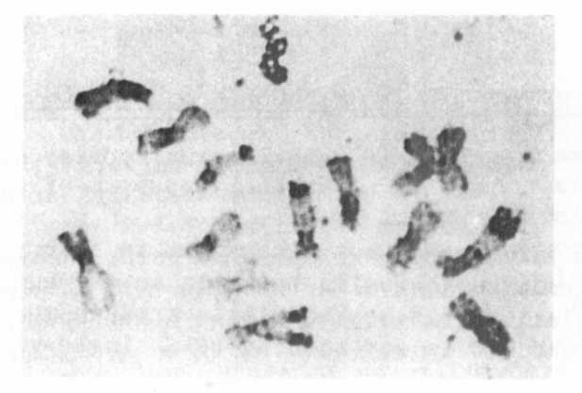
Fig. 1. C-banded metaphase of the root tip of Pisum sativum, var.
'Dippes Gelbe Viktoria'.
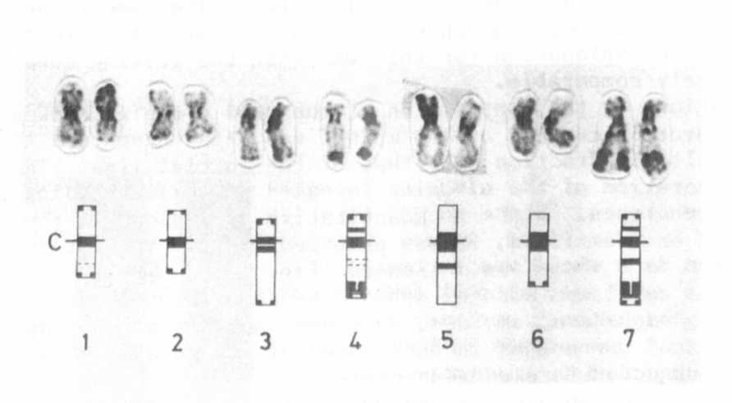
Fig. 2. Karvogram of C-banded pea chromosomes (DGV); below a schematical
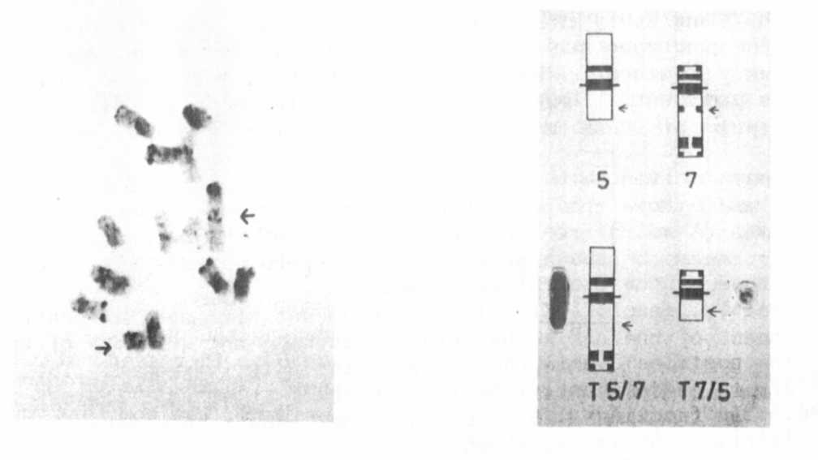
Fig. 3. C-banded metaphase of a
translocation heterozygous
line (T198) of DGV, arrows
pointing to the two trans-
chromosomes.
drawing; C=centromere
Fig. 4. Schematical drawing of the two
translocation chromosomes. Below,
normal chromosomes; above arrows
pointing to the region of breakage
and reunion.

