STUDIES ON MUTATIONS IN PEAS; COMBINED TREATMENT BY Nf AND NEU

Swiecicki, W. K. Plant Experiment Station, Wiatrowo, Poland

Our mutation studies at Wiatrowo, using combined doses Nf + NEU,
are aimed at finding and characterizing new mutants of pea. We seek
genes which not only are new, but also are of some importance for
breeding and cultivation. An hypothesis about the influence of the
joint action of genotype x mutagen on the spectrum of induced mutations
was also tested, the main points of which are summarized here.
Though the combined action of mutagens in Ml was stronger than the
same dose of each mutagen used separately, it was less than additive.
The effect of a combined treatment with Nf and NEU in Ml was strongly
dependent on which mutagen was administered first. Increasing doses of
Nf administered after one and the same dose of NEU caused an increase of
M1 damage whereas increasing doses of NEU after one and the same dose of
Nf increased the M1 damage less or, for certain characters, not at all.
On the basis of preliminary investigations (4, 5) the optimum dose
of Nf + NEU has been chosen for line Wt 3527 (200r + 0.014% - 25% reduc-
tion of M1 seedling length) and Wt 4042 (500r + 0.014% - 50% reduction
of seedling length) and, for comparison, Nf and NEU separately.
The results indicated that lower doses, causing less Ml damage,
could, depending on genotype of the treated material, be the most effec-
tive. The analysis of mutation frequency and spectrum in M2 confirmed
this (6, 7).
From a population of 30,000 M2 plants (5,000/dose = 500 families x
10 plants) 1314 mutation events have been selected (Table 1). Compari-
sons of the mutagens used, viz. Nf. , NEU, Nf + NEU, based on the kinds
and frequency of mutations in M2, showed that NEU was more effective
than Nf and that the combined treatments gave higher values still.
Again the effect of combined treatments was less than additive. The
mutagenic effectiveness of the combined dose used for Wt 3527 was very
high: 432 mutation cases found in 500 M2 families. Thus, for a given
genotype, a dose can be chosen to yield almost one mutation for each
treated seed. The number of mutation events calculated as a percent of
M₂ families seems to be a more suitable expression than the number of
mutants per 100 or 1,000 M2 plants as is commonly reported in the
literature. Combined doses also induced a higher number of multi-mutant
homozygotes (Fig. 1).
Mutants were classified and named according to PGA gene rules and
guidelines (see Induced mutation spectrum based on 1314 mutations [8]).
Interestingly, the results indicate that the combined treatments in com-
parison to the mutagens used separately acted as a different, third
mutagen. This is evident from the distribution of mutation types. Some
types were, at least in this experiment, specific for a given mutagen,
i.e. types induced by only one of the mutagens in a treated genotype.
Some can even be said to be doubly specific, i.e. they appear only after
treatment with "one" of the mutagens (combined treatment here regarded
as a separate mutagen) in one of the genotypes (numbers in brackets,
Table 2). Such specific types were induced by each mutagen, with the
greatest number appearing in Wt 3527 after combined treatments. Nf,
which was clearly less effective with regard to number of mutations,
induced twice as many specific mutations per induced mutant than the
combined treatments and three times as many as NFL. Among the specific
mutation types, hitherto unknown genes, e.g. orange pod, necrosis, were

RESEARCH REPORTS 3
PNL VOLUME 17 1985

J

recovered. Moreover, the spectrum of induced mutations was found to be
influenced by genotype x mutagen interactions.
The induced mutants resulting from these investigations are pre-
served in gene banks. Almost immediately after some of them were des-
cribed they became the subject of investigation in various laboratories
(1, 2, 3) as well as in our own breeding projects. After the locus
identity test crosses had been performed the new mutants were used in
mapping studies (8, 9).
ACKNOWLEDGEMENTS
The above summary reflects the results of investigations carried
out over a number of years and were the basis of a post-doctoral disser-
tation defended at IHAR/Radzikow in June 1984. I gratefully acknowledge
the invaluable encouragement, advice, and help given by Dr. S. Muszynski
and by Dr. S. Blixt during my FAO fellowship in his laboratory.
I also wish to convey my sincere gratitude to Prof. Dr. W.
Gottschalk, the official foreign reviewer of my dissertation. The
severe but friendly review has given me special satisfaction.

1. Muller, H. P. 1984. PNL 16:52-53.
2. Murfet, I. 1984. PNL 16:57-58.
3. Nozzolillo, C. 1983. PNL 15:48.
4. Swiecicki, W. K. 1979. PNL 11:33-34.
5. Swiecicki, W. K. 1981. Mut. Breed. Newsl. 17:10.
6. Swiecicki, W. K. 1981. Bull, de L'Acad. Pol. 29:7-8,
7. Swiecicki, W. K. 1984. Gen. Pol.
8. Swiecicki, W. K. 1985. PNL 16:70-72.
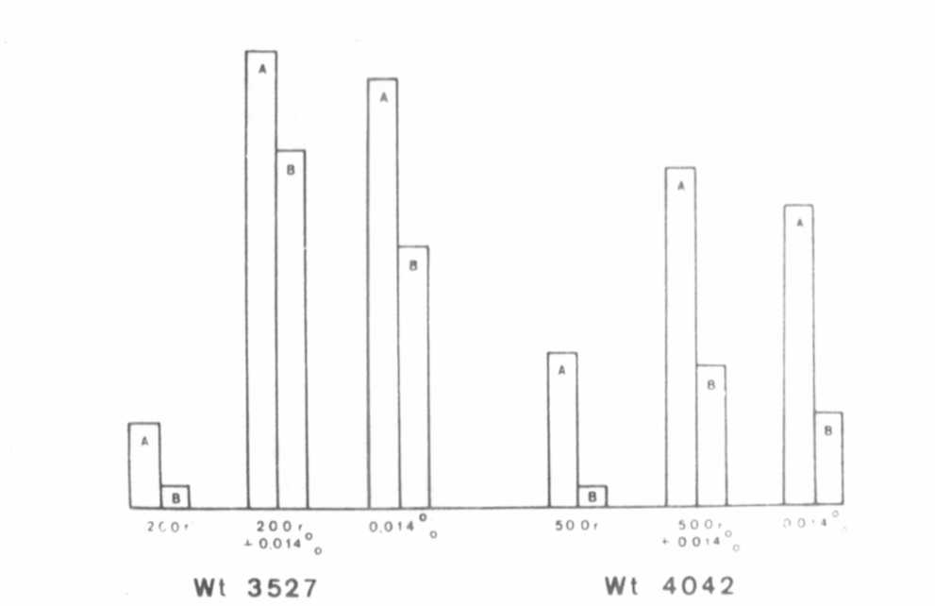
Fig. 1. Induction of multiple mutants. A-Percent of families with more
than one mutation; B-number of double mutants.
9. Swiecicki, W. K. 1985. PNL 17:70-71.

mMMHHHMMBMHH

1985
PNL Volume 17
5

RESEARCH REPORTS

