PNL Volume 17 1985 RESEARCH REPORTS

A SECOND GENE arthritic (art-2) ON CHROMOSOME 3

Swiecicki, W. K. Plant Experiment Station, Wiatrowo, Poland

The spontaneous mutant arthritic (art), isolated by L. G. Cruger
and named and described by Marx, is located on chromosome 6 (1, 2). A
mutant with a seemingly identical phenotype was recovered after treating
seed of the cv. 'Paloma' (Wt 3527) with 200r Nf + 0.014% NEU (see Figs.
1 and 2 in [1]). The induced mutant was given the number Wt 16125 in
the Wiatrowo collection. Segregation in M2 and M3 indicated that it is
a monogenic mutation. Wt 16125 was crossed with WL 1238, a multi-marker
line from Weibullsholm. In a preliminary analysis, a portion of the F2
seeds was sown in the greenhouse in the autumn of 1981. The segregation
of the mutant character confirmed the monogenic inheritance but the
dihybrid segregation pointed to a close linkage (~11 units) between
Wiatrowo's gene arthritic and gp on chromosome 5 (Table 1).

Table 1. Phenotypic distribution in F₂ populations segregating
for arthritic from cross WL 1238 x Wt 16125.
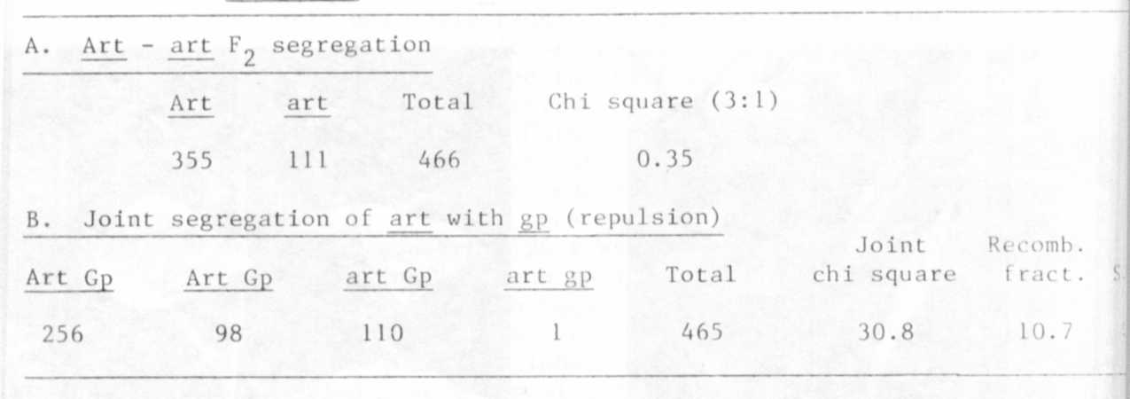

Because the above finding was unexpected and surprising, a locus
identity test cross was conducted twice: Wt 16126 - type line for gene
art (Marx's C78-346) x Wt 16125, Wiatrowo's mutant. In both cases (in
1982 and 1984) the F1 plants were normal, indicating that the arthritic
mutants from Geneva and Wiatrowo reside at different loci. The second
part of the F2 population of the cross WL 1238 x Wt 16125 therefore was
sown in the field in 1983 localize on chromosome 5 more precisely. The
dihybrid segregation between arthritic and markers te and gp (Table 2)
produced the following estimated Cr-0 values and gene order:
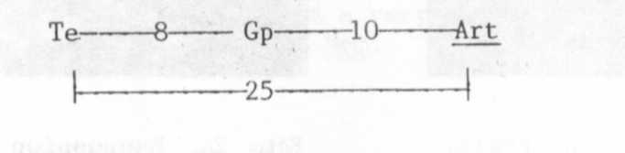

RESEARCH REPORTS 2
PNL Volume 17 1985

It is suggested that the symbols art—1 (chr. 6) and art-2 (chr. 5)
be used to designate the genes from Geneva and Wiatrowo, respectively.
But before this proposal is finally accepted, Wt 16126 and Wt 16125
should both be crossed with WL 110 (standard karyotype) to ascertain
that translocations of the art segment between chromosome 5 and 6 are
not involved.

1. Marx, G. A. 1981. PNL 13:38-39.
2. Marx, G. A. 1982. PNL 14:50-52.

Table 2. Phenotypic distribution in F2 population segregating
for arthritic from WL 1238 x Wt 16125.
