'IMPiHM|l^{M}'*^{,a}*^{MI}*^{IR}*,'^{,RI}'M

NECROSIS (nec); A NEW GENE ON CHROMOSOME 5

Swiecicki, W. K. Plant Experiment Station, Wiatrowo, Poland

A large number of new pea mutants have been induced using fast neu-
trons (Nf), N-nitroso-N-aethylurea (NEU) and combined doses of these
mutagens (1, 2, 4). Among them is a group of mutants that cause degene-
ration of leaf tissue (3). Three mutations, each with similar expres-
sion, were individually isolated after seed treatment of line Wt 3527
(cv. 'Paloma') by:
Wt 16124 - 200r Nf + 0.014% NEU - found in M₂ population
Wt 16128 - 200r Nf + 0.014% NEU - found in M₃ population
Wt 16130 - 0.014% NEU - found in M₂ population.
The mutations were of the "necrosis" type. The leaf surface of
such plants are green with necrotic, brownish yellow areas at the
leaflet and stipule margins, covering the interveinal area as well as
the veins. Towards the center of the leaflets and stipules the green
color remains mainly adjacent to the veins (Fig. 1, 2). The character
is easy to observe even in st and af genotypes.
Crosses between mutant x initial line bore normal Fi plants. The F2
produced an undisturbed segregation pattern of 3 normal : 1 necrosis
(680:210 X²_{3:1} =1.06). The suggested symbol for this monogenic, reces-
sively inherited character is nec (necrosis).
Because the world pea collection contains some similar mutation
types (e.g. degenerating leaves) it was necessary to perform locus iden-
tity tests. A diallel test included the following lines: Wt 16124,
Wt 16128, Wt 16130 - necrosis; Wt 16129 - gold necrosis, and Wt 16117 -
degenerating leaves (type line for Gottschalk's dgl). The F1's of
crosses among Wt 16124, Wt 16128, and Wt 16130 plants were of the necro-
sis type, indicating that all three independently isolated necrosis
mutants are controlled by the same gene nec.
Wt 16124 x Wt 16129 and Wt 16124 x Wt 16117 gave normal F1's indi-
cating that the degenerating leaf and gold necrosis mutants are con-
trolled by genes at loci other than nec.
For the linkage test two lines were crossed: Wt 16124 (necrosis) x
WL 1238 (testerline from the Weibullsholm Pea Collection of the Nordic
Gene Bank). The F₁ plants were normal and fully fertile. The F₂ gener-
ation (247 plants) was grown in the field in 1983. No evidence of
linkage was detected between gene Nec and markers on chromosomes 1, 2,
3, 7. Evidence of linkage was, however, found between Nec and genes in
chromosome 5 (Table 1).

Gene U has not been included in this analysis due to irregular
segregation, but the data suggested a very significant linkage with Nec,
placing U somewhere between Gp and Nec.
1. Swiecicki, W. K. 1981. Mut. Breed. Newsl. 17:10.
2. Swiecicki, W. K. 1983. Hod. Rosl. Ak. i Nas. 27:4.
3. Swiecicki, W. K. 1984. PNL 16:70-72.
4. Swiecicki, W. K. 1985. PNL 17:72-74.
The four point analysis suggests the following gene order:

RESEARCH REPORTS 2
PNL Volume 17 1985

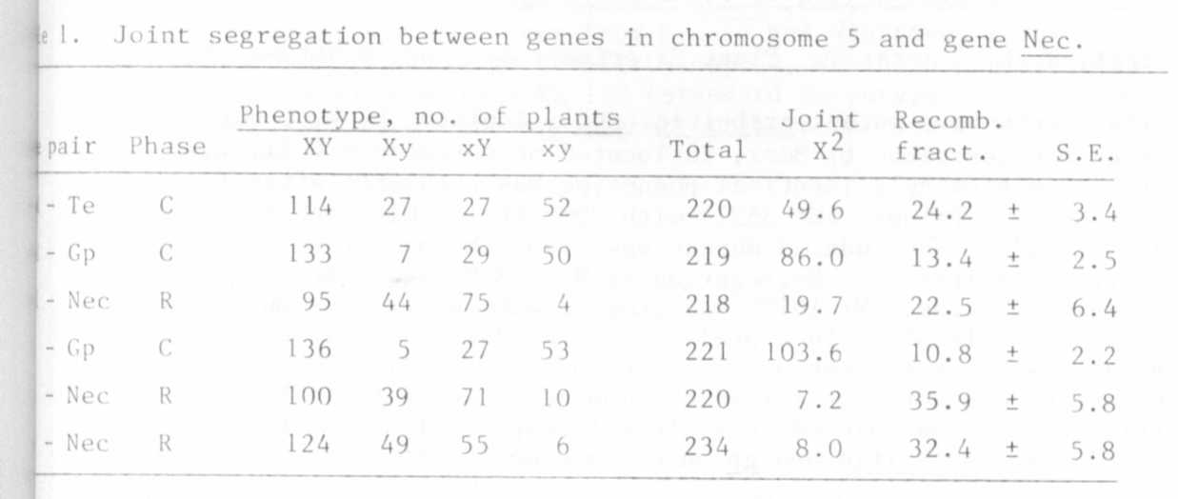

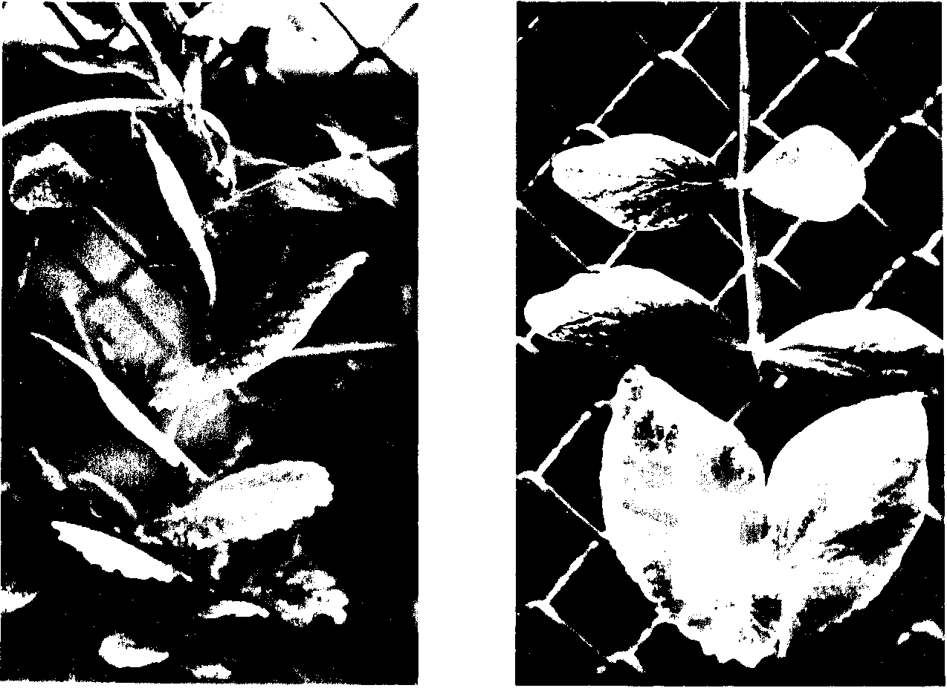

Fig. 1. Mutant 16124 - necrosis.
Fig. 2. Expression of gene nec
on leaves.

