PIGMENT CHANGES DURING THE ONTOGENY OF PLANTS

Schmitz, R.
Institute of Genetics, University of Bonn
Federal Republic of Germany

Numerous chlorophyll mutants of pea and other species have been
described. When the chlorophyll concentration of these mutants is
measured, usually the determination is made at a single stage of
development. Still, it is known that there are changes in pigment con-
centration during the ontogeny of plants. Therefore, three chlorophyll
mutants were investigated in comparison with the initial line (IL)
'Dippes Gelbe Viktoria' at three stages of ontogeny:
I. Plant with ten leaves
II. Beginning of flowering
III. End of flowering
The pigments were determined in plants grown under field conditions.
Variation in chlorophyll concentration of leaves from the four genotypes
is shown in Fig. 1. Leaves from the upper nodes had a higher pigment
concentration than leaves from the lower nodes but the genotypes showed
different rates of increase. The difference in concentration between
the mutants and the IL was greatest at node 18, while the leaves at node
5 showed only a slight deviation.
Fig. 2 shows how the pigment concentration changed in the leaves
from node 5 and node 8. The chlorophyll content decreased, especially
in the IL. Only mutant 29 exhibited an increase in pigments.
The decrease of pigments in the lower leaves was the result of
senescence. However, the decline of chlorophyll in different stages was
not the same for all genotypes, the mutants showing less reduction than
the IL.
Whenever attempts are made to correlate pigment concentration with
productivity, due consideration should be given to the variation of pig-
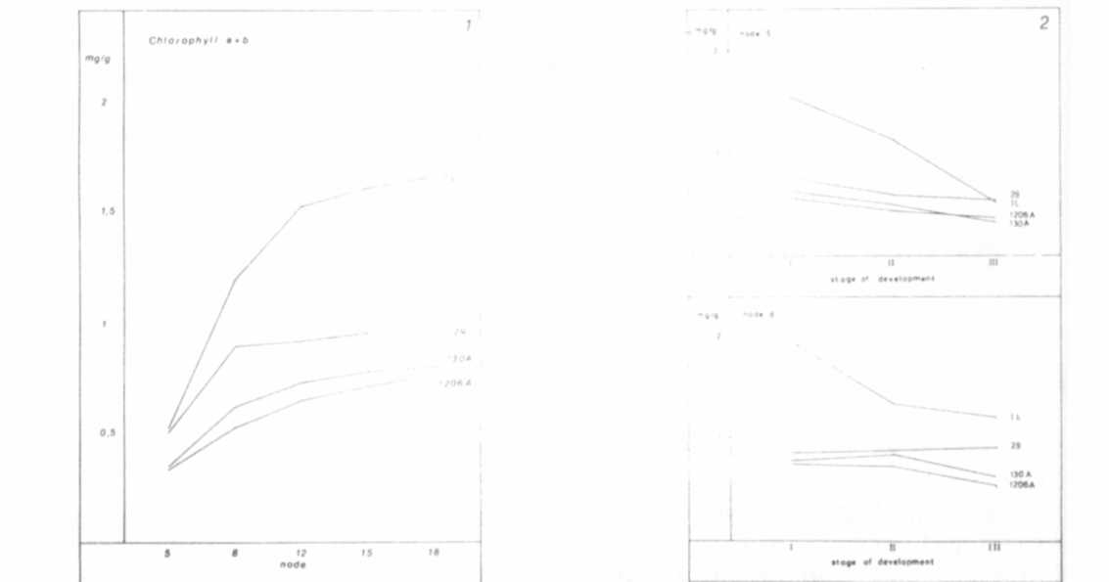
Fig. 1.
Chlorophyll concentration of leaves
from nodes 5, 8, 12, 15, and 18 at
the end of flowering.
ments during the ontogeny of the plants.
Fig. 2.
Chlorophyll concentration of leaves
from node 5 and node 8 in three stages
of ontogeny (I, II, and III.) IL -
initial line 'Dippes Gelbe Viktoria';
29-chlorotica mutant; 130A and 1206A-
mutants without chlorophyll b.

