PNL Volume 17 1985 RESEARCH REPORTS 1

COMPARISON OF PROTEIN AND ENZYME PATTERNS IN SEEDS FROM FIELD- AND
PHYTOTRON-CULTIVATED PLANTS.

Muller, H. P. Institute of Genetics, University of Bonn
Federal Republic of Germany

Use of controlled environment facilities allows study of the
genetic control of the photoperiodic and thermoperiodic reactions of
various genotypes. Mature seeds from numerous genotypes with differing
growth and flowering behavior were analyzed electrophoretically with
regard to their protein and isozyme patterns. We used material from
plants grown under 12 hr photoperiod at 25C day and 15C night, and com-
pared the patterns with those obtained from field grown material. (The
seed material was kindly provided by Dr. Gottschalk.) The results are
shown in Figs. 1 and 2.
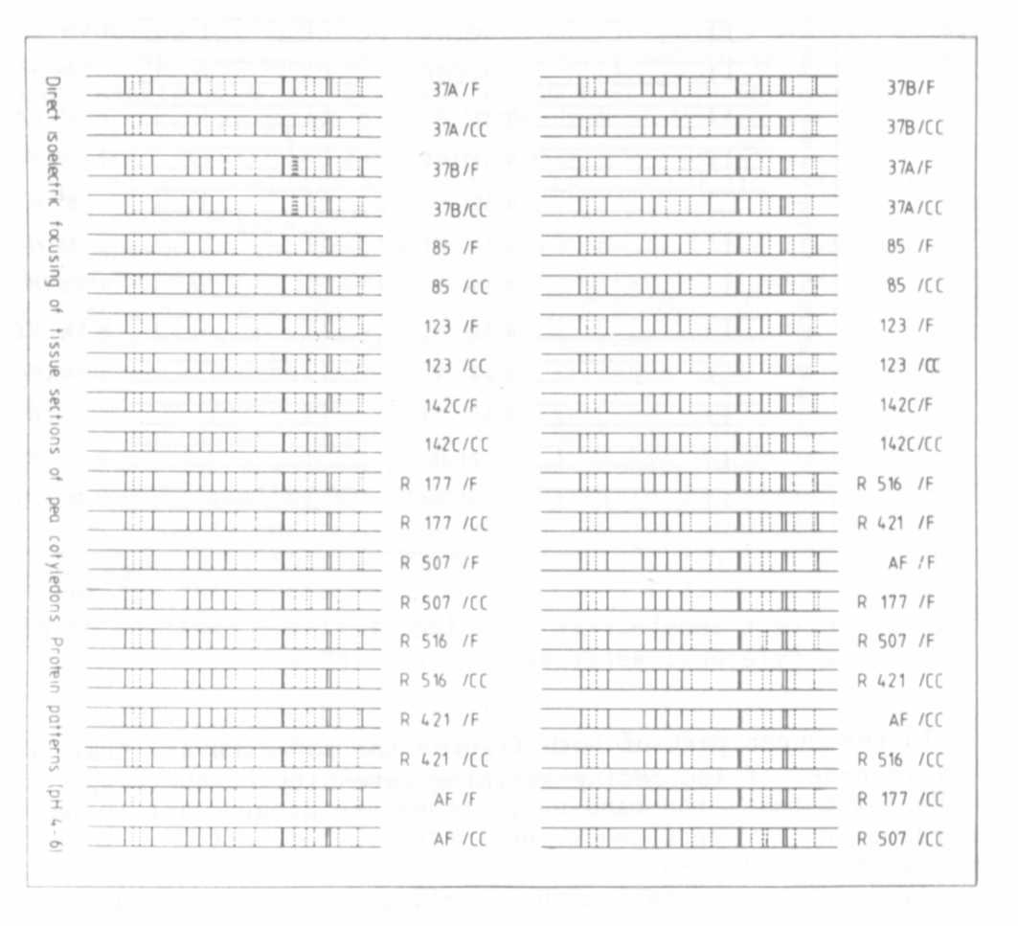
Fig. 1. Direct isoelectric focusing of tissue sections of pea
cotyledons: protein patterns (pH gradient 4-6).

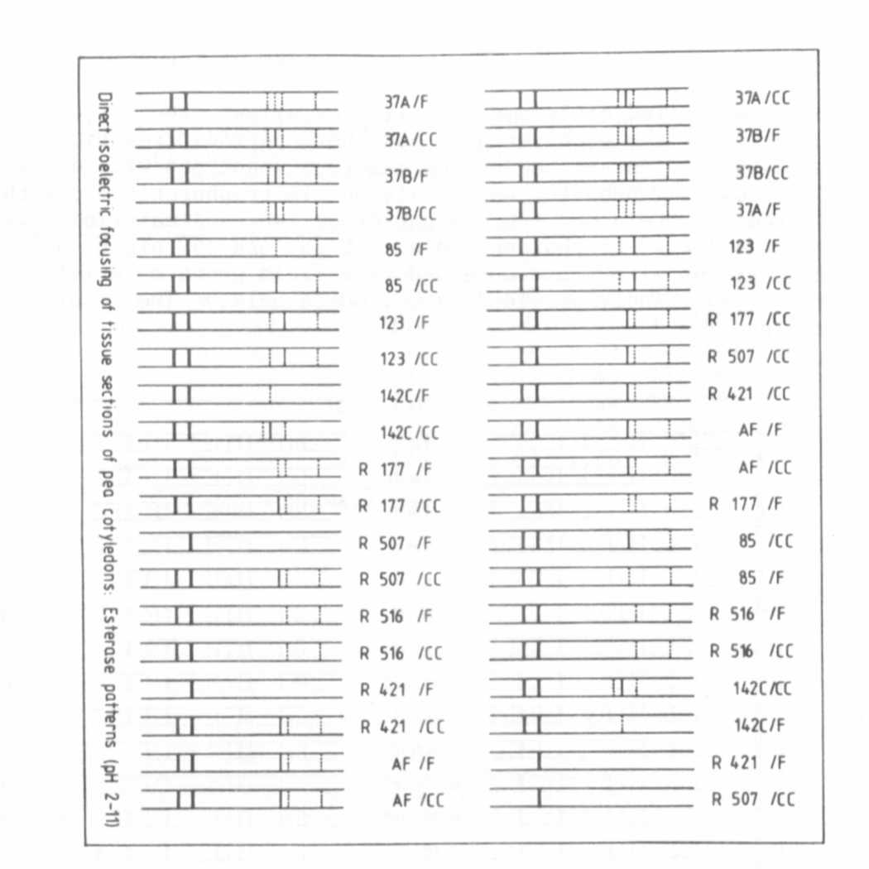
In the upper part of both figures the patterns are drawn schemati-
Fig. 2. Direct isoelectric focusing of tissue sections of pea
cotyledons: esterase patterns (pH 2-11).
cally in order of increasing staining intensity of the respective bands;
in the lower parts the banding patterns are grouped for comparison
according to the genotypes grown in the phytotron (CC) and in the
experimental field (F).
It can be seen that, although all genotypes were uniform for many
seed protein characters, distinct quantitative differences are discerni-
ble. The comparison of the protein and isozyme patterns from seeds
deriving from the experimental field and the phytotron also reveals dis-
tinct quantitative differences among numerous bands, indicating a dif-
ferent expression of the respective genes which code for them. This
provides a way to analyze the influence of environmental factors on the
regulation of protein incorporation into seeds. Of great interest are
genotypes which show qualitative differences, indicating substantial
changes in gene expression. Such changes may be seen in the esterase
patterns of genotypes 142, 507, and 421. This provides a "selection
filter" for the rapid selection of mutant genotypes which can be
analyzed in detail for the understanding of regulatory processes.

