INFLUENCE OF af , st AND tl GENES ON NITRATE REDUCTASE ACTIVITY IN
PEAS
Marano, B., Agricultural Chem. Inst., Univ. Naples, Portici, Italy

A. Leone, Plant Beeding Inst., Univ. Naples, Portici, Italy
and L. Frusciante C.N.R., Centro Studi Miglioramento, Genet. Ortaggi,
Portici, Italy

Lodging is one of the major problems in the cultivation of the pea
crop and many authors have suggested new plant models in order to im-
prove standing ability. Pea mutants with a modified leaf morphology due
to the presence of the af, st, and tl genes have largely been studied
for this purpose. Some of them, however, influence the yield components
negatively (1, 4). The af gene reduces the seed production per plant by
reducing the number of fertile nodes and pods, st by reducing pod
fertility and seed weight, whereas tl increases pod set and number of
seeds at the first fertile node.
Eight isogenic lines, provided by G. A. Marx, with all eight combi-
nations of the three genes, were analyzed for nitrate reductase activity
(NRA) of leaves, according to a procedure adapted from Salomonson (1).
The sampling was performed at five stages during plant development, at
full daylight.
Data in Table 1 show that NRA declined during plant development in
all eight lines. A correlation between this enzyme and the final yield
was found for several species (2) and our results seem to confirm this
relationship.
When the eight lines were considered according to the presence/
absence of each of the three genes (Fig. 1), plants recessive for tl had
a higher NRA than the Tl plants, whereas the af_ plants had a lower NRA
than Af plants. No effect of st locus was found.
The strong influence of af and tl on morphology and productivity is
well known; our results reveal that they also affect plant metabolic
aspects. Other biochemical traits should be investigated in order to
understand the basis for action of these major genes.

1. Gritton, E. T. 1972. PNL 4:11-12.
2. Miflin, B. J. 1980. In The Biology of Crop Productivity.
P. S. Carlson, ed.
3. Salomonson, L. P. 1975. Plant Physiol 56:853-855.
4. Snoad, B. 1981. Scient. Hort. 14:9-18.

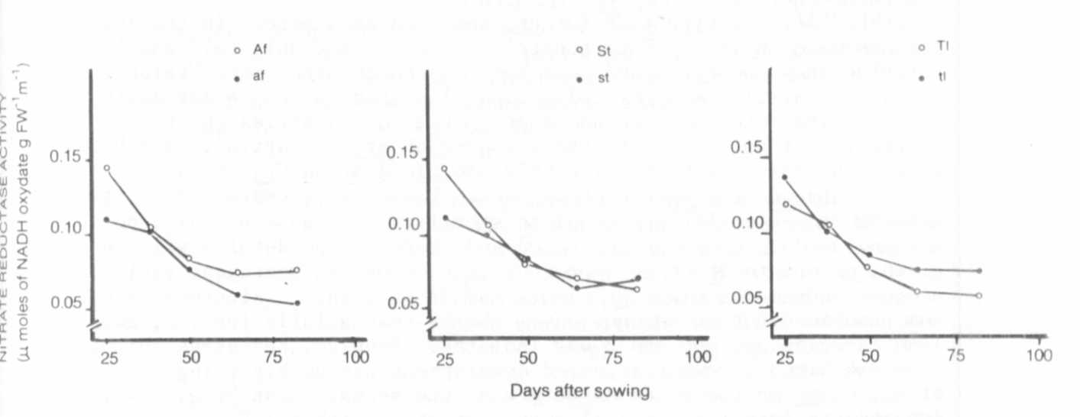
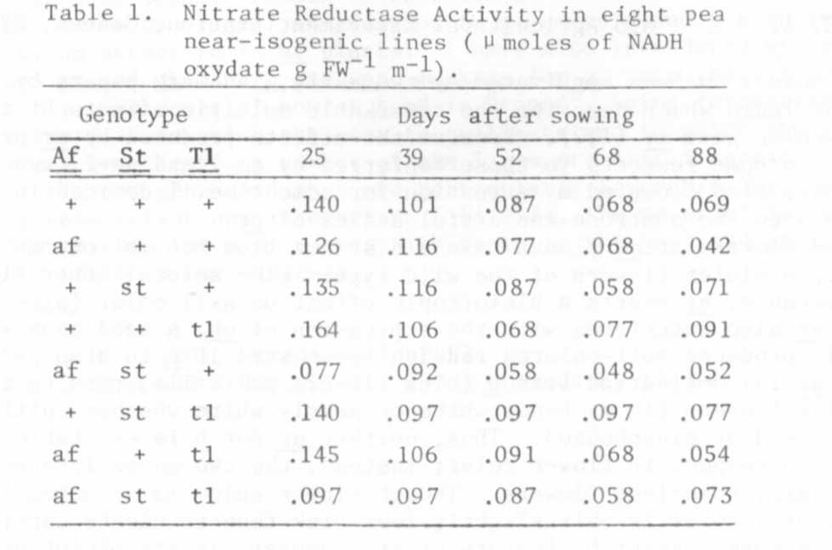
Fig. 1. Nitrate Reductase Activity (NRA) during plant development
in near-isogenic lines based on the allelic status of af,
st, and tl.

