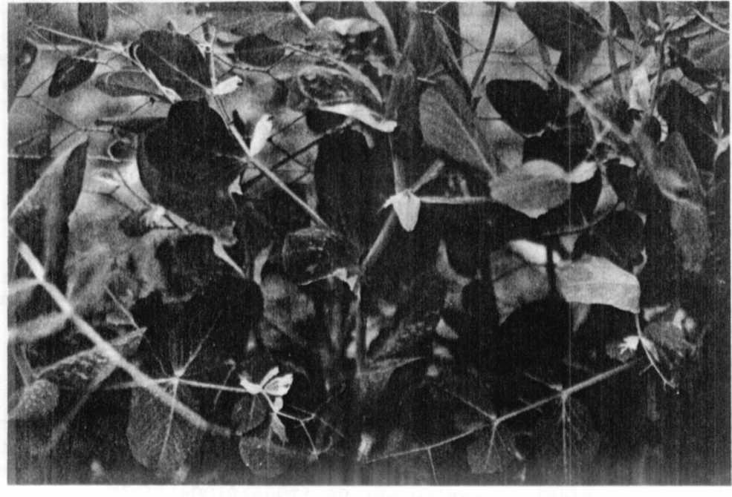
Fig. 1. M3: Descendants of chlorophyll mutant which appeared
after treatment with chloramphenicol.

CAROTENOID COMPOSITION AND PROVITAMIN A VALUES OF F₂ SEEDS FROM THE
CROSS OF WL 3527 (orc) x Wt 11145 (Orc)

Ludwicki J., . Agricultural University/SGGW, Warsaw, Poland
and W. K. Swiecicki Plant Experiment Station, Wiatrowo, Poland

The composition and content of carotenoids was investigated in dry
and fresh seeds of lines Wt 3527 (orc I- yellow cotyledons), Wt 11145

Orc 1 - orange cotyledons), and in dry F₂ seeds of the hybrid Wt 3527 x
Wt 11145. F2 seeds were divided into five groups: yellow, dark yellow,
light orange, orange, brick (see [1]).
The seeds were ground and hydrolyzed (KOH in alcohol) prior to ex-
traction with hexane. Chromatographic separation of carotenoids was
done on an MgO column using hexane as the mobile phase followed by 10
and 20% solutions of acetone in hexane.
Moreover, the separation of pigments was investigated by TLC on
silica gel using solvent mixture of hexane-ethylacetate-methanol
(75:20:7) as the mobile phase.
The content of a given carotenoid was estimated on the basis of a
spectrophotometric assay using tabular values of E^{1%}_{1cm}, viz: beta-carotene
2592; beta-cryptoxanthin 2386; lutein 2550.
For the determination of the provitamin A value, the biological
activity of beta-carotene was taken as 100% beta-cryptoxanthin as 57%, and
lutein as 0%.

Column chromatography of pigment extracts from dry seeds of line
Wt 3527 showed the presence of two fractions migrating in 10% and 20%
solution of acetone in hexane. But carotenoids from dry seeds of line
Wt 11145, fresh seeds of line Wt 3527, and all F₂ recombinants had three
fractions, eluted in turn by hexane, 10% and 20% solution of acetone in
hexane. Fresh seeds of line Wt 11145 did not contain the carotenoid
eluted from the column by 20% solution of acetone.
The TLC method showed that the fraction eluted from the column by
20% solution of acetone contained not only lutein but also two addi-
tional carotenoid pigments (Fig. 1). The following substances were iden-
tified in solutions obtained by separation of carotenoids by column
chromatography:
Further examination of the pigment in the 20% fraction which migra-
ted below lutein on the TLC chromatogram (Fig. Id) had absorption maxima
in the following wave lengths (nm): 420, 445, 472, corresponding to
taraxanthin. The lowest migrating carotenoid was not identified (Fig.
le).
Wt 11145 had two to four times more total carotenoids than the
other lines, but 90% of this was lutein (Table 1). Lutein was the pre-
dominant carotenoid in dry seeds. Fresh seeds contained greater amounts
of 6-carotene and beta-cryptoxanthin. The amount of beta-cryptoxanthin in dry
seeds was the least variable constituent: 94-110 mkg/lOOg.
The highest provitamin value was found in dry seeds of an F₂ from
cross Wt 3527 x Wt 11145 having dark yellow cotyledons (Table 2). Other
segregants had less than half the provitamin A.

Fresh

Dry

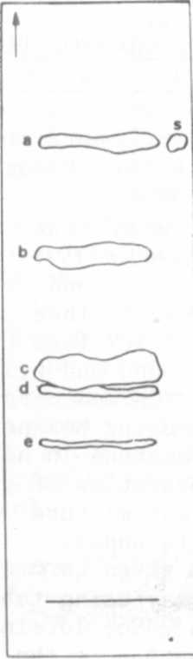

1. Blixt, S., and W. K. Swiecicki. 1983. PNL 15:9-10.

Fig. 1. Carotenoid separation
extracted from seeds of
hybrids WT 3527 and WT 11145.
a) beta-carotene;
b) beta-cryptoxanthin;
c) lutein;
d) taraxanthin;
e) unidentified;
s) standard all-trans-
beta-carotene.

RESEARCH REPORTS 4
PNL Volume 17 1985

Table 1. Carotenoid content isolated from pea seeds by column chromatography.
Fresh and dry seeds of parents and dry seeds of selected F₂'s.
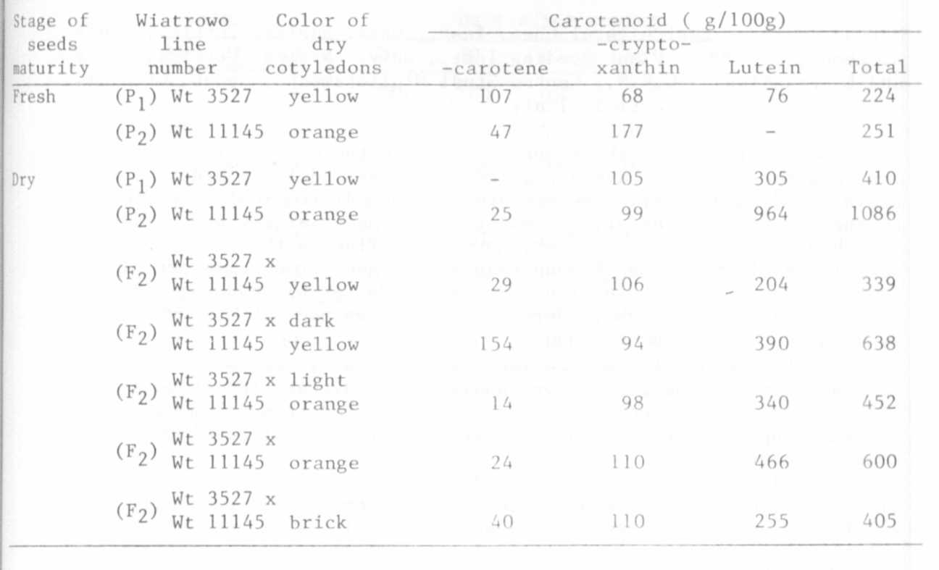

Table 2. Provitamin A value of pea seed (in g of -carotene/lOOg)
