50 PNL Volume 17 1985 RESEARCH REPORTS

ANTIBIOTICS-MUTAGENESIS-TESTS WITH PEAS

Loennig, W. E. Institute of Genetics
University of Bonn, Federal Republic of Germany

As described previously (3), streptomycin blocks chlorophyll-syn-
thesis in pea. A similar effect was found in pea seedlings when the
seeds were treated with chloramphenicol, but treatment with the antibio-
tics nitrofurazon and neomycinsulphate produced no such effect.
With respect to the streptomycin treatment, 87 families (altogether
1424 plants) of the prospective M₂ were investigated. No chlorophyll
mutants were detected among these plants. Two out of 87 families
yielded no plants at all. The mother plant of one of these two had pro-
duced only six seeds, all of which were smaller than those of DGV and
were of greenish color (instead of the normal yellow of DGV); none
germinated. For the second case no special features were noticed. A
weak mutagenicity of streptomycin would be in agreement with the
findings of Manna and Karmakar (2), but in disagreement with other
authors (see review by Suter and Jaeger [4]). The present results seem
still too scanty to decide the question, but if streptomycin is a muta-
genic agent it does not seem to be very potent. Normally the production
of different chlorophyll mutations is the first indication of a potent
mutagen in plants.
Chloramphenicol proved to be mutagenic in several bacterial tests,
but non-mutagenic in others (see [4]). As a pilot test, 200 seeds were
treated with chloramphenicol (100 seeds in 0.25% and 100 in 0.50%
chloramphenicol solution for 14 hours). Only six seeds germinated of
the group treated with the 0.5% solution and 19 of the other; two from
the latter group showed white spots in the lower leaves and lower parts
of the stems in the M1. The resulting 25 M2 families consisted of 653
plants. One of these M₂ families (with 40 plants in all [M1 treated
with 0.25% chloramphenicol-solution]) showed a mutant with relatively
large white sectors in the leaves in the upper part of the plant.
Inasmuch as our mutant collection contains no mutants resembling this
phenotype and inasmuch as no 3:1 segregation took place in the M₂, a
cross fertilization can be excluded. The M3 corroborated the conclu-
sion.
Most of the descendents of the mutant plant showed the same fea-

tures as the mother plant. Moreover, several families were descended
from the family in which the new mutant first appeared. The mother
plants had not shown the mutant character, but in some M3 families the
new mutant segregated, demonstrating that the mutation event had actual-
ly taken place in the M1 plant. I want to provisionally suggest the
symbol 1ws (large white spots) for this mutant.
So the pilot test with this small sample of only 25 families has
already produced at. least one mutant (another possible mutant affecting
internode length has not yet been proved). To verify the mutagenic
potential of chloramphenicol and its mutation spectrum in pea, a large
scale study is needed. As there have been several reports that chloram-
phenicol is also very dangerous in man (1), mutation tests with higher
plants may corroborate the bacterial test results concerning the "posi-
tive" mutagenic potential of chloramphenicol.

1. Langbein, et. al. (eds.). 1983. 'Bittere Pillen', pp. 368-
369. Kiepenheuer & Witsch, Cologne.
2. Manna, G. K., and M. Karmaker. 1979. The Nucleus 22:96-103,
3. Loennig, W.-E. PNL 15:36-37.
4. Suter, W. and I. Jaeger. 1982. Mutation Res. 97:1-18.
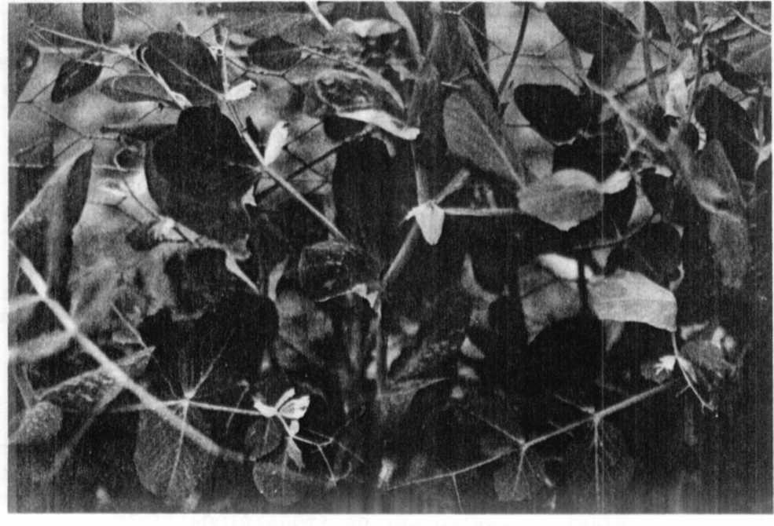
Fig. 1. M3: Descendants of chlorophyll mutant which appeared
after treatment with chloramphenicol.

CAROTENOID COMPOSITION AND PROVITAMIN A VALUES OF F₂ SEEDS FROM THE
CROSS OF WL 3527 (orc) x Wt 11145 (Orc)

Ludwicki J., . Agricultural University/SGGW, Warsaw, Poland
and W. K. Swiecicki Plant Experiment Station, Wiatrowo, Poland

The composition and content of carotenoids was investigated in dry
and fresh seeds of lines Wt 3527 (orc I- yellow cotyledons), Wt 11145

Orc 1 - orange cotyledons), and in dry F₂ seeds of the hybrid Wt 3527 x
Wt 11145. F2 seeds were divided into five groups: yellow, dark yellow,
light orange, orange, brick (see [1]).
The seeds were ground and hydrolyzed (KOH in alcohol) prior to ex-
traction with hexane. Chromatographic separation of carotenoids was
done on an MgO column using hexane as the mobile phase followed by 10
and 20% solutions of acetone in hexane.
Moreover, the separation of pigments was investigated by TLC on
silica gel using solvent mixture of hexane-ethylacetate-methanol
(75:20:7) as the mobile phase.
The content of a given carotenoid was estimated on the basis of a
spectrophotometric assay using tabular values of E^{1%}_{1cm}, viz: beta-carotene
2592; beta-cryptoxanthin 2386; lutein 2550.
For the determination of the provitamin A value, the biological
activity of beta-carotene was taken as 100% beta-cryptoxanthin as 57%, and
lutein as 0%.

