THE PEA'S NECTARIES AND INSECT VISITORS

Loennig, W. E. Institute of Genetics
University of Bonn, Federal Republic of Germany

As the pea has been commonly viewed to be a strictly autogamous
plant genus, little attention has been given to the pea's nectaries and
there are no reports on their anatomy and physiology. In fact, this
topic has nearly fallen into oblivion.
That the pea produces nectar was described in the classical work of
the Christian Konrad Sprengel, 1793 (5).

Pisum sativum. Erbse. In dieser Blume habe ich den
Saft oftmals vergebens gesucht, endlich aber doch
gefunden. ...Sie wird von einer groBen Hummel besucht.
Da dieselbe sich aber nicht auf das Schiffchen, sondern
seitwarts setzt, und alsdann ihren Saugrussel zwischen
den Nagel des einen Flugels und dem Nagel der Fahne
steckt : so sehe ich nicht ein, wie sie dadurch die
Befruchtung der Blume hervorbringen konne.

Pisum sativum. Pea. I had often looked in vain lor
nectar (literally; sap) in this flower, but after all I
have found it. ...It is visited by a large humble bee.
As this (bee) does not sit down on the keel, but sits
down at the side and puts its proboscis between the
ungula of one wing and the ungula of the sai1: I do not
understand how it can by this procedure pollinate the
flower.
Concerning the humble bees, Sprengel's observations are correct
insofar as these bees often sit down at the side of the flowers and pro-
ceed as described by him, but he does not seem to have observed other
types of behavior. The majority of bees I observed landed on the pea
wings and subsequently went to the keel. There is another mention of
the pea's nectar production by J. G. Kurr in 1832 (2). He points to
Sprengel's description:
23. Pisum sativum ...secrete honey according to Conrad
Sprengel.
The only other work I found mentioning the subject (excluding the Erie I
comment by Myers and Gritton [4] made last year) is that of Makasheva
(1973/1983) (3). She writes on page 109:
Self-pollination occurs in a closed bud although its
flower has zygomorphic structure and a sweet juice is
discharged into the flower at the attachment of the
filaments.
She asserts that especially the "larvae of thrips" are responsible lor
cross-pollinations in pea as "honey bees or bumble bees (are) visiting
already open flowers".
She is correct concerning honey bees (Apis mellifica) (Fig. 1) but
not for humble bees which later visit both young and old flowers (com-
pare photographs in PNL 16, p. 40). As for thrips, I have not yet made
many observations but have repeatedly found them in the flowers. As the
adult individuals of many species are able to fly, they may partake in
cross-pollinations. Besides the humble bees, I have found also a soli-

tary bee (Osmia or Megachile with a layer of pollen on its lower
abdomen) which was active on and in pea flowers (Fig. 2). It also in-
serted its proboscis to the bottom of the flowers.
Concerning the "sweet juice discharged into the flower at the
attachment of the filaments", I have made the same observation as quoted
by Makasheva above. I also made a few simple tests: Reaction for C₆H₁₂O
by means of the Glucose-Test-Method (of Boehringer Mannheim) was posi-
tive. Sometimes I found little droplets at the base of the staminal
tube, generally near the base of the carpel, i.e. in the tube. It
appears important to point out that nectar production in pea seems to
depend perhaps more than in many other species on the stage of develop-
ment and there seem to be differences in different lines. In a few
cases I found the carpel literally standing in sweet sap. Many pea
lines obviously possess nectaries at the bottom of the staminal tube
around the carpel. Although it is necessary to remove or disturb flower
parts in order to observe the nectar, the nectar is not an artifact of
injury. It is not too difficult for the insects with a long proboscis
to reach this part of the flower since there are two apertures (left and
right of the free anther rod) near the base under the two upper sepals.
Concerning evolutionary questions with regard to nectaries and
allogamy, it is to be noted that some plant species have autogamous
lines among allogamous ones, often all belonging taxonomically to one
species (Mendelian factors being involved). The pea seems to make use
of both possibilities. Dr. Blixt wrote me (1984) that he has observed
"that pea lines from collections in warmer areas with larger bees are
not lines but show every indication of being cross-pollinated...". I do
not know whether these bees are necessarily large. Xy1ocopa, for
instance, which was observed by Harland (1) on peas in Peru, is also
found in Central Europe. If, however, the garden pea should have lost
an original ability of being cross-pollinated to a higher percentage,
then we would have a case of degenerat ion in such lines.
As I am leaving pea genetics (beginning work at another institute
working with other species and probably will not have much time to work
with peas), I would only hope that someone else will begin a careful
investigation of the anatomy and physiology of the pea's nectaries.

1. Harland, S. C. 1948. Heredity 2:263-269.
2. Kurr, J. G. 1832. Untersuchnungen ubei die Bedeutung dei
Nektarien in den Blumen aur eigene Booha< ht ungen und Verstic he
gegrundet; PhD. thesis Stuttgart; above quotation p.. 67.
3. Makasheva, R. Kh. 1973/1983. The Pea. Leningrad, Washington
and New Delhi. (Translated from the original Russian).
4. Myers, J. R. and E. T. Gritton. 1984. PNL, 16:62-63.
3. Sprengel, Ch. K. 1793. Das entdeckte Geheimnis dei Natur im Ban
und in der Befruchtung der Blumen. (Reprint IS¹)4; ed P. Knuth;
above quotation from the 3rd Vol., p. 65, - Leipzig).

I- i

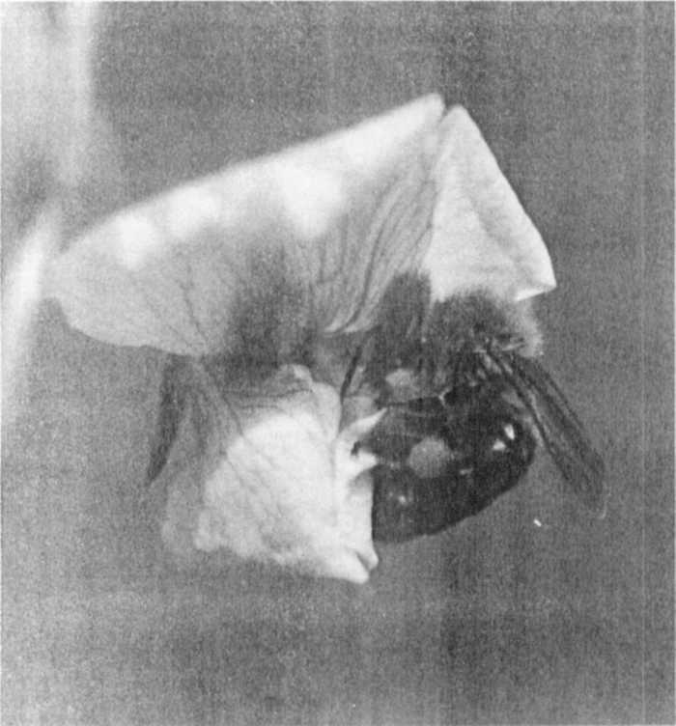
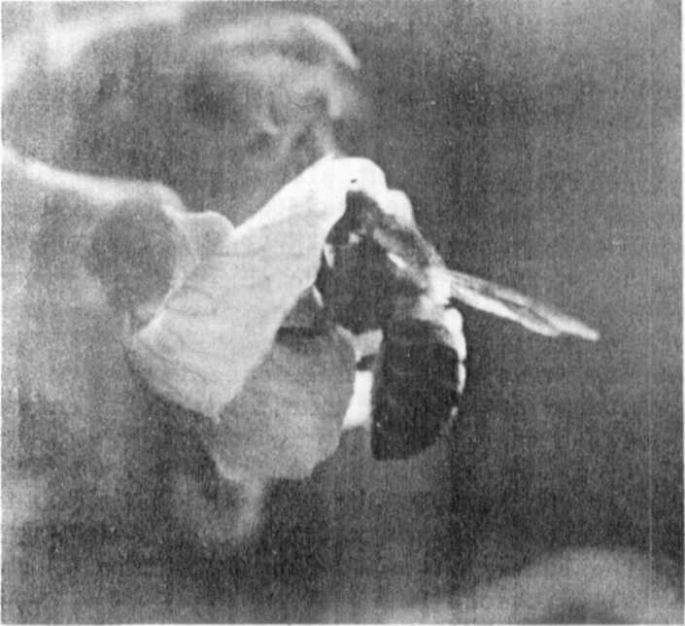
Fig. 1. A honey bee (Apis mellifica) visiting an open flower and
gathering pale pollen.

Fie. 2. A solitary bee. These bees were observed to insert their
proboscises to the bottom of the pea flowers while
slithering pollen (younger and older flowers).

