CROSS FERTILIZATION IN PEAS UNDER DIFFERENT ECOLOGICAL CONDITIONS (II)

Loennig, W. E. Institute of Genetics
University of Bonn, Federal Republic of Germany

The work on natural cross fertilization in peas, studied by growing
control lines with green cotyledons among a great majority of plants
with yellow cotyledons (1,2), has been extended. WL 6040 was tested
again in 1984 in two ecologically different locations (Tables 1 and 2).

Table 1. Percent of cross fertilizations on Location I (WL 6040) .
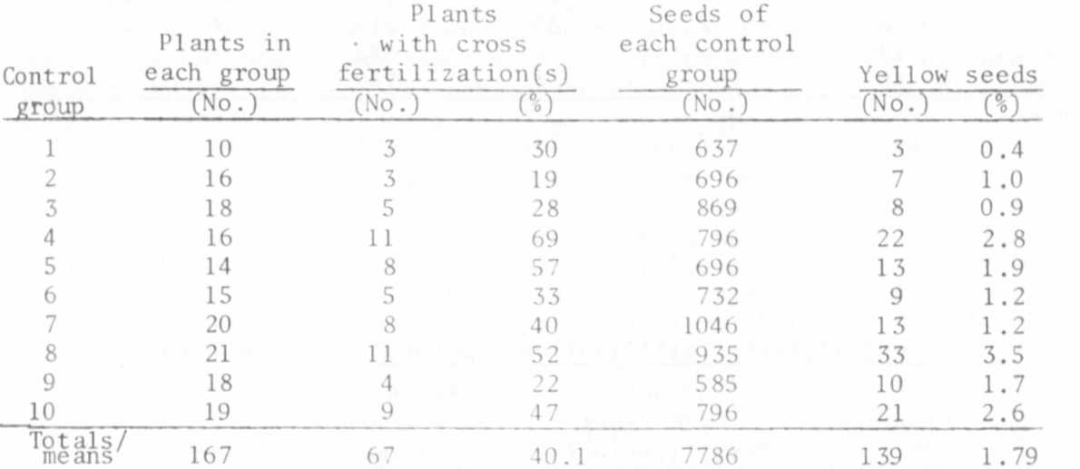

For location I the percentage of contaminated plants was about 10%
higher in 1984 than in 1983 (cf. PNL 16, p. 38) and for contaminated
seeds the difference was a bit more than a half percent above the value
of 1983. The values for location II were, however, very similar in the
two years (% of plants with cross fertilizations 1983: 30.4 and 1984:
29.87; % of yellow seeds 1983: 1.92 and 1984: 1.73).
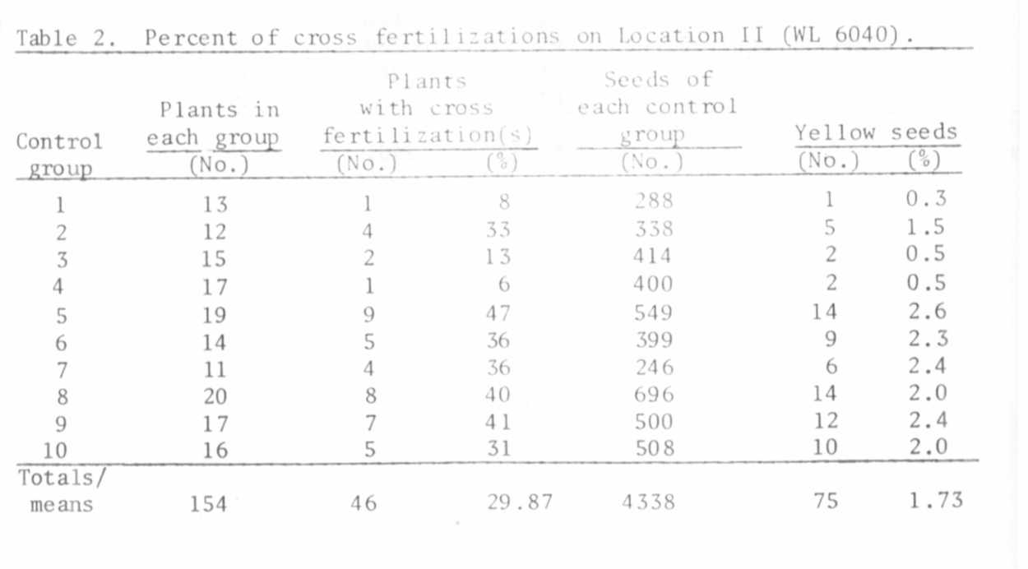

RESEARCH REPORTS
1985
PNL Volume 17
44

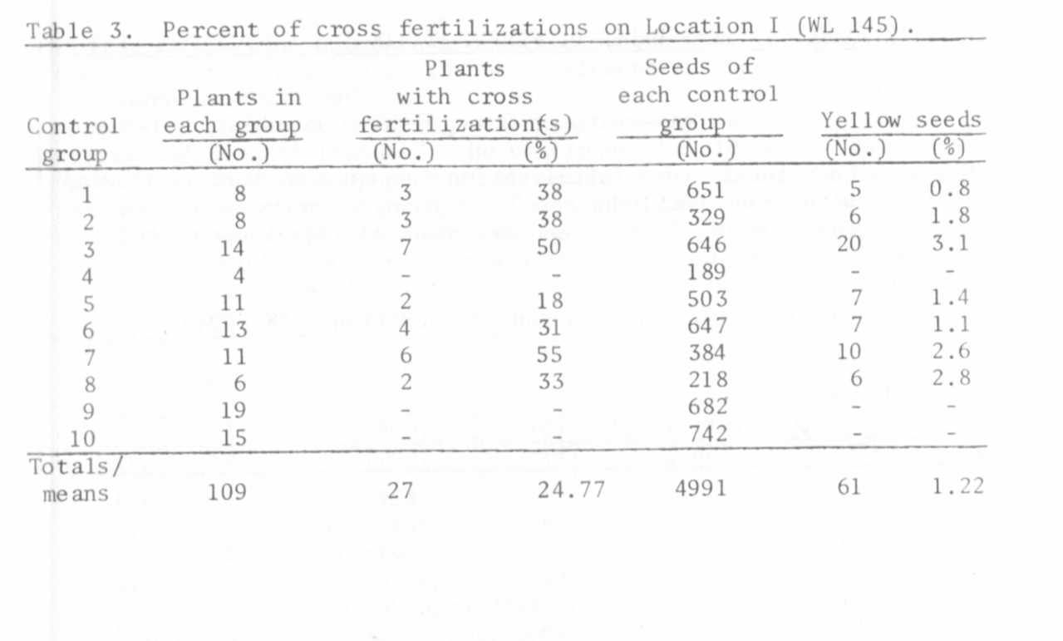
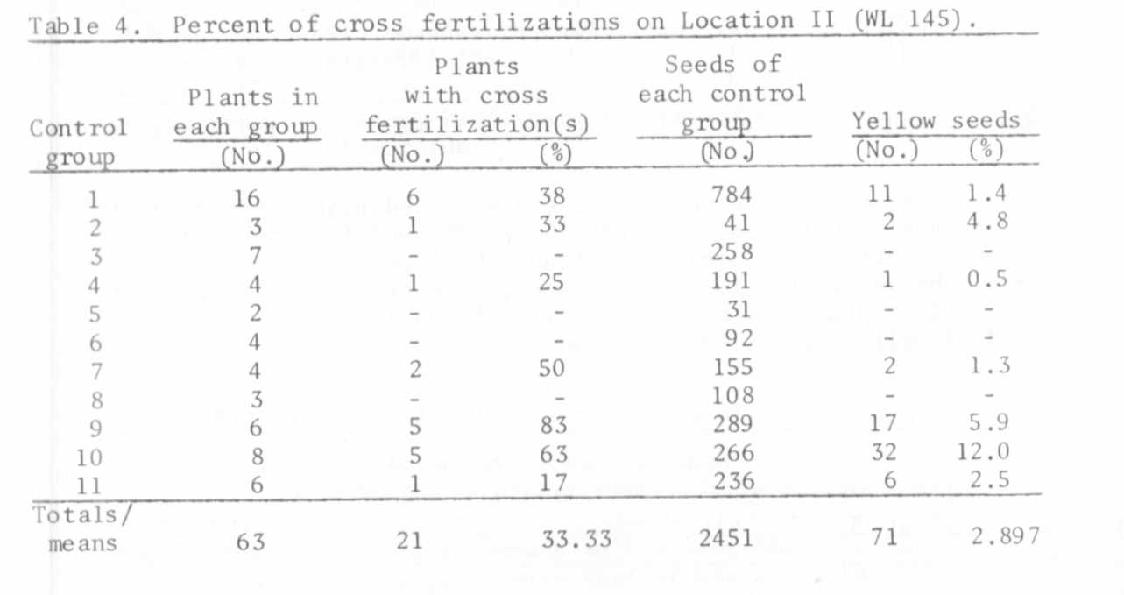

RESEARCH REPORTS 45
PNL Volume 17 1985

Since Location II seems to have a richer insect fauna than Location
I, the higher percentage of contaminated plants found at Location I this
year was quite unexpected. Since no insecticide was sprayed on Location
II in 1984, this perhaps should have allowed a further increase in the
percentages of contaminated plants and seeds. It did not. Yet, because
the field was not sprayed, seed production was greatly reduced as a re-
sult of a high incidence of disease, particularly viral disease. This
explains the difference in the average seed production per plant between
the two fields (46.6 seeds per plant on Location I vs. 28.2 seeds per
plant on Location II).
Cross fertilization rates were also determined using WL 145 (long,
late, non-fasciated, green cotyledons). Table 3 shows the results for
Location I and Table 4 for Location II.
Usually 20 seeds were sown for each control group in both fields,
so the loss of plants was especially high in this line. The difference
between the average seed production per plant (45.8 seeds per plant on
Location I and 38.9 on Location II) was not as great as in the case of
WL 6040. The percentage of contaminated plants and seeds was greater in
Location II than Location I but the high values on Location II were
mainly due to the surprisingly high rates of cross fertilizations of
control groups 9 and 10 and for which there is no satisfactory expla-
nation. Having watched (and filmed) the different kinds of bumble bees
and a solitary bee species for many hours, I noted that these bees do
not seem to have the refined information systems that the honey bee has
for communicating the most productive parts of a field. Moreover,
bumble bee behavior is often rather erratic: leaving a red pea flower,
turning to different plant species of the meadow nearby, returning to
the pea field, flying from white to red flowers and vice versa, some-
times crossing the entire field and beginning its activity anew at the
most distant part of the field, etc.
Besides the two lines mentioned, WL 118 (medium height, as early as
DGV NF 15-1, non-fasciated, green cotyledons) also was investigated.
The control group, consisting of 36 plants, had two contaminated plants
(=5.6%) and produced 1682 seeds, two of which had yellow cotyledons
(=0.12%).
Moreover, a few recombinants were selected, resulting from cross
fertilizations between WL 6040 and probably DGV. They were in most res-
pects similar to DGV (height, non-fasciation, flowering and ripening
times, etc.) except, of course, for the green cotyledons (Table 5).
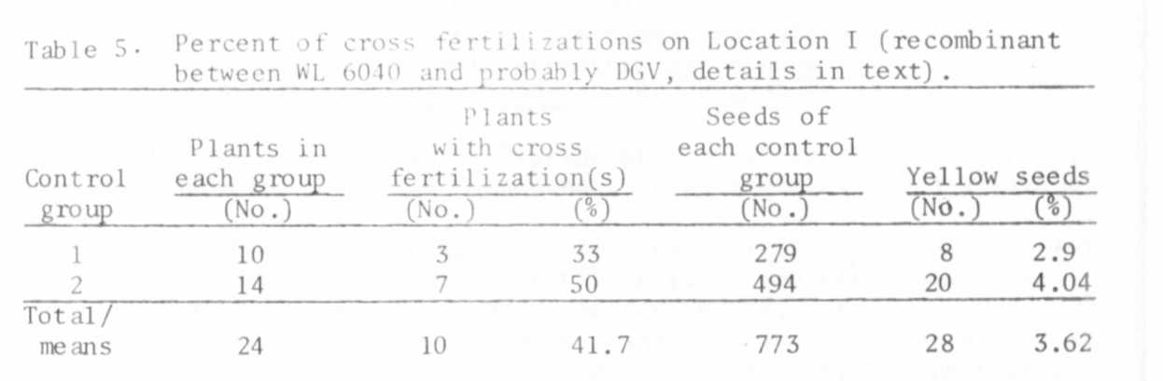

The final group investigated derived from a cross fertilization
between WL 6040 and probably again DGV, having green cotyledons but
which was still normally segregating in fasciated and non-fasciated
plants. Of the six non-fasciated plants, four were contaminated; all
six plants together produced 214 seeds, 14 of which had yellow cotyle-
dons. All four fasciated plants were contaminated; the four plants to-
gether produced 131 seeds, nine of which had yellow cotyledons (6.5 and
6.9% respectively for the non-fasciated and fasciated plants).
To make sure again that no mistakes had been made in determining
the cross fertilizations, 21 F2 families were studied (566 plants).
Since the M2 of R 650 A (3) contained several plants with the dominant
alleles Fa and/or Af (some of them with anthocyanin pigmentation) and
since we had several other similar cases among another M2, such plants
were chosen to determine whether any seeds of other lines might have
been mixed up with the M₂ seeds. All 21 families segregated. Among the
anthocyanin-producing plants we were able to ascertain the pollen source
as P. arvense from the color of the seed coats. These also segregated
for cotyledon color.
The real values for the cross fertilizations were in fact generally
slightly higher than given in the tables because doubtful cases were
systematically eliminated. On investigating such doubtful cases, we
found that some of them had really been the products of cross fertiliza-
tions.
Since the initiation of this study we have found at least:
969 plants with green cotyledons
620 plants for segregations
858 plants - M2 of R 650 A (plus other M₂'s not evaluated for
2447 this problem.

Moreover, at least 37,474 seeds have been investigated (segregations for
yellow and green seeds not included).

1. Loennig, W. E. 1983. PNL 15:40.
2. Loennig, W. E. 1984. PNL 16:38-40.
3. Loennig, W. E. 1984. PNL 16:42.

