RESEARCH REPORTS
1985
PNL Volume 17
40

DETAILED DOCUMENTATION OF THE OBSCURATUM PHENOMENON IN PISUM

Loennig, W.-E.
Institute of Genetics, University of Bonn
Federal Republic of Germany

In a line of Pisum sativum (arvense) there appeared the phenomenon
long known as obscuratum (1, 3-7, 9), showing a certain percentage of
self-colored, violet-black seeds among a large majority of violet
spotted ones (F, Fs, or F Fs). The character requires the presence of
anthocyanin (A) for expression but it is not heritable. Although the
phenomenon has often been observed and described, few data are available
providing actual counts and percentages. Tables 1 and 2 give such data
gathered in the experimental fields of Bonn in 1983 and 1984. Table 1
shows the numbers of seeds and the percentages of violet-black seeds in
seven families derived from individual plants which themselves bore only
spotted seeds.
Table 1. Percentages of violet-black and partly colored seeds of
seven families of a line of Pisum arvense (1983).

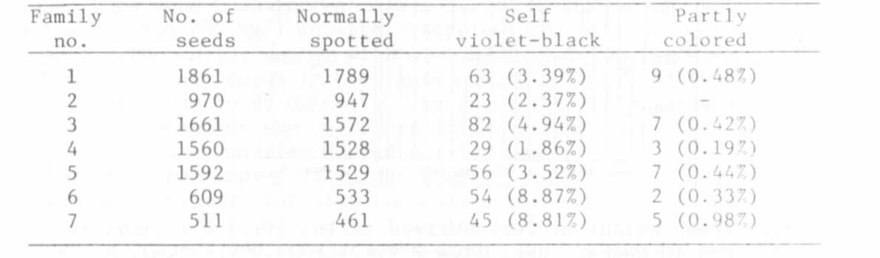

The violet-black seeds from these populations were selected and the 184
plants grown from them were investigated in the field in 1984 (Table 2).

Table 2. Percentages of violet-black and partly colored seeds. All
the plants producing these seeds were grown from violet-black
seeds.
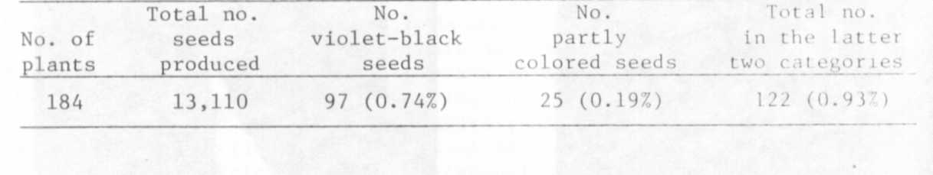
The 122 self-colored or partly colored seeds were distributed on 24
(13%) of the 184 plants; all 24 plants also bore spotted seeds. Three
categories could be distinguished for the colored seeds: five plants
bore only violet-black seeds, eight plants bore violet-black and partly
colored seeds, and eleven plants had only partly colored seeds, so that
the ratio of the first two categories to the last was nearly 1:1 (in
four groups of plants we found the following ratios: 6:6 in 71 plants;
2:2 in 48 plants; 3:2 in 44 plants; and 2:1 in 21 plants).

RESEARCH REPORTS 41
PNL Volume 17 1985

Table 3 gives an example of the distribution per plant for each
category (we usually counted from the first fertile node upwards).

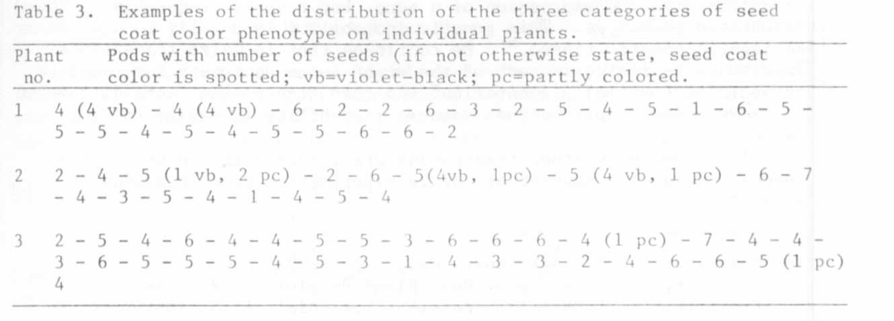

Sixteen plants grown from partly colored seeds were also investi-
gated. They produced 1,448 seeds, 35 of which were violet-black and 6
partly colored (2.42% and 0.41%, respectively). The violet-black and
partly colored seeds were distributed on 3 (19%) of the 16 plants. All
three plants bore violet-black as well as partly colored seeds.
After having crossed the P. arvense line with long P. sativum lines
(latter being derived from hybrids between mutant 489C and DGV), the F₂
was investigated for violet-black and partly colored seeds. The pheno-
menon of somatic instability had also appeared in the F1, but was not
counted in larger numbers there. Table 4 gives the details for the
three F2 families investigated, but since only A plants produce colored
seeds, only their seeds are given in the table.

Table 4. Percentages of violet-black and partly colored seeds in three
F₂ families of the cross P. arvense x P. sativum ( 1983).
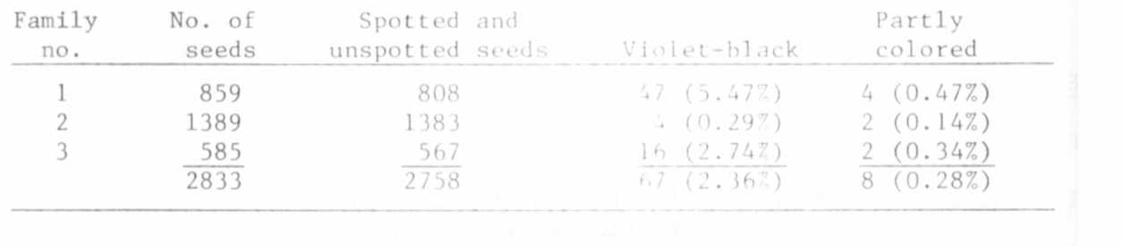
From family No. 3 of Table 4 40 Light brown^{1/} seeds were selected
(details about segregations for seed coat colors of similar crosses, see
Marx [8]). In the 30 F3 plants evaluated in 1984, exactly 1500 seeds
were counted, none of which was violet-black or partly colored. The
light brown seeds were generally very slightly spotted, but some of them
did not show spotting. These F3 plants may have lost the gene (or ele-
ment) which makes possible the instability to the degree described
above. However, as already noted by Lamprecht (4), there may be a cer-
tain relationship between the percentage of violet-black seeds and the
amount of insolation. In contrast to the sunny summer of 1983 in
Central Europe, we had long periods of rain in 1984, which may explain
the general differences in the percentages of violet-black seeds produced.

^{1/} A discussion of the nomenclature concerning flower and seed coat color
is beyone the scope of the present paper. The terms are only descriptively
and tentatively used in their normal usage of everyday language.

Freeling (2), commenting on the work of McClintock and the ques-
tion how insertion elements are recognized, writes (p. 281): "The most
common way to recognize an insertion element is when the element lowers
or obliterates the expression of a gene, but reverts frequently to the
nonmutated phenotype. This genetic instability is usually recognized as
variegated somatic tissue." He continues that in maize transposons
"are known to reside in each of the eight genes necessary for complete
anthocyanin (purple) pigmentation" and that transposons "were discovered
at these genes simply because somatic instability is easily recogni-
zable".
The question whether transposons are involved in the obscuratum
phenomenon may be answered by future experimental work in molecular
genetics.

1. Blixt, S. 1972. Agri Hort. Genet. 30:1-293.
2. Freeling, M. 1984. Ann. Rev. Plant Physiol. 35:277-298.
3. Fruwirth, C. 1909. Arch Rass. u. Ges. Biol. 6:433-469.
(Quoted by Blixt, 1972).
4. Kajanus, B. 1913. Fuhlings Landw. Ztg. 62:153-160.
(Quoted by Lamprecht, 1956.
5. Lamprecht, H. 1956. Agri Hort. Genet. 14:19-33.
6. Lamprecht, H. 1958. Agri Hort. Genet. 16:49-53.
7. Lamprecht, H. 1974. Monographie der Gattung Pisum.
8. Marx, G. A. 1984. PNL 16:43-45.
9. Rimpau, W. 1891. Landwirthschaftliche Jahrbucher 20:366-369.
(Quoted by S. Blixt, 1972).

Acknowledgement: I thank Prof. Marx for providing references to the
obscuratum.

Erratum

PNL 16, p. 41

1) There is a typographical error on line 2 of the last paragraph.
It should read: "As no Fa plants with..." (Fa instead of fa).

2) Concerning the editor's comment in brackets (line 4, same paragraph)
the author maintains he is sure that it was a non-fasciated plant.

