SDS-ELECTROPHORETIC INVESTIGATION ON SEED ALBUMINS OF SOME PISUM
GENOTYPES

Abou-Salha, A.
Institute of Genetics, University of Bonn
Federal Republic of Germany

The electrophoretic seed albumin patterns of nine genotypes from
Gottschalk's collection were analyzed, including the mother variety
(IL), the stem bifurcated mutant 1201A (bif-1)f, the fasciated mutant
489C (more than 18 mutant genes), and six recombinants (RM 20D, R 46C,
RM 427, RM 432, RM 836, and RM 1126) (Table 1).

Table 1. Origin and characterization of the recombinants.
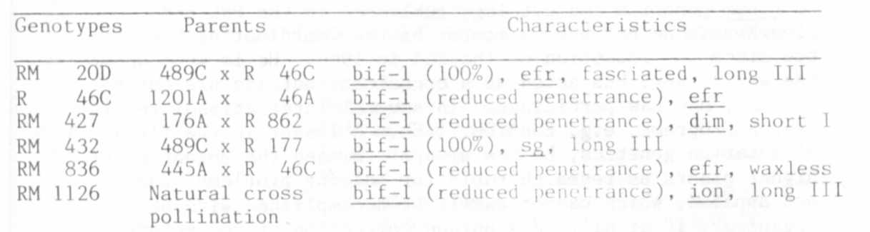
The albumin fraction was extracted with 0.5 M NaCl (pH 6.85) and
dialyzed against water. Electrophoretic analysis was performed on SDS-
polyacrylamide gel.
The albumin proteins of mutant 1201A, recombinants R 46C, RM 427,
and RM 836 all gave banding patterns similar to that observed for IL. A
prominent doublet with molecular weight of 67.5 Kd may be easily seen in
this pattern (Fig. la). In contrast, the albumin pattern of RM 1126
exhibited only faint bands in this region. This difference appeared to
be of a quantitative nature. Qualitative variation in the albumin pat-
terns was not observed among the above lines although these lines dif-
fered in a number of morphological characters.
An additional band (MW about 67.5 Kd) was present In three geno-
types (489C, RM 432 in Fig. lb and RM 200 in la). The albumin pat-
terns of these lines also exhibited a number of small quantitative dif-
ferences. Further studies must he performed to characterize these dif-
ferences.

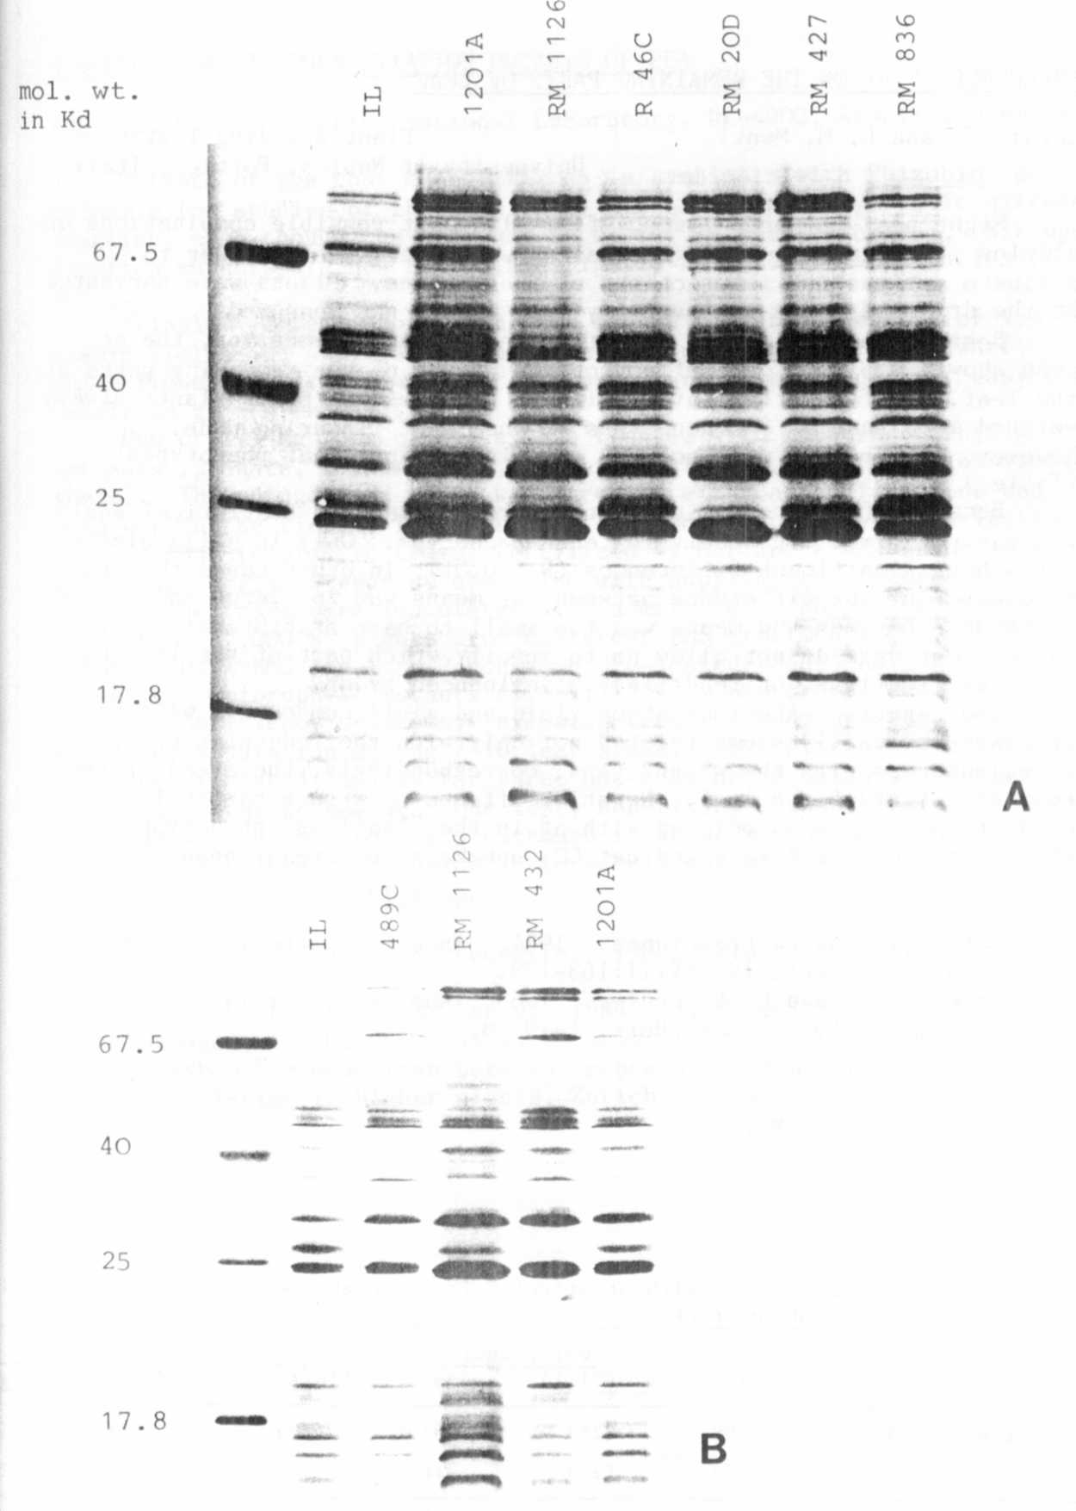
Fig. 1. SDS-electrophoregrams of seed albumins in the stem bifurcated
mutant 1201A, the fasciated mutant 489C, and six recombinants
compared with the IL.

