INDUCTION OF SOMATIC EMBRYOS IN PEA, PISUM SATIVUM L.

Kyse1y, W.
University of Bonn
Federal Republic of Germany

Successful application of tissue culture technology to the improvement
of crop plants depends upon the ability to regenerate plants in vitro.
Plant regeneration, however, has been quite difficult with seed legumes
as peas and beans (Glycine, Phaseolus, Vicia). In pea, an attempt was
made to overcome the regeneration problem by screening several genotypes
for their in vitro behavior in order to select embryogenic cell lines.
Ten genotypes of pea were tested, including the variety 'Dippes
Gelbe Viktoria' (DGV), five X-ray and neutron-induced mutants of the
variety DGV (A89C, 251A, 37A, 39, and 176A), three recombinants from
crosses with the fasciated mutant 489C and DGV (R 1115, R 15±1, R 20±1
—the last two are named according to the number ol their sterile
nodes), and a line of Pisum arvense.
For callus formation leaf explants (6 mm in diameter) of 13-day-old
pea seedlings were transferred to a modified MS-medium (MS-salts, 2 mg/1
thiamine HC1 and 250 mg/1 inositol) supplemented with 3% sucrose and
0.8% agar. The callus medium with 0.06 mg/1 picloram (4-amino-3,5,6-
-trichloropicolinic acid) in combination with 0.1 mg/1 BA (benzyl-
adenine) was found to be optimal. The pH of the media was adjusted to
5.8. Callus formation was performed at 27C in the dark. For suspension
cultures, the same modified MS-medium was used.
The genotypes showed different genetic behavior, not only for
callus growth (Fig. 1) but also for callus morphology. The recombinants
R 1115, R 15±1, and R 20±1 as well as the accession of P. arvense
developed a compact and nodular embryogenic callus whereas the other
genotypes produced only a compact callus which however exhibited nodular
structures upon transfer to liquid MS-medium. The callus cultures of
genotype 37A segregated into a slow growing, yellowish, soft, and com-
pact callus and into a fast growing, yellowish-white, compact callus.
In suspension cultures, some of the nodular callus structures de-
veloped into embryos (Fig. 2, 3). When torpedo-shaped embryos were
transferred to hormone-free solid MS-medium, some of them showed root
formation, but no shoot morphogenesis has yet occurred. In a limited
number of cases, an additional root was formed in the apparent shoot
apical region after 2-5 days. Growing the embryos in liquid MS- media
with added soluble starch, casein hydrolysate, activated charcoal, or
culturing with varying combinations of BA alone or in combination with
IBA (indole-3-butyric acid) or PAA (pheny1-acetIc acid) did not result
in shoot morphogenesis.

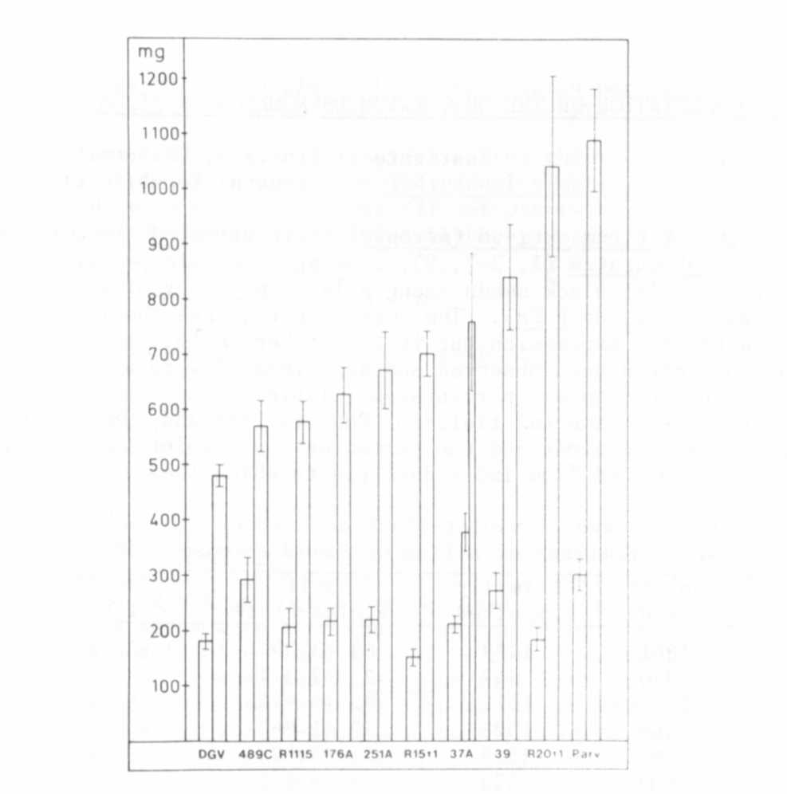
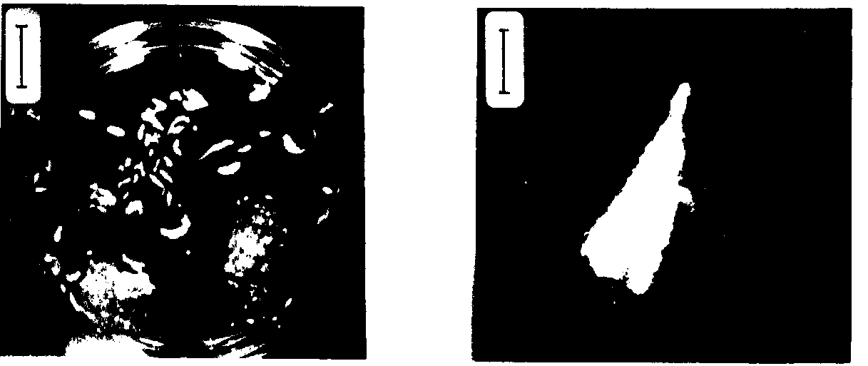
Fig. 1. Mean fresh weight of leaf-derived callus after a culture period
of 5 and 10 weeks. Bars give ± S.E. of 9-12 replicates.
Fig. 2. Embryogenic callus with Fig. 3. Single embryo (vertical
embryoids and embryos in bar : 1 mm).
suspension
(vertical bar : 1 cm).

