GENETICAL STUDIES OF THE PISUM SATIVUM ROOT SYSTEM

Jensen, F. H. Pajbjergfonden Plant Breeders
Dyngby, DK-8300 Odder, Denmark

Very little is known about the genetics of the pea root in general
or of the variability of roots of different pheno-/genotypes and the
relations to seed yield components.
Jean (2), in his early work on the heritability of root morphology
in peas, concluded: "The evidence, then, suggests strongly that heredi-
tary genes accompanying those that determine height are the causative
factors that determine root penetration in the case of peas, and not the
physiological demands alone of the aboveground parts". It has been im-
possible to find other references of similar studies since then, but
Veitenheimer and Gritton (4) have initiated a crossing program to study
root genetics.
Zobel (5) used mutagenesis to study root systems of peas and indi-
cated that selection for desired root variability should be successful
either by utilizing genepools or through mutation breeding. Ali-Khan
and Snoad (1) analyzed seven root and shoot characters of 30 pea geno-
types and found considerable genetic variation in all characters
studied.
At Pajbjergfonden a three-year project has been funded to investi-
gate the root system of peas^{1/}. Two experiments have yielded the
following results:
A. The initial root growth of ten pea varieties was studied in the
greenhouse in Jan/Feb 1984. Table 1 shows the varieties used, among
which were white and colored flowered dry edible and garden peas.
'Filby' is a leafless pea and M131-81 and 'Wensum' are semi-leafless.
M131-81 is a progeny from a cross 'Finale' x 'Filby'. The plants were
grown in a sandy loam in PVC tubes (85 cm long, 10.5 cm diam), two
plants per tube. Five replicates of each variety were harvested at
four-day intervals, beginning six days after sowing. Total root length
was measured using procedures described by Newman (3).
The results in Table 1 show highly significant differences in most
characters. Of genetical interest are the varieties Finale, Filby, and
M131-81, and I believe the significant similarities and differences
between these three varieties give some indications of heritability.
Both from this experiment (Table 2) and from a screening of 400
varieties, we found good correlations between total root length and
shoot length. If this correlation is caused primarily by physiological
interactions between root and shoot there may be difficulty in breeding
for larger roots.
B. Results from a screening of 39 pea genotypes (most old land-
races) from Stig Blixt are shown in Table 3. Here, too, the root/shoot
ratio shows a large variation among varieties.
To study in more detail the interaction between root/shoot, crosses
have been made between very tall varieties with a large root system and
commercial varieties with smaller roots. F2 will be grown this spring
for a root test. In addition a crossing program has been set up using
genotypes with well described genes for the shoot received from I. C.
Murfet.

1. Ali-Khan, S. T. and B. Snoad. 1977. Ann. Appl. Biol. 85:131-136.
2. Jean, F. C. 1928. Botanical Gazette 86:318-329.
3. Newman, E. I. 1966. J. Appl. Ecol. 3:139-145.
4. Veitenheimer, E. E. and E. T. Gritton. 1984. PNL 16:73-74.
5. Zobel, R. 1974. PNL 6:58-59.

^{1/} Financial support for the project was provided by the Danish
Agricultural and Veterinary Research Council.

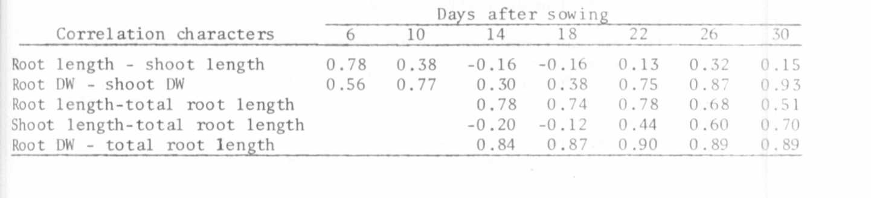
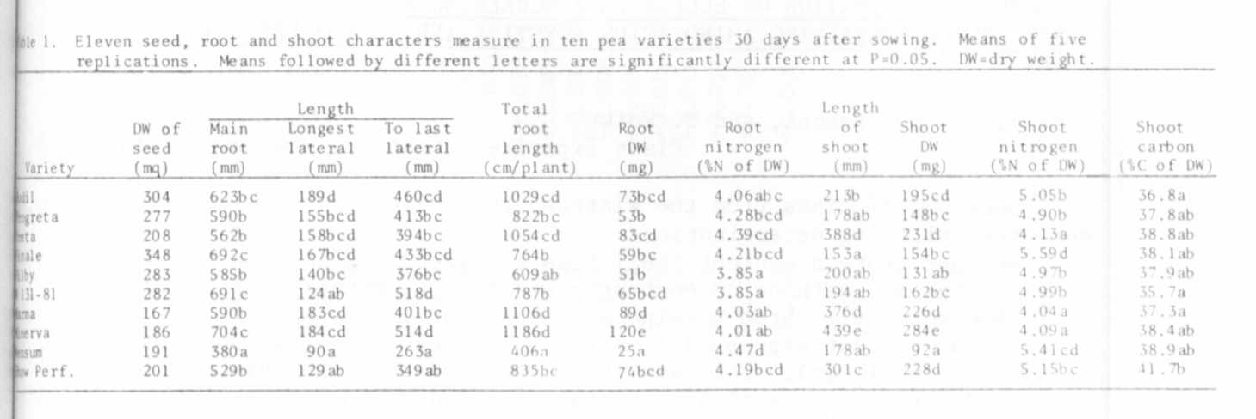
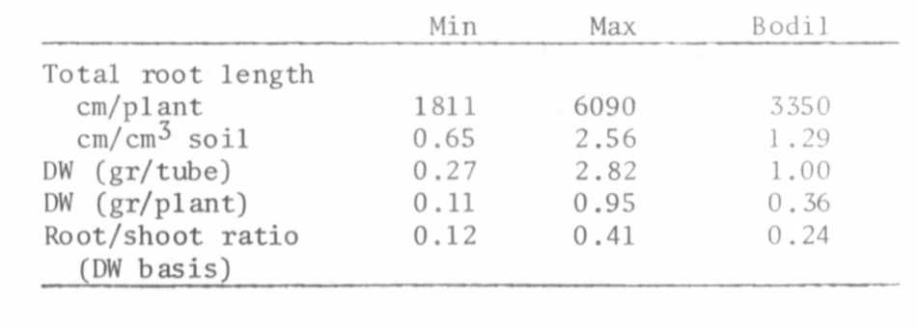
Table 2. Correlation coefficients among five root and shoot characters
in seven successive harvests of ten pea varieties.
Table 3. Ranges of root measurements of 39 pea geno-
types from S. Blixt, compared to Bodil , the
most grown dried pea in DK. Grown to
beginning podfilling in soil in PVC-tubes.

