MORPHOLOGICAL STUDIES ON THE HIGHLY NODULATING MUTANT nod-3 AND ITS
PARENT VARIETY 'RONDO'

Jacobsen, E. and A. Schuil Dept. of Genetics, University of Groningen
Kerklaan 30, 9751 NN Haren, The Netherlands

After inoculation with Rhizobium 1eguminosarum, the nodulation
behavior of mutant nod-3 contrasts sharply with the behavior of the wild
type. The mutant persistently nodulates in the presence of high amounts
of nitrate as well as nodulating abundantly on nitrogen-free aerated
liquid medium (1). Taproot length of nod-3 plants after nodulation was
found to be much shorter than that of cv 'Rondo'. To investigate
whether this difference in taproot length is a result of the abundant
nodulation or a direct effect of the mutation, the root and shoot
morphology of nodule-free seedlings of both genotypes, cultured on nit-
rogen-free aerated liquid medium (3), have been investigated during the
first three weeks after sowing.
No clear differences between the two genotypes were noted in the
period immediately following germination. Seedlings were examined 9,
13, 17, and 22 days after sowing (Table 1). The shoot, taproot, and
total root length (taproot + all lateral roots) of mutant nod-3 were
much shorter than that of the wildtype cv Rondo. The number of primary
lateral roots was essentially the same in both genotypes, whereas the
number of secondary lateral roots, the first ones appearing about 14
days after sowing, was much higher in the mutant. The distance between
the root tip and the point at which lateral roots first appear on the
taproot as well as on the primary lateral roots is shorter in the mu-
tant. Therefore, notwithstanding the differences in root length, the
number of primary lateral roots per cm of the rooted part of the taproot
is the same in three-week-old seedlings of both genotypes (Rondo 2.5 and
nod-3 2.7). The number of secondary lateral roots per cm of the rooted
part of the primary lateral roots clearly were different (cv Rondo 2.3
and nod-3 7.0).
Comparable differences were observed when seedlings of both geno-
types were nodulated after inoculation with Rhizobium 1eguminosarum
(data not shown). However, in this case also the number of secondary
lateral roots per primary lateral root was higher in three-week-old
seedlings of the mutant (Rondo: 5.2 and nod-3: 8.6) but the difference
was smaller than under nodule-free conditions (Table 1, B2). This de-
decreased number of secondary lateral roots in nodulated mutant plants is
directly connected with a relatively high number of nodules present on
such primary lateral roots (2).
All these observations indicate that the root morphology and shoot
length of mutant nod-3 also differs from that of the wildtype when
nodules are absent. After crossing mutant nod-3 with wildtype, no
recombination between persistent nodulation and an altered root morpho-
logy of the mutant was observed in an F2 population of over one hundred
plants, suggesting that we are dealing with pleiotropic characters.
The altered root morphology and shoot length of mutant nod-3 as
well as its persistent nodulation could be caused by a changed hormonal
makeup or balance of the plant. Investigations have been started to
determine auxin and cytokinin levels in seedlings of both genotypes with
the view to discover the basis for the difference in behavior. Prelimi-
nary observations indicated that in young root systems of nod-3 plants
contain a higher amount of indole acetic acid.

1. Jacobsen, E. and H. Nijdam. L983. PNL 16:31-32.
2. Jacobsen, E. and W. J. Feenstra. 1984. Plant Sci. Letters
33:337-344.
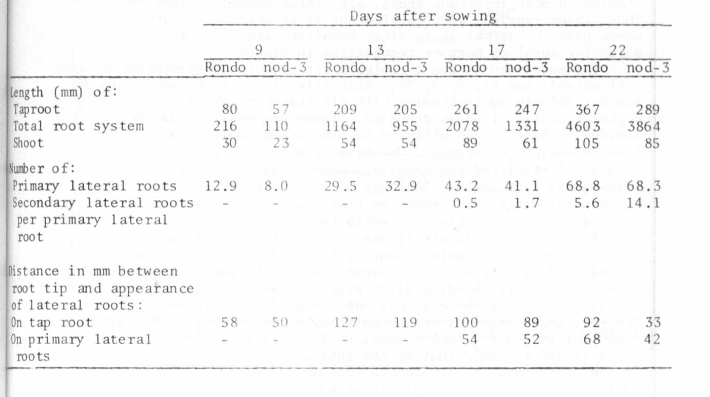
3. Jacobsen, E. 1984. Plant and Soil. (In press.)
Table 1. Root morphology and shoot length of uninoculated seedlings
of mutant nod-3 and cv Rondo during the first three weeks
after sowing.

