A SIMPLE ASSAY FOR GENOTYPE-DEPENDENT AUXIN-SENSITIVITY WITH YOUNG
SEEDLINGS OF PISUM SATIVUM

Ingensiep, H. W. Institute of Genetics
University of Bonn, Federal Republic of Germany

Based on earlier investigations and considerations about auxin-
dependent morphogenetic response of pea seedlings (1, 2), a simple assay
has been developed for pre-screening auxin-sensitive genotypes in the
young seedling stage using 2,4-D, NAA, and IAA. The idea was to try to
correlate morphogenetic differences (from the initial line) with some
alteration(s) in the endogeneous auxin control system of the plants. The
main regulation points for the latter may be on the level of auxin syn-
thesis, auxin reception or auxin inactivation. The irreversible degrada-
tion of auxin by oxidation and the possible reversible conjugation to
amino acids seem especially important to establish endogenous gradients
of the free auxin controlling shoot eleongation or axillary bud elonga-
tion. Therefore seedlings of the initial line (IL), 'Dippes Gelbe Vik-
toria', were compared with a recombinant (R 650 A) which contains genes
for long internodes, afila, fasciation, and extremely late flowering in
an assay system which may give some hint if these deviations are due to
some alteration in genes involved in the system of auxin inactivation.
Seedlings of IL and R 650 A grown in moist vermiculite for about one
week (light/dark=16/8 hr, 25C, 50% RH) were decapitated 1 cm above the
second node and prepared pieces of chromatography paper,dipped in
ethanolic solutions of the auxins up to 10⁻²M, were inserted at the top.
After 24 hr the pieces were removed and the seedlings were observed
during the following period of cultivation under the same conditions.
Fig. 1 shows the typical morphogenetic reaction pattern of IL seed-
lings in this assay after apical application of 2,4-1) with increasing
amount. 1) Apical shoot tissue swelled and showed callus structures with
increasing concentrations of 2,4-1) up to 10⁻² M. 2) Axillary buds at the
second node were inhibited in elongation and often swollen with in-
creasing amounts of 2,4-D which is in contrast to the control where these
buds elongated and were the dominant regenerating shoots, 3) Axillary
buds at the first node showed a maximum elongation at about 10⁻³ M, but
were inhibited at higher concentrations. The IL control normally shows no
bud elongation growth at the first node. At the concentration of 10⁻² M
2,4-D a characteristic morphogenetic reaction pattern was evident which
is similar to the well known "herbicida1" morphogenetic response.
Now, the other auxins, NAA and LAA, were compared to 2,4-D and the
control at these higher concentrations (10⁻² M) using seedlings of IL
(Fig. 2, below). 1) The NAA- and IAA-treated seedlings did not show the
drastic tissue proliferation in the apical region that 2,4-D did. 2)
Axillary buds at the second node were more inhibited in elongation com-
pared to the control, but less inhibited compared to the 2,4-D seedlings.
Lowest inhibition was observable after IAA-treatment, 3) Axillary bud
elongation in the first node was inhibited similar to the control in the
case of IAA and a stimulation of bud elongation was observed after NAA—
treatment as in the case of 2,4—D.

^{1/} This paper is dedicated to Prof. Dr. W. Gottschalk, who kindly sup-
ported my scientific work over the past years at our Institute.
This mode of different: morphogenetic response of IL shoots to the
three auxins seems to depend on the different ways of inactivation of
each auxin as has been shown for roots earlier (1): IAA is mainly inacti-
vated by oxidation (irreversible) and conjugation to aspartic acid (pos-
sibly reversible), NAA by conjugation to amino acids, and 2,4-D is only
minimally affected by both, i.e. it is very stable in its free active
form. More interesting is the morphogenetic reaction pattern of the re-
combinant R 650 A, where two main points deserve emphasis (Fig. 2, upper
part): 1) The control showed stimulated elongation of both axillary buds.
2) IAA-treated seedlings showed a strict inhibition of both axillary buds
within the first week after decapitation and auxin applications. Al-
though these are the main differences in the morphogenetic reaction pat-
tern between IL and R 650 A, the 2,4-D and the NAA-effects seem also to
be stronger than in the IL.
Interpretation of these results is very difficult. Obviously this
recombinant is more sensitive to exogenous auxin than the initial line.
One explanation could be that it is less able to inactivate the exogenous
auxin, but it cannot clearly be decided it genes governing the oxidation
or the conjugation system are involved. In the case of a negative muta-
tion in a gene controlling the oxidation system (for instance, for the
degrading enzyme or enzymes that produce Inhibitor substances) the resul-
ting effect of a higher amount of free active auxin within the shoots
could lead to enhanced bud inhibition as found here for the recombinant.
On the other hand, the 2,4-D and especially the NAA-treated recombinants
show more inhibition of bud growth compared to the initial line. This
would imply mutations in genes which have something to do with the conju-
gating system.
Another point is that in these early seedling stages the recombinant
shows two remarkable morphogenetic effects which may have something to do
with their endogenous auxin level: the double bud stimulation after de-
capitation and the long internodes (up to 3 times longer than in the IL).
The double bud stimulation points to a deviation in the endogenous auxin
gradient. While normally the buds at the first and the second node can
distinguish between different levels of the auxin along the axis, which
leads to a dominance of the second node bud, the recombinant is obviously
not able to distinguish clearly between the two node buds. This suggests
that in systems normally establishing these endogenous auxin gradient
something is altered. Also the long internodes of the recombinant could
be explainable by a defect in the endogenous auxin inactivation system,
leading to higher amounts of endogenous auxin and therefore to a striking
stimulation of elongation growth in the internodes. Further investiga-
tions are required before these findings can satisfactorily be inter-
preted.

1. Ingensiep, H. W. PNL 13:21-23.
2. Ingensiep, H. W. PNL 14:19-20.

RESEARCH REPORTS 29
PNL Volume 17 1985

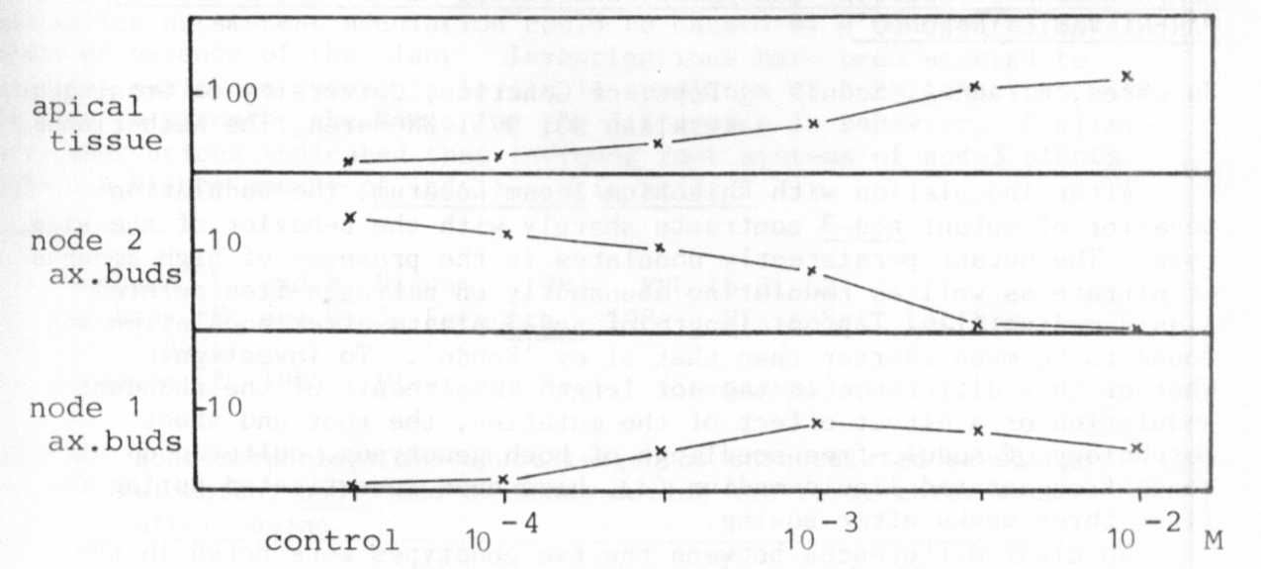
Fig. 1. Growth of apical tissue and axillary buds at the first and
second node of decapitated pea seedlings (IL) two weeks
after apical application of 2,4-D 10⁻⁴ - 10-² M. Apical
tissue in mg weight of the tissue above the second node.
Elongated shoot buds at node 1 and 2 in cm length.
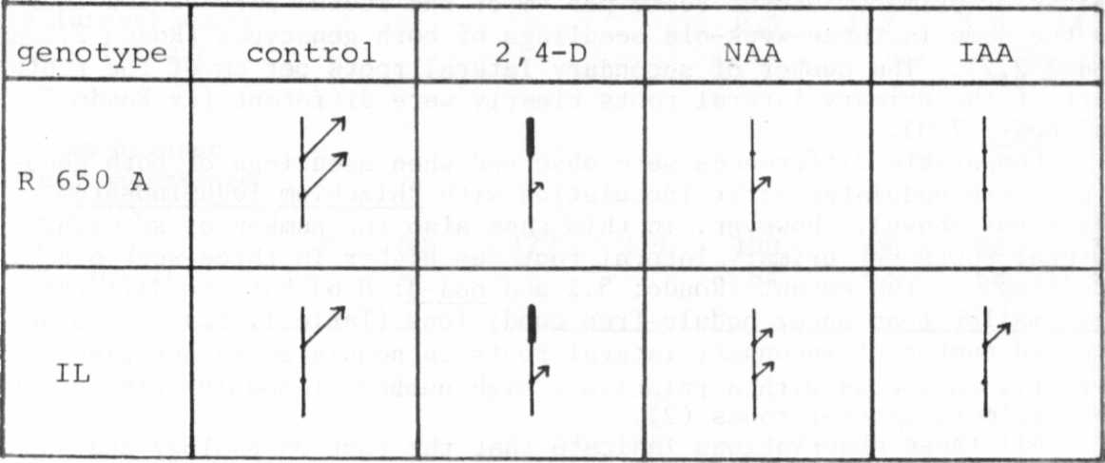

Fig. 2. Morphogenetic reaction pattern of pea seedlings (IL and
R 650 A) one week after decapitation and application of
the auxins 2,4-D, NAA, and IAA (10-²M) to the apex. The
arrows indicate the degree of bud elongation at the first
and second node. The thick lines indicate strong tissue
swelling and callus structures.

