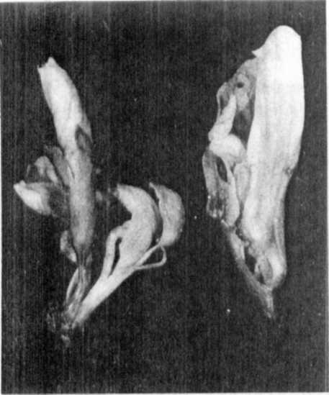

Fig. 1. Flowers of mutant 175

Left: Inflorescence with two flowers derived from
a single growing point. The calyx of the lower
flower was removed; the second flower, sitting
on a short stalk, comes from the central region
of that calyx.

Right: Inflorescence with three flowers derived
from a single growing point. Most of the lower
flower was removed. The middle flower consists
only of a single petal opposite to the leaf-
like carpel of the lowest flower. Between these
two organs, the stalk is discernible carrying
theapical flower inside the petal of the middle
flower.

INFLUENCE OF TEMPERATURE ON THE FLOWERING BEHAVIOR OF FASCIATED AND
BIFURCATED PISUM GENOTYPES

Gottschalk, W.
Institute of Genetics
University of Bonn, Federal Republic of Germany
and

The flowering behavior of four mutants with dichotomous stem bifur-
cation, four bifurcated recombinants, three fasciated mutants, and a
fasciated recombinant was studied in the phytotron under the following
temperature conditions:
12.5C constant (experiment 1)
I2.5C night, 25.5C day (experiment 3)
23.5C constant (experiment 2)
The plants were grown under 18 hr light and 6 hr darkness in all
three experiments. Number of days from sowing to the beginning of
flowering was determined in ten plants per genotype. The mean values
and the variability observed are given in Fig. 1 together with the
values of the mother variety 'Dippes Gelbe Viktoria' (DGV).
The bifurcated mutants 239CH and L201A are homozygous for gene
bif-1; mutant 157A is homozygous for bif-2 which is polymeric to bif-1.
Both these genes show reduced penetrance. The mutant gene of 37B is
allelic to bif-1 but it shows full penetrance. The bifurcated re-
combinants, considered in the lefthand part of the figure, contain bif-1
together with genes for waxlessness, different internode lengths and/or
different seed sizes. As expected, all these genotypes flowered con-
conciderably later under constant low temperature than under high tempera-
ture. The differences between experiment 2 and 3, however, were very
small. In experiment 3, the high temperature was only given over a
period of 6 hr per day, i.e. between 10:00 a.m. and 4:00 p.m. From 6:00
to 10:00 a.m. the temperature gradually rose from 12.5 to 25.5C and from
4:00 to 9:00 p.m. it fell from 25.5 to 12.5C. This relatively short
duration of the high temperature had a very positive effect on the
flowering behavior of the bifurcated genotypes tested. Thus, the period
of low temperature had relatively little effect on the rate of develop-
ment , provided that the plants were exposed to high temperature during
daytime. DGV plants behaved similarly. Plants of mutant 1201, however,
showed a certain degree of earliness in experiment 2 which was not ob-
served in experiment 3.

RESEARCH REPORTS 21
PNL Volume 17 1985

The fasciated mutants 123, 251A, and 489C are homozygous for more
than 20 mutant genes, most of them being identical in the three geno-
types. Recombinant R 176X contains in addition gene dim-1 for small
leaves, flowers, pods, and seeds derived from mutant 176A. These four
genotypes behaved differently from the bifurcated genotypes just dis-
cussed (righthand part of Fig. 1). In experiment 1, three of them were
considerably later than most of the bifurcated genotypes tested. Of
particular interest, however, is the fact that they flowered later in
experiment 2 than in experiment 3. Therefore the constant high tempera-
ture of 25.5C caused a delay in flowering as compared to the daily
change of low and high temperature. This delay is especially pronounced
in mutant 489C. Under the "normal" temperature conditions of experiment
3, the plants of this genotype began flowering about 70 days after seed
sowing. Under constant low temperature, the plants had only minute
flower buds 100 days after seed sowing when the experiment was stopped.
Surprisingly, the same behavior was observed under the constant high
temperature of experiment 2. In both these experiments, the plants of
mutant 489C would have needed at least two weeks more for producing
fully opened flowers.
Thus, the constant temperature of 25.5C influences the flowering
behavior of the three fasciated genotypes negatively, whereas it has a
positive effect on the mother variety, the bifurcated genotypes tested,
and many other genotypes not considered in the present paper.
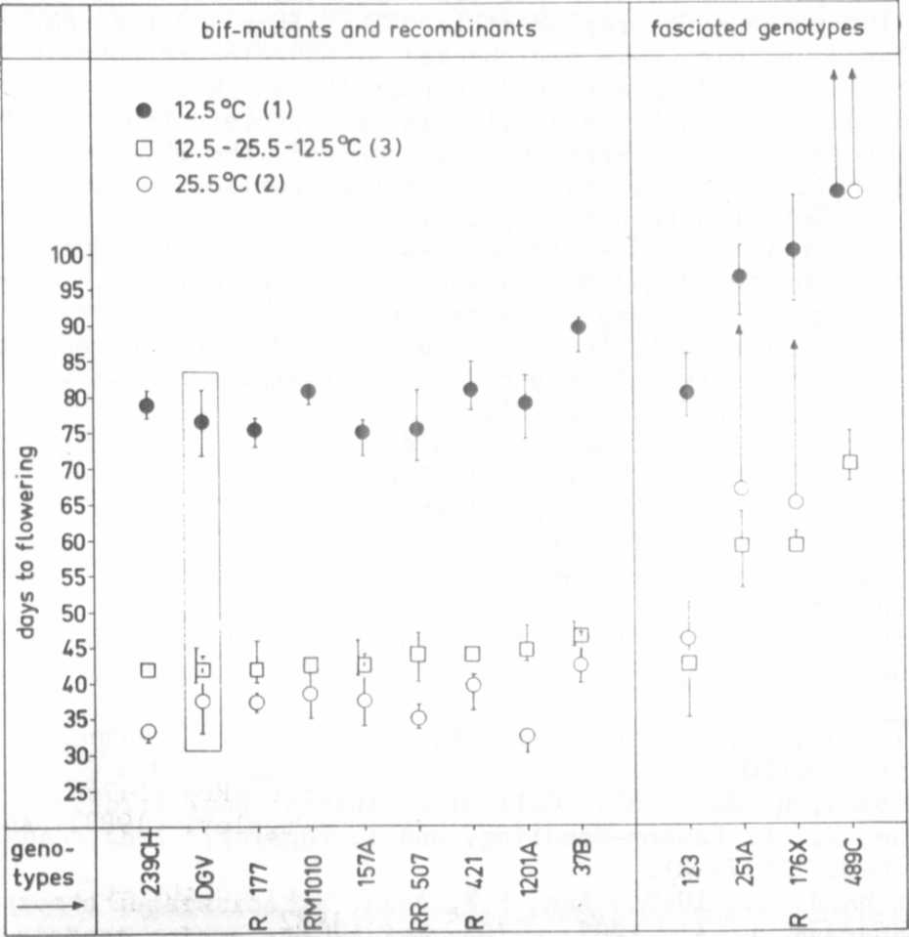
Fig. 1. The flowering behavior of 8 genotypes with dichotomous
stem bifurcation and 4 genotypes with apical stem fasciation
grown in the phytotron together with the mother variety DGV.

