A GENE FOR FLOWER DOUBLING IN PISUM

Gottschalk, W. Institute for Genetics
University of Bonn, Federal Republic of Germany

The flowers of the X-ray induced recessive mutant 175 of our
collection are doubled. Doubling is due both to an increase in the
number of petals in the corolla and to the formation of petal-like
organs in the staminate whorl. The later the flowers are formed the
higher is their degree of doubling. Most of the stamens have petal-like
appendices of varying size and shape. Sometimes these organs carry a
rudimentary anther with predominantly sterile pollen grains. The ovary
is mostly open; style and stigma are present but ovules are absent.
Thus, the mutant is both male and female sterile.
The gene causes an additional anomaly: from many growing points,
inflorescence-like organs develop instead of single flowers (Fig. 1).
Differentiation begins normally in the basal region of these growing
points, forming a normal calyx, a doubled corolla, and a corolla-like
staminate whorl. The pistil, however, shows a stronger reduction as
compared to the same organ in the single flowers of the mutant. It is
completely open and has a petal-like shape; only a narrow centrally lo-
cated sector consists of carpel tissue. In this way, the basic flower
of such an "inflorescence" is formed. A second t lower is produced from
the same growing point sitting on a short stalk, but there is no calyx
and no pistil in most of these apical flowers and the number of petals
and petal-like stamens is reduced.
More rarely even three—flowered inflorescences are produced from
such growing points. Their middle flower is strongly reduced, con-
sisting mostly of a single petal only. Calyx, staminate, and pistillate
cycles are lacking. Also the apical flower is reduced but not to such a
high degree. There is no calyx and the staminate and pistillate cycles
are mostly absent. The whole flower consists exclusively of petals the
number of which is somewhat higher than In normal pea flowers. In a few
cases, even five strongly reduced flowers were different Lated from a
single growing point. The uppermost two or three flowers of these "in-
florescences" were small, consisting only of a large number of scale
like leaflets without any specific characteristics.
The differentiation of the growing points of this mutant is a very
labile process resulting in flowers or even inflorescence-like organs
which differ from each other in many details even within the same plant.
This lability is interpreted as variable expressivity of the mutant
gene. In all those cases in which inflorescences are produced, distinct
regions of the growing points remain meristematic whereas other regions
undergo some degree of differentiation. Later these meristematic zones
produce somatic tissues in the form of small stalks. Finally, their
apical regions differentiate into flowers. As a consequence of this
"fractionated differentiation", not the usual single flowers but reduced
inflorescences arise from the respective growing points.

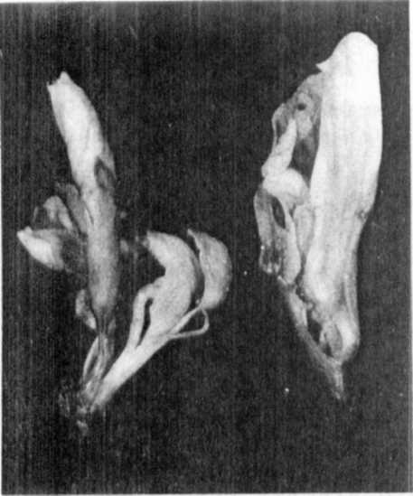

Fig. 1. Flowers of mutant 175

Left: Inflorescence with two flowers derived from
a single growing point. The calyx of the lower
flower was removed; the second flower, sitting
on a short stalk, comes from the central region
of that calyx.

Right: Inflorescence with three flowers derived
from a single growing point. Most of the lower
flower was removed. The middle flower consists
only of a single petal opposite to the leaf-
like carpel of the lowest flower. Between these
two organs, the stalk is discernible carrying
theapical flower inside the petal of the middle
flower.

INFLUENCE OF TEMPERATURE ON THE FLOWERING BEHAVIOR OF FASCIATED AND
BIFURCATED PISUM GENOTYPES

Gottschalk, W.
Institute of Genetics
University of Bonn, Federal Republic of Germany
and

The flowering behavior of four mutants with dichotomous stem bifur-
cation, four bifurcated recombinants, three fasciated mutants, and a
fasciated recombinant was studied in the phytotron under the following
temperature conditions:
12.5C constant (experiment 1)
I2.5C night, 25.5C day (experiment 3)
23.5C constant (experiment 2)
The plants were grown under 18 hr light and 6 hr darkness in all
three experiments. Number of days from sowing to the beginning of
flowering was determined in ten plants per genotype. The mean values
and the variability observed are given in Fig. 1 together with the
values of the mother variety 'Dippes Gelbe Viktoria' (DGV).
The bifurcated mutants 239CH and L201A are homozygous for gene
bif-1; mutant 157A is homozygous for bif-2 which is polymeric to bif-1.
Both these genes show reduced penetrance. The mutant gene of 37B is
allelic to bif-1 but it shows full penetrance. The bifurcated re-
combinants, considered in the lefthand part of the figure, contain bif-1
together with genes for waxlessness, different internode lengths and/or
different seed sizes. As expected, all these genotypes flowered con-
conciderably later under constant low temperature than under high tempera-
ture. The differences between experiment 2 and 3, however, were very
small. In experiment 3, the high temperature was only given over a
period of 6 hr per day, i.e. between 10:00 a.m. and 4:00 p.m. From 6:00
to 10:00 a.m. the temperature gradually rose from 12.5 to 25.5C and from
4:00 to 9:00 p.m. it fell from 25.5 to 12.5C. This relatively short
duration of the high temperature had a very positive effect on the
flowering behavior of the bifurcated genotypes tested. Thus, the period
of low temperature had relatively little effect on the rate of develop-
ment , provided that the plants were exposed to high temperature during
daytime. DGV plants behaved similarly. Plants of mutant 1201, however,
showed a certain degree of earliness in experiment 2 which was not ob-
served in experiment 3.

