RESEARCH REPORTS 1
PNL Volume 17 1985

Table la. Crosses performed between L-83 and lines of normal structural
type.

Cross Parental lines Genotype and karyotype References
A L-83 x L-44 Gp, T(3S-5L) x gp, N-type PNL 9:26-27
B L-83 x L-1072 Gp, T(3S-5L) x gp, N-type Lamm (unpub.)
C L-83 x L-1458 Gp, T(3S-5L) x gp, N-type Current values

Table lb. Frequency, in crosses listed in Table la, of various types
of trisomies carrying the interchange chromosomes (3⁵) long
or (5³) short, respectively, in addition to the normal
karyotype.
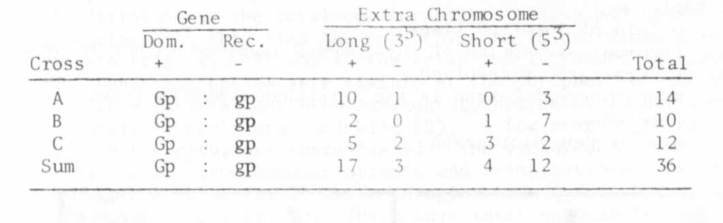

BSG-STAINTNG ARGUMENTS FOR A SHIFT IN LOGATION OF LINKAGE GROUPS II
AND IV

Folkeson, Donald Institute of Genetics, University of Lund
Solvegatan, Lund, Sweden

Because of the appearance of C-bands in the proximity of the secon-
dary constrictions, BSG-staining, as demonstrated by Lamm (3), has become
a powerful tool for identifying the satellite chromosomes 4 and 7 in
mitosis as well as in meiosis. This method has recently been used by me
(2) to verify the interchanges of L-lll T(3S-7S) and L-112 T(5L-7S).
Further analysis has been carried out on L-108, L-114, and L-180, belon-
ging to Lamm and Miravalle's tester set (6), and L-58, analyzed by Blixt
(1), for the coordination of linkage group IV with a relevant chromosome.

The result of BSG-staining indicates that linkage group II instead
of linkage group IV belongs to the short satellite chromosome viz.
chromosome 4 (see table and photomicrograph).

1. Blixt, S. 1972. Agri Hort. Genet. 30:1-293.
2. Folkeson, D. 1984. Hereditas 101:119-121.
3. Lamm, R. 1981. Hereditas 94:45-52.
4. Lamm, R. 1983. PNL 15:33-35.
5. Lamm, R. 1982. PNL 14:32-35.
6. Lamm, R. and R. J. Miravalle. 1959. Hereditas 15:417-440.
LIGHT

Gaul,

Table 1. Compilation of cytogenetic results involving four
translocation lines.

Key to table:
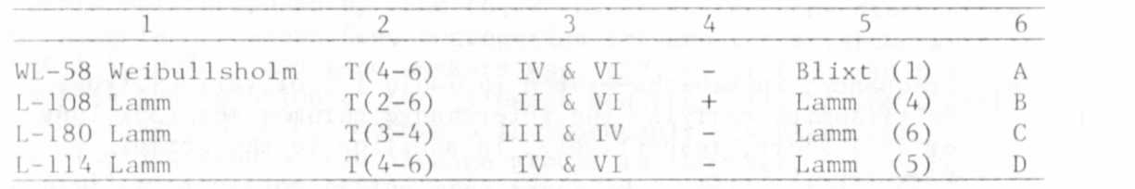
1. Origin of involved lines
2. Previous assumption of chromosomes involved in the interchanges
3. Linkage groups involved
A. Appearance of C-band in the interchange system (ring of four)
5. Reference
6. Key to photomicrograph

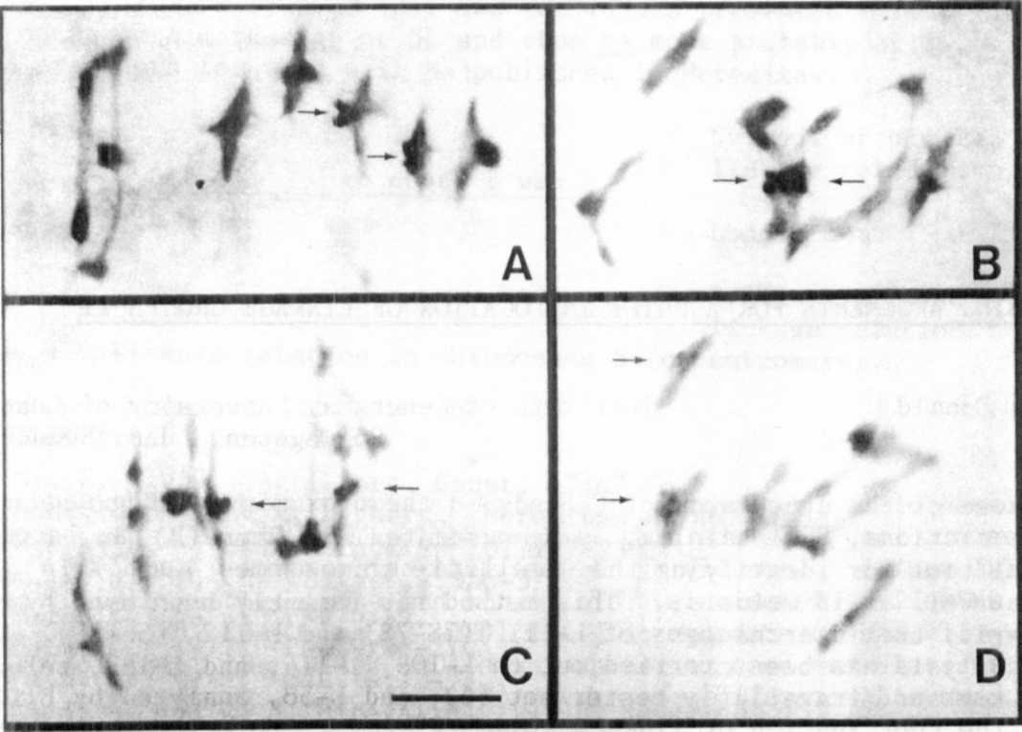
Fig. 1. Giuemsa C-bands in meiosis of pollen mother cells. For
key to figure see Table 1. The arrows indicate the
location of the C-bands; bar represents 10 mkm.

1,
2.

