RESEARCH REPORTS
1985
PNL Volume 17
1

A REVISED LINKAGE MAP OF CHROMOSOME 5 IN PISUM

Folkeson, D.
Institute of Genetics, University of Lund
Solvegatan, Lund, Sweden

Further analysis for the orientation of linkage group V has been
carried out by the use of tertiary trisomies and linkage analysis, as
recommended by Lamm (6). Mitotic measurements by Blixt (1) have clearly
shown that L-379 is a T(3S-5L) interchange. L-379 and L-83 have appa-
rently the same origin and have been shown to be structurally identical
by Lamm (5). Analysis of tertiary trisomies and of linkage relations of
L-83 has been performed by Lamm (4). The junction of linkage group V and
VII as previously proposed by Lamm (4, 7) has elicited some discussions.
Linkage analysis has shown free segregation between the interchange point
of Merton I (3Sp-7Sp) and gene markers wsp, tl^{w}, r, bt (3). In the
latter paper, the location of the "linkage sequence" VII in the distal
part in the long arm of chromosome 5 is thoroughly discussed (cf.
Fig..l). The junction of two linkage groups is, however, not so remark-
able, a similar situation having been recorded in barley (2). The inver-
sion of linkage sequence V in chromosome 5 has previously been pointed
out by Lamm (6). To extend his analysis, I have performed the following
cross:
L-83 x L-1458 (Gp_, Ce, Fs, T[3S-5L] x gp_, ce, fs, N-type.)
The result of this cross (Table la) reveals the following linkage rela-
tion:
Fs - 1.6% - Ce - 19.6% - T - 13.8% - Gp
A compilation of previous cytogenetic measurements by Blixt (1), analyses
of tertiary trisomies by Lamm (8), and the values presented here (Table
lb) place the gene marker gp at 5L and thus ce most probably at 5S.
Detailed arguments for this will be published in Hereditas.

Fig. 1. Linkage relation in chromosome 5 (c=centromere).

1. Blixt, S. 1959. Agri Hort. Genet. 17:47-75.
2. Burnham, C. R. and A. Hagberg. Hereditas 42:467-482.
3. Folkeson, D. 1984. Hereditas 101:227-233.
4. Lamm, R. 1951. Hereditas 37:356-372.
5. Lamm, R. 1974. PNL 6:19.
6. Lamm, R. 1977. PNL 9:26-27.
7. Lamm, R. 1978. PNL 10:32-33.
8. Lamm, R. and R. J. Miravalle. 1959. Hereditas 15:417-440.

RESEARCH REPORTS 3
PNL Volume 17 1985

Table la. Crosses performed between L-83 and lines of normal structural
type.

Cross Parental lines Genotype and karyotype References
A L-83 x L-44 Gp, T(3S-5L) x gp, N-type PNL 9:26-27
B L-83 x L-1072 Gp, T(3S-5L) x gp, N-type Lamm (unpub.)
C L-83 x L-1458 Gp, T(3S-5L) x gp, N-type Current values

Table lb. Frequency, in crosses listed in Table la, of various types
of trisomies carrying the interchange chromosomes (3⁵) long
or (5³) short, respectively, in addition to the normal
karyotype.
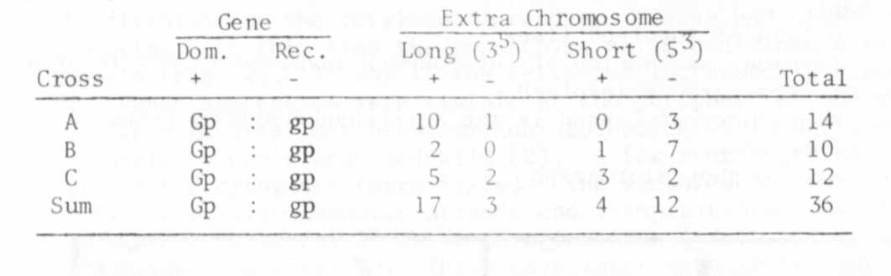

BSG-STAINTNG ARGUMENTS FOR A SHIFT IN LOGATION OF LINKAGE GROUPS II
AND IV

Folkeson, Donald Institute of Genetics, University of Lund
Solvegatan, Lund, Sweden

Because of the appearance of C-bands in the proximity of the secon-
dary constrictions, BSG-staining, as demonstrated by Lamm (3), has become
a powerful tool for identifying the satellite chromosomes 4 and 7 in
mitosis as well as in meiosis. This method has recently been used by me
(2) to verify the interchanges of L-lll T(3S-7S) and L-112 T(5L-7S).
Further analysis has been carried out on L-108, L-114, and L-180, belon-
ging to Lamm and Miravalle's tester set (6), and L-58, analyzed by Blixt
(1), for the coordination of linkage group IV with a relevant chromosome.

The result of BSG-staining indicates that linkage group II instead
of linkage group IV belongs to the short satellite chromosome viz.
chromosome 4 (see table and photomicrograph).

