RESEARCH REPORTS
1 3
1985
PNL Volume 17

IN VITRO CULTURE OF EXPLANTS FROM A SINGLE PEA SEE

D^{1/}

Filippone, E.
C.N.R., Centro Studi Miglioramento
Genetico Ortaggi, Portici, Italy

A method was devised to obtain several explants from a single pea
seed as a way of meeting certain needs in breeding, physiological, and
genetical studies.
Seeds of cv 'Proteo' were surface sterilized with calcium hypochlo-
ride (2%, 20 min), rinsed several times with sterile water, and sown on
sterile medium (deionized water plus agar 0.8%) , and then placed in a
growth chamber at 24C in continuous light. Seven-day-old seedlings were
dissected as shown in Fig. 1 to obtain from each: a) root; b) epicotyl
bud; c) epicotyl segment; d) bud with only one cotyledon; e) shoot apex.
All operations were performed under a dissection microscope in a laminar
flow hood. Table 1 lists the media used and the potential uses for the
explants. The explants were incubated in a growth chamber at 24C, under
16 h light/8 h dark. Only the roots were grown in total darkness.
Callus proliferation occurred after 15 days in the epicotyl seg-
ments, and a whole plant was obtained from the bud with only one cotyle-
don. After 40 days each epicotyl bud produced an average of eight
shoots.
Using this technique, a single seed can be used to mass propagate
genetically identical tissue for different studies. Moreover, the coty-
ledon without embryo can be used for analysis ot seed protein.

T. Raggio, M., N. Raggio, and J. G. Torrev. 1957. Amer. J. Botany
44:325-334.
2. Lindsmaier, E. M. and F. Skoog. 1965. Phvsiol. Plant. 18:100-127.
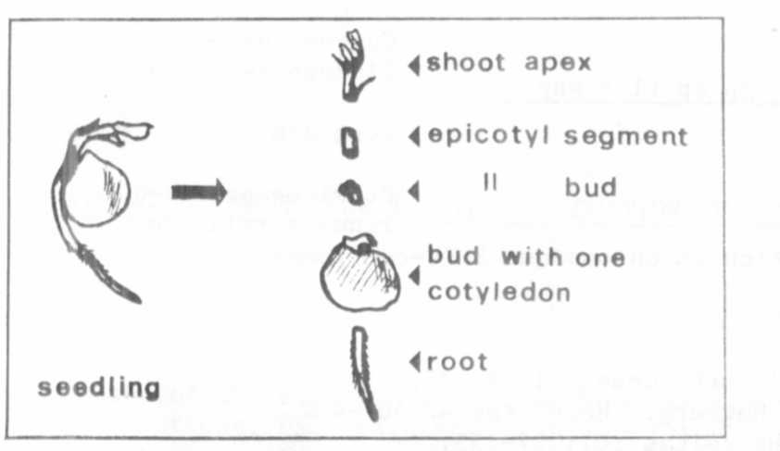
Fig. 1. Explants from a single pea seed.

— Contribution no. 11 from Centro di Studio per il Miglioramento
Genetico degli Ortaggi - C.N.R. - Portici (Napoli) - Italy.

