1 PNL Volume 17 1985 RESEARCH REPORTS

IN VITRO ROOTING OF PEA SHOOTS'/

Filippone, E.
C.N.R., Centro Studi Miglioramento
Genetico Ortaggi, Portici, Italy

In vitro cultures of pea epicotyl buds produce several shoots which
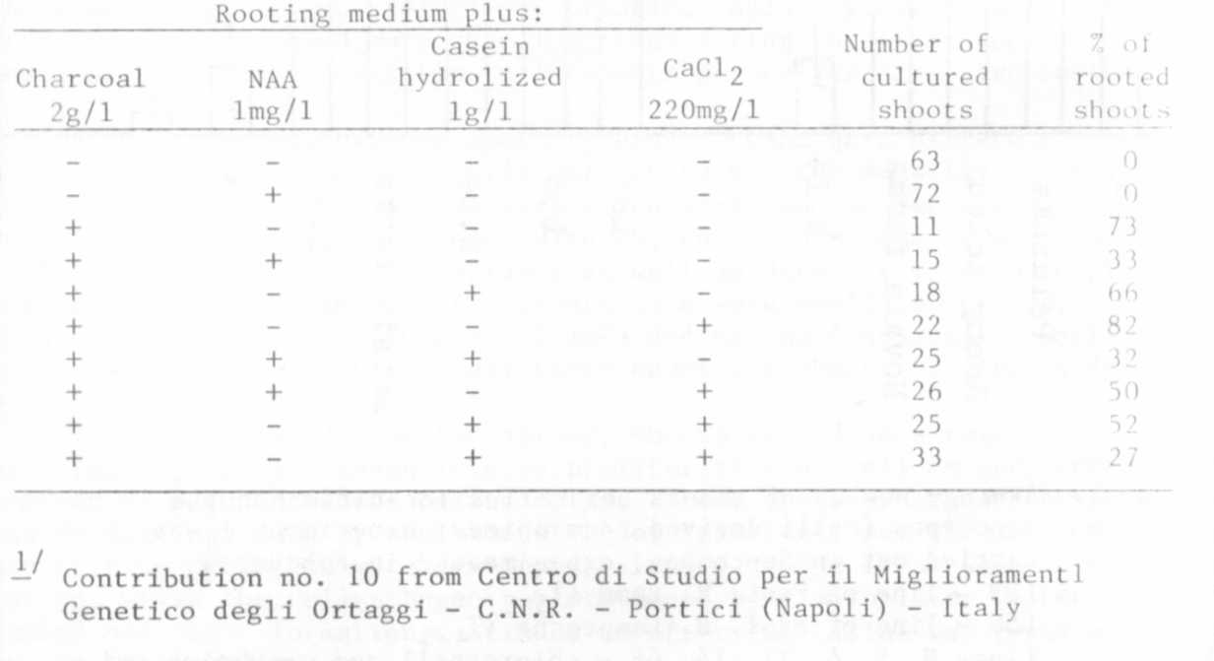
are difficult to root. For that reason we undertook to find the condi-
tions conducive to good radical formation.
Seeds of 'Proteo' were surface sterilized and, alter several rinses
in sterile water, were sown on agar medium (deionized water and 0.8%
agar). Seven-day-old seedlings were removed and the- epicotyl buds (2
for each seed) were excised under sterile conditions and placed on
Lindsmaier and Skoog agar medium (1) to which IBA 1 mg/1, BA 5 mg/1,
Sucrose 20 g/1, agar 0.6% were added. Explants were incubated in a
growth chamber (24C, light 16h, dark 8h) and, after 40 days, an average
of eight shoots without roots were obtained from each bud. The shoots
were placed on a rooting medium consisting of half strength Lindsmaier
and Skoog medium supplemented with Sucrose 1%, 0.8% agar, 1 mg/1 NAA,
200 mg/1 CaCl₂, 2 g/1 charcoal, 1 g/1 casein hydrolized, as shown in
Table 1 .
Only in the presence of charcoal were roots formed. The rooting
medium containing charcoal and CaCl₂ gave the best results, with 82% of
shoots rooted after two months.
Whole plants were transferred to Jiffy pots in the greenhouse and
fully fertile plants were obtained.

T. Lindsmaier, E. M. and F. Skoog. 1965. Physiol. Plant. 18:100-127.

Table 1. Percentage of rooted shoots (rooting medium: L.S. half
strength, sucrose 1%, agar 0.8%).

1.

2.

