STUDY OF SHOOT FORMING CAPACITY IN PEA CALLUS CULTURE

Ezhova, T. A., A. M. Bagrova, and S. A. Gostimski
Moscow State University, USSR

The morphogenetic capacity of callus cultures derived from apices,
epicotyls, internodes, and leaves of aseptic seedlings of different pea
genotypes was studied. The induction of callus and shoot regeneration
from apices of 3- to 5-day-old seedlings was obtained using the method
of Gamborg et al. (1). The culture medium contained casein hydrolysate
2 g/1, sucrose 30 g/1, NH NO 0.8 g/1, alpha-naphtylacetic acid (NAA) 0.2
mg/1, and benzylaminopurine (BA) 0.1 mg/1.
Segments of epicotyls, internodes, and leaves from 4- to 10-day-old
seedlings cultured under the same conditions produced very poor callus.
To induce callus we therefore cultured these explants on the medium con-
tainding NAA 2 mg/1, BA 1 mg/1. After four weeks callus cultures were
transferred to the medium with 0.2 mg/1 NAA and 5 mg/1 BA to induce
organogenesis. The percentage of calli with shoots and frequency of
shoots per callus were calculated after two months of culturing in all
cases. All cultures were incubated at 26 +/- 2C under 16-hour photoperiod
(approximately 5,000 lux).
The shoot forming capacity of the explants could be arranged in the
following order: apices > epicotyls > internodes > leaves. Only certain
genotypes could form shoots from epicotyls, internodes, and leaves. The
percentage of calli with shoots for different lines ranged from : 7.1-
8.5% (apices), 0-31.32 (epicotyls), 0-11.1% (internodes), 0-5.0%
(leaves).
The genotypes differed in their capacity to form callus and in
their capacity lot organogenesis (Fig. 1). Moreover, shoot forming
capacity was not correlated with callus growth intensity. Of 25 geno-
types studied only L-83 from Prof. R. L. Lamm (translocation T3-5) and
var. 'Ranny zeleny 3V (USSR origin) readily formed callus from apices.
These were light green, relatively friable, rapidly growing calli (their
fresh weight Increased more than 100 times during the first month) that
could produce many shoots (up to 11 shoots per callus after two months).

Also, it was determined that different organs gave different types
of organogenesis. When epicotyls were cultured, the majority of the
shoots derived from explant tissues which were not yet dedifferentiated.
When internodes and leaves were cultured, the shoots came from friable
callus on the peripherv of explants as well as directly from the explant
tissues. Because segments of explants used were small (epicotyls,
internodes 2-4 mm long, leaves 1-2 mm²) and had no fragments of aeri-
stems, we considered that in all. these cases the shoots originated de
novo.
In calli derived from the apices, shoots formed as a result of
meristem (apical and adventitious) proliferation as well as redifferen-
tiation of parenchymatous callus cells. These types of organogenesis
can be distinguished by the time of shoot formation: the shoots from
preexisting meristems were developing already at the first week of cul-
turing, while the callus began to form shoot buds much later (after 3-4
weeks) and their formation continued on after the callus was transferred
to the fresh medium.
Most transplanted pea calli died, but in some cases we managed to
obtain transplantable calli from apices, epicotyls, internodes, and
leaves which hadn't lost their organogenic capacity. Some of them have
already been cultured for more than three years.
1. Gamborg, 0. L., F. Constabel, and J. P. Shyluk. 1974. Physiol.
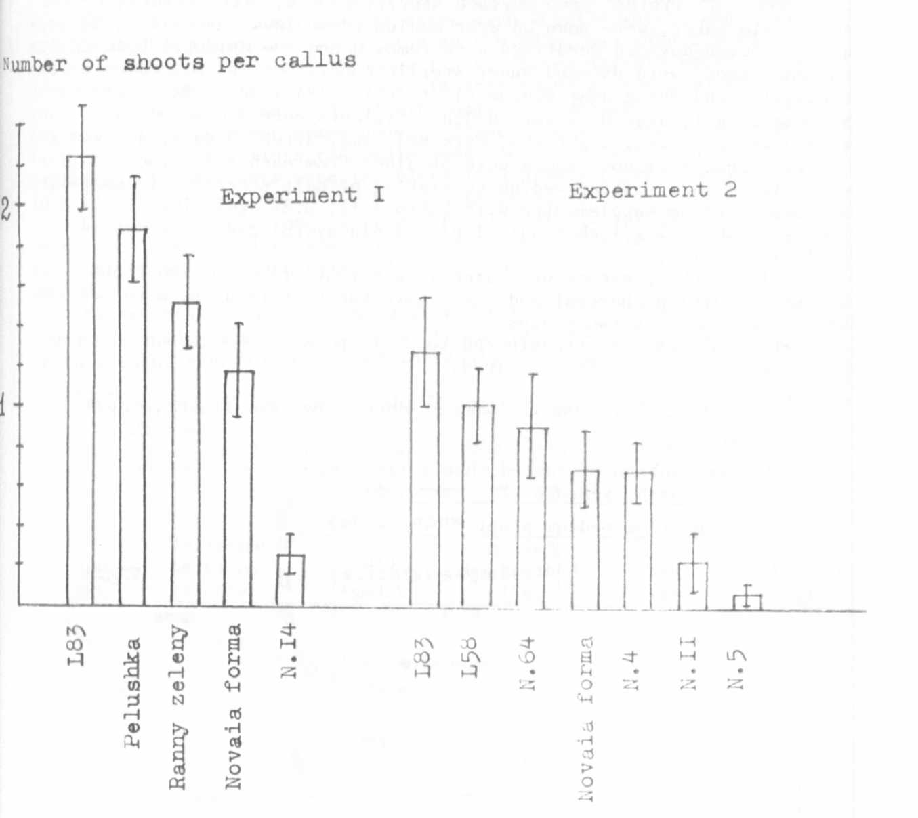
Plant. 30:125-128.
Fig. 1. Average number of shoots per callus for different pea
genotypes (calli derived from apices; experiment 1 was
carried out in September, experiment 2 in February).
L83 - line of Prof. R. Lamm (T3-5 )
L58 - line of Prof. H. Lamprecht (T4-5)
Lines N. 5, 4, 11, 14, 64 - chlorophyll and morphological
mutations from collection of Dept. of Genetics and
Selection (Moscow State Univ.)
Novaia forma - line marked with genes af, i, r, tl
Ranny zeleny-33 - grain pea var.
Peluska Falenskaia - fodder pea var.

