1 PNL Volume 16 1984
STOCKS AVAILABLE

STOCKS AVAILABLE

Swiecicki, W. K. Plant Experiment Station
Wiatrowo, Poland
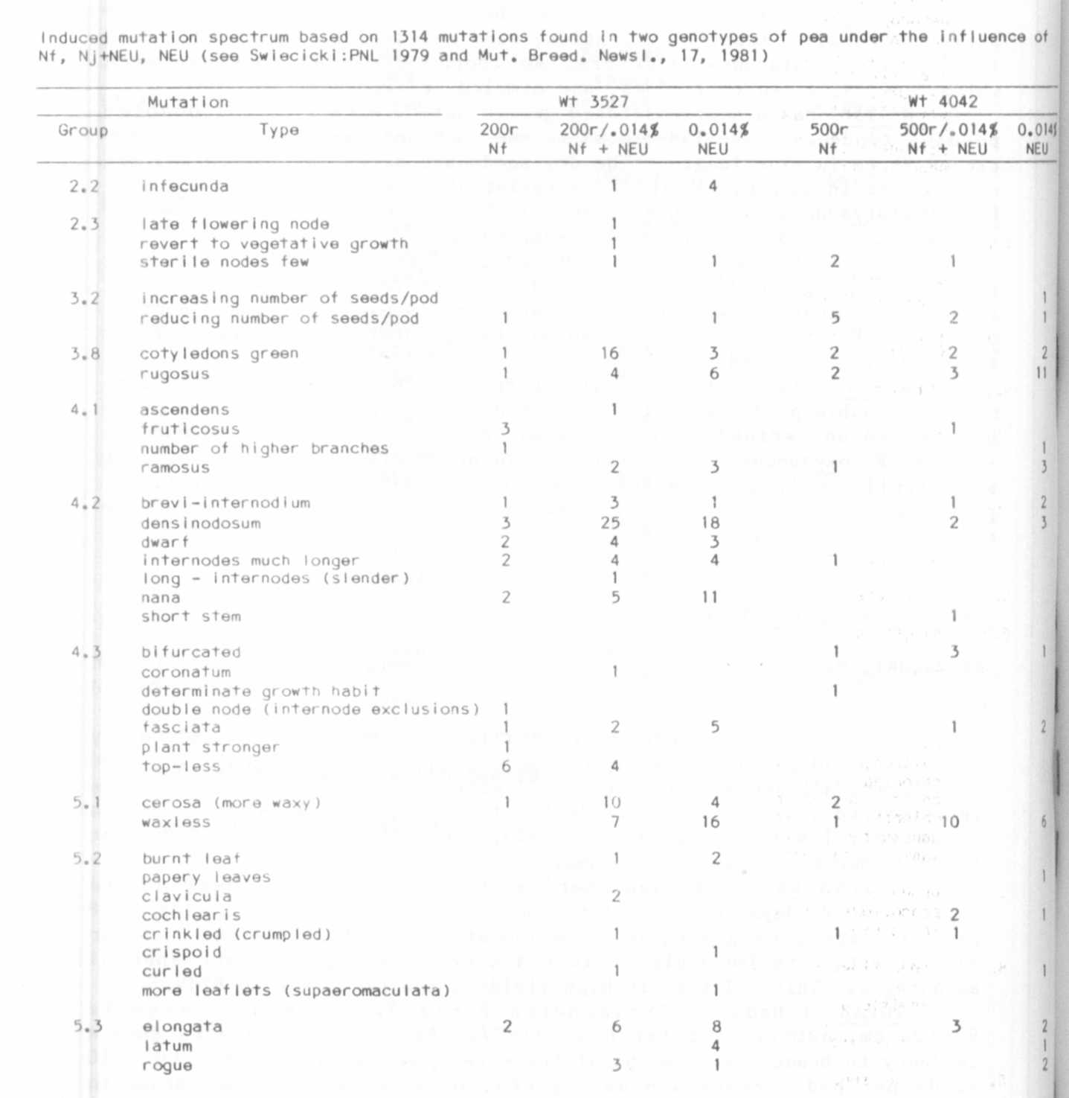

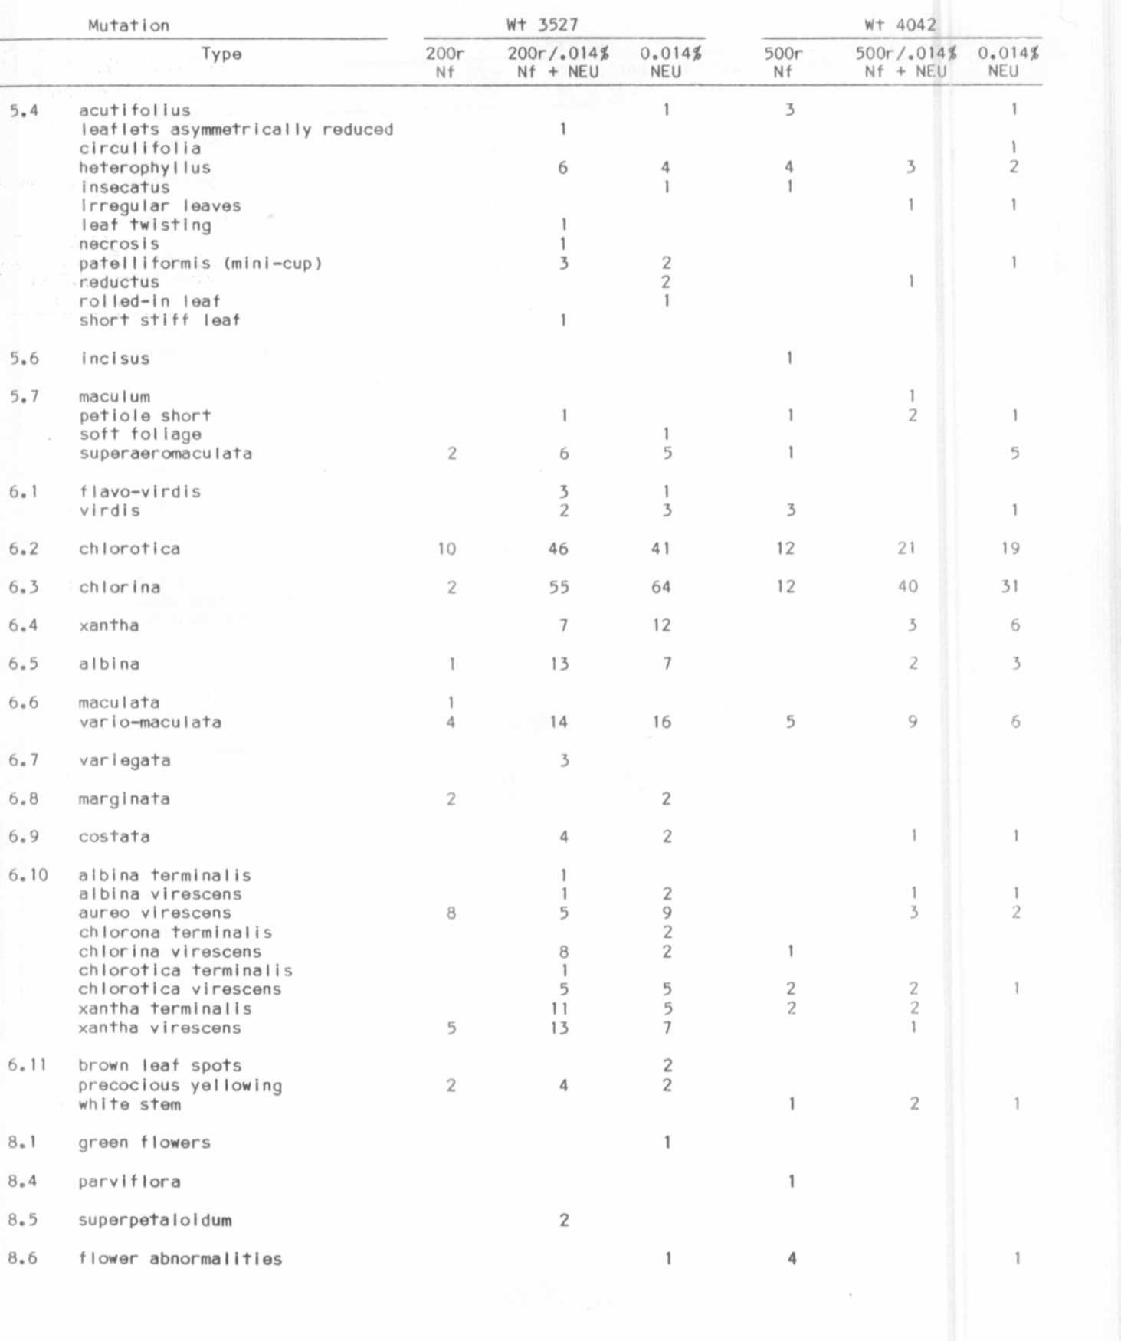
Group
3 PNL Volume 16 1984
STOCKS AVAILABLE

