1 PNL Volume 16 1984
RESEARCH REPORTS

INHERITANCE OF GROWTH RATE AND NODE DEVELOPMENT IN A DIALLEL CROSS OF
PEAS AND CORRELATIONS WITH OTHER TRAITS

Csizmadia, L. Research Station of Vegetable Crops Research Institute
Ujmajor, Hungary

The vigorous early growth of plants is one of the prerequisites of
a high pea yield, inasmuch as vigorous plants are better able to
withstand many of the problems which commonly occur in the Middle
European climate, e.g. drought, heat and leaf weevil. Although environ-
mental and cultural conditions are important factors influencing
seedling establishment, smooth-seeded peas usually show more rapid early
growth than wrinkled-seeded types. There are, however, considerable
differences among the wrinkled-seeded varieties themselves.
To study the inheritance of growth rate and node development in the
first three weeks following emergence, six wrinkled-seeded varieties
('Skinado', 'Green Arrow', 'Jof', 'Puget', 'Wav. 18045' and 'Rapid')
and their F1 hybrids ( without reciprocals) were evaluated. Four plants
of each parent or hybrid were grown in a 25-cm container replicated 3
times in a randomized block design. The experiment was carried out in a
growth room under the following conditions: 23/18C day/night tempera-
tures, a 16 hr photoperiod and at least 60% relative humidity. Shoot
extension per week, node development (number of days required for the
full development of a node), plant height at flowering, days to first
flower, and first flowering node were determined. The statistical
analysis of data was done by Griffing's Method 2, Mode] 11.
Only the specific combining ability (SCA) variance component was
significant for rate of growth, indicating that non-additive effects are
important for this trait (Table 1). In accordance with the insig-
nificant s²_{g}, the narrow sense heritability value was low. Both GCA and
SCA variance components were significant for node development and they
were nearly of the same magnitude. The narrow sense heritability value
(52.8) suggests that progress in node development could be achieved by
breeding procedures that are able to increase the frequency of those
genes that are primarily additive.
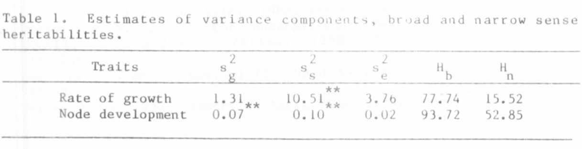

Table 2. Phenotyplc and genotyplc correlations in parental and F1
generations.
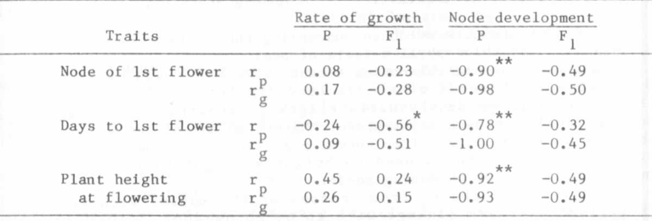
Most of the significant phenotypic correlations (r_{p}) had negative
signs (Table 2). The association was stronger in the parental popula-
tion except rate of growth vs days to first flower. More rapid node
development was associated with late flowering, flowering at higher
nodes and taller plants. The behavior of rate of growth was different:
an increased rate of growth was associated with early flowering. The
associations noted in the rp values were indicated again in the similar
genotypic correlation coefficients (r_{g} ).

