PNL Volume 16 1984
RESEARCH REPORTS

A GENE CODING ISOCITRATE DEHYDROGENASE IS LINKED WITH D ON CHROMOSOME 1

Weeden, N. F. and G. A. Marx NYS Agricultural. Experiment Station
Geneva, NY USA

NADP-speclf1c Isocltrate dehydrogenase (1DH) has been shown to be a
polymorphic enzyme in many plant species. Polymorphism for this enzyme
also occurs in peas, although each line typically exhibits only one of
these forms. Three distinct mobility classes have been observed in the
approximately 200 pea lines we have tested for their IDH phenotype. Two
of these variants, here designated "slow" and "fast", are relatively
common while a third much faster migrating form has been found In only
two lines (John Innes #JI73 and USDA #PI343972).
The genetic bases of the two common variants was investigated in
several F2 populations from the following crosses:
(1) B78-288 x A1078-236
(2) A1078-234 x B777-248
(3) C82-243 x A171-235-(2)
(4) B77-254 x A78-237
IDH phenotypes were determined by starch gel electrophoresis using a N-
3(aminopropy1)-morpholine/cltric acid buffer system at pH 6.1 (1). The
assay mixture consisted of 25 ml 0. 1 M Tris-HCl pH 7.1 containing 1 mM
MnC1₂, 15 mg sodium isocitrate, 5 mg NADP, 4 mg 3 - ( 4 , 5 -
dimethylthlazolyl-2)-2,5-diphenyltetrazolium bromide (MTT), and 0.5 mg
phenozine methosulfate.
Segregation data (Table 1) indicate that the two forms are coded by
distinct alleles at a single locus we designate Idh. The alleles ex-
hibit codomlnant expression; however, the individual bands cannot be
distinguished in the heterozygote but appear as a wide blur. Analysis
of the joint segregation at Idh and D was performed in the first three
crosses, the fourth not exhibiting segregation at D. The tight linkage
observed (Table 2) indicates that Idh is situated on chromosome 1 very
close to D. Some F plants could not be confidently scored for D-d or,
in a few cases, for Idh, and were therefore excluded from the analysis.
Note also that populations 1 and 2 differ from 3 in their cis/trans
relationship.
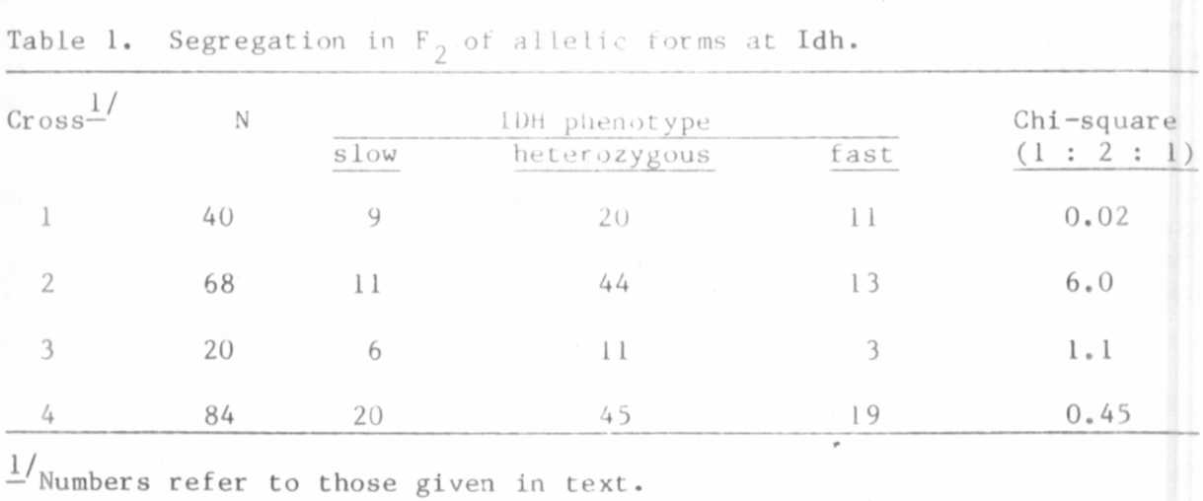

Table 2. Joint segregation of Idh and D. Dominance at D locus indicated by (+)
and recessivity by (-).
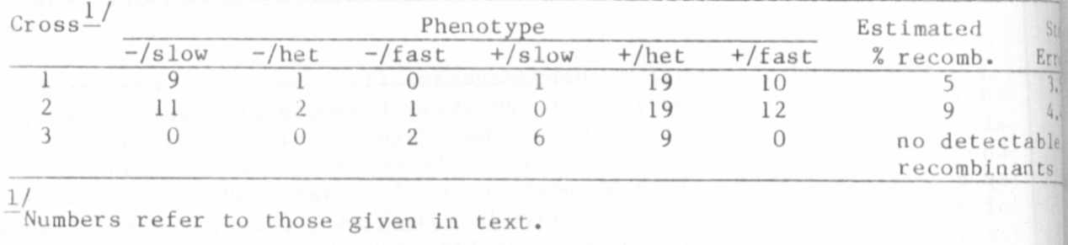
The IDH phenotype may be determined using small tissue samples from
seeds or young seedlings and this advantage together with the codominant
expression of alleles should make Idh an excellent genetic marker for
chromosome 1.

1. Clayton, J. W. and D. N. Tretiak 1972. J. Fish. Res. Bd. Can. 29:
1169-1172.

