PRELIMINARY ROOT STUDIES OF PISUM SATIVUM

Veitenheimer, E. E. and E. T. Gritton Department of Agronomy
University of Wisconsin, Madison, WI USA

In spite of the vital role roots play in the life cycle of a plant,
very little is known about the range of heritable variation for rooting
habit in peas. We therefore undertook a series of studies in an effort
to expand our knowledge of the pea root system.
Various shoot and root characteristics were measured on 42 diverse
genotypes grown in nutrient solution for one month. Freezing and can-
ning cultivars, breeding lines, and 28 uprooting-resistant and root-rot
tolerant lines from G. A. Marx were included. Highly significant
variability for most shoot and root parameters was found (Table 1).
Many significant, positive correlations were found among the shoot and
root parameters. The length of the primary root, length to the last
lateral, average lateral length, root volume, and root fresh and dry
weights were all highly, positively correlated. No correlation was
found between a plant's previously expressed tolerance to root rot
(Aphanomyces euteiches Drechs.) and its root morphology.
In order to identify the proper experimental procedure to use in
future studies, four pea lines were grown in four different culture
media (hydroponics, vermiculite, sand, and a soil/sand mix) and har-
vested at three different growth stages (9th node, flowering, and 28
days after flowering). The growth stage and culture medium had a sig-
nificant effect on entry rankings for various root traits. We
concluded, therefore, that pea root studies that are to have application
to the field should be undertaken using a soil-based medium.
Lines with root systems larger than any previously tested were
identified in greenhouse tests uitilizing soil-filled clay pots. Four
lines were chosen for a field study involving six replications in a
randomized complete block design. Each replication consisted of a nine-
plant grid with plants 15cm apart. At flowering the root system of the
center plants were dug using a core sampler 25cm in diameter and 30cm
deep. Two soil cores per plant were separately soaked overnight, poured
into screenlined boxes, and all the soil and debris were washed away.
Results are shown in Table 2. Relative differences obtained in the
field study were comparable to those obtained in the greenhouse test.
We have begun crossing lines with larger root systems to currently
grown varieties and breeding lines. A generation means analysis should
provide information on relative gene effects and heritability of root
volume and root dry weight. In addition to providing new basic
knowledge about the pea root system, studies such as these could prove
useful in improving water and mineral uptake and increasing tolerance to
root diseases.

2 PNL Volume 16 1984
RESEARCH REPORTS

Table 1. Ranges of root characteristics measured on 42 pea lines grown
in hydroponics for one month.
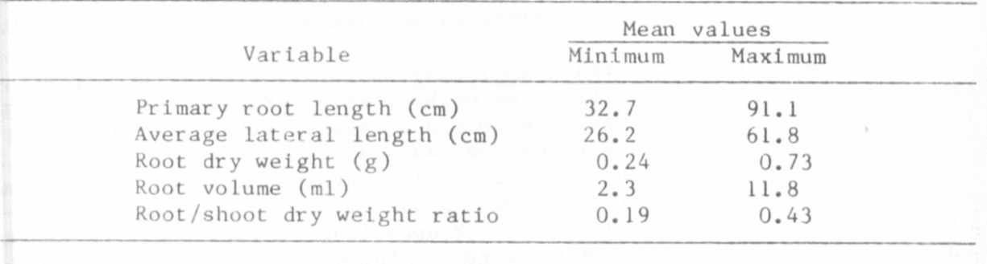

Table 2. Average values for shoot and root characteristics of field-
grown peas sampled at flowering (Arlington, 1982).
