ELECTROPHORETIC EVIDENCE^{1/} OF A SPECIFIC SEED ALBUMIN OF PISUM FULVUM

Przybylska, J., E. Kozubek Institute of Plant Genetics
Polish Academy of Sciences, Poznan, Poland
Blixt, S. Weibullsholm Plant Breeding Institute
Landskrona, Sweden

In previous investigations of electrophoretic (EP) seed albumin
patterns in Pisum, nine such EP-patterns, designated I to IX, were
distinguished. The patterns were formed by different combinations of
several well defined protein bands, designated a - f. Albumins cor-
responding to the characteristic bands, called "specific albumins", were
recovered in the sephadex fraction with MW about 40,000 (the S2
fraction). Only in the case of the Pisum form representing EP III,
i.e., line WL-1490 called P.cinereum, was the characteristic band b not
observed on an electropherogram of the S2 fraction (1, 2, 3).
The recently reported side-by-side slab gel electroophoresis of the
S2 fractions, performed for the Pisum forms representing EP I-V and VII-
IX (Pisum forms with EP VI seem to have no S2 fraction) revealed a
variation in electrophoretic mobility of apparently homologous bands.
Thus, the b band of EP V from P. fulvum WL-1256 migrated faster than the
b band from P. sativum WL-110, representing the commonly occurring EP I.
The band b from line WL-1256 was then called b₁ and the b band from line
WL-110 was designated b₂ The band b from P. sativum VIR 1987 with
EP VII, a pattern found in a number of accessions originating from
Transcaucasia and obtained from VIR, corresponded to band b₂. These
observations raised the question whether or not band b₁ is characteris-
tic of P. fulvum.
In this work five accessions of P. fulvum and 152 accessions repre-
senting other Pisum forms were analyzed. Of these other forms 143
accessions represented P. sativum, five accessions P. elatius and four
accessions P. humile, having b-containing EP patterns EP I and EP VII.

— Cooperative investigation performed under an Agreement between the
Royal Swedish Academy of Sciences and the Polish Academy of Sciences.
The project involves cooperation with Prof. Dr. R. Kh. Makasheva from
N.I. Vavilov All-Union Research Institute of Plant Industry, VIR,
Leningrad, USSR (Agreement between the Ail-Union Academy of Agricultural
Sciences of USSR and the Polish Academy of Sciences) and Dr. Ch. Lehmann
from Zentrallnstltut fur Genetlk und Kulturpflanzenforschung of German
Academy of Sciences, Gatersleben, GDR. The study was carried out under
Project MR 11/7, coordinated by the Institute of Plant Physiology of the
Polish Academy of Sciences.

PNL Volume 16 1984
RESEARCH REPORTS

The material analyzed was obtained mainly from the Pisum Gene Bank at
Weibullsholm and from N. I. Vavilov All-Union Research Institute of
Plant Industry, VIR, Leningrad (2, 3). For every Pisum accession one
seed (the cotyledons) was analyzed. Crude protein extracts with large
proportions of albumins were subjected to electrophoresis on slab gels
as described in a previous paper (3).
The results indicated that of the Pisum accession examined only
Pisum fulvum accessions have the b₁ band while the other accessions have
band b₂. The b₁ band was observed in four P. fulvum accessions having
the EP V characteristics of the taxon and also in one P. fulvum acces-
sion having a deviating EP pattern ("Population 1" wild-growing in
Israel). Thus the b₁ band seems verily to be characteristic of
P. fulvum. Fig. 1 shows the electrophoretic patterns of the Pisum
fulvum accessions and of some accessions representing other taxa.

1. Jakubek, M. and J. Przybylska. 1979. Genetica Polonica 20:369-
380.
2. Przybylska, J., S. Blixt, J. Hurich, and Z. Zimniak-Przybylska.
1977. Genetica Polonica 18:27-38.
3. Przybylska, J., Z. Zimniak-Przybylska, E. Kozubek, and S. Blixt.
1984. Genetica Polonica (in press).
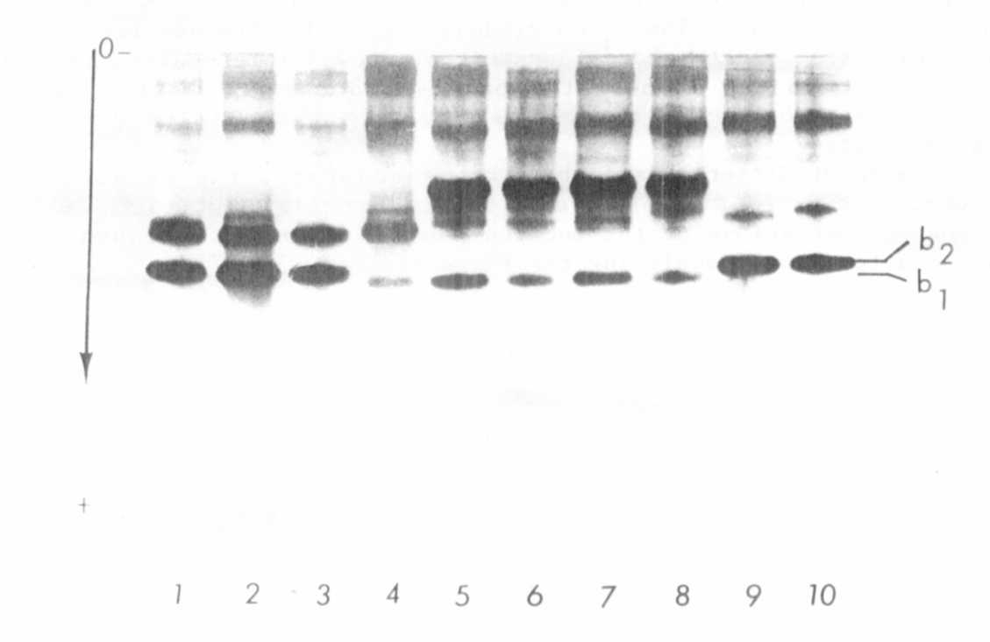
Fig. 1. Slab gel showing that the b band (b₁) in P_. fulvum accessions
(4-8) migrates faster than the b band (b₂) in other Pisum taxa (1-3,
9-10). The patterns shown were produced by the following accessions:
(1) - WL-110, P. sativum (EP 1); (2) - WL-226, P. elatius (EP I); (3) -
WL-1951, P. sativum (EP I); (4) - P. fulvum population wild-growing in
Israel, obtained from the Hebrew University of Jerusalem and called
"Population 1" (EP deviating); (5) - VIR 3397, P. fulvum (EP V); (6) -
Jl 224a, P. fulvum (EP V); (7) - Jl 224b, P. fulvum (EP V);
(8) - WL-1256, P. fulvum (EP V); (9) VIR 1987, P. sativum (EP VII);
(10) - VIR 2381, P. sativum (EP VII).

