ELEVATED ACTIVITIES OF PHOSPHOENOLPYRUVATE CARBOXYLASE (PEPc) IN
DEVELOPING WRINKLED (r/r) COMPARED WITH ROUND (R/R) PEA COTYLEDONS

Price, D. N. and J. B. Taffs Plymouth Polytechnic, Devon, U.K.

PEPc is thought to play an important role in the carbon economy of
developing pea fruits. As part of a wider survey, the activity of this
enzyme was compared in the developing seeds of round (R/R) and wrinkled
(r/r) near-isogenic lines (kindly supplied by Dr. C. L. Ledley, JI
Institute, U.K.). Plants were kept in a controlled environment (16h
day, 17 C) and the extractable PEPc activity of the cotyledons measured
by a coupled NADH oxidation spectrophotometric method (1). These ac-
tivities, together with fresh and dry weight data, are presented in
Pig. I).
Until 28 days after anthesis cotyledonary growth was similar in the
two lines but from day 20-40 there was a greater fresh weight increase
in the r/r line (Fig. la). Reference to dry weights shows this to be
due to the increased water uptake associated with the wrinkled-seeded
phenotype. The PEPc activity of the cotyledons of both lines increased
dramatically with development, generally running ahead of overall weight
increase (Fig. lb). Levels declined between day 30 and 35, but in-
creased again by day 40. This pattern was confirmed with several
repeats. From day 20 onwards PEPc activities were consistently higher
in r/r than R/R cotyledons and this difference was maintained irrespec-
tive of the basis chosen for enzyme expression. From appropriate
ancillary studies, we are sure that this discrepancy is not due to
differences in the intrinsic kinetic properties of the enzymes in the
two lines nor to differential effects of any interfering enzymes.
Relative differences were not dependent on assay conditions and no
evidence of higher levels of enzyme inhibitors in R/R cotyledons could
be found. We therefore conclude that the difference in extractable PEPc
activities is a real expression of the round vs. wrinkled phenotypes.
The relationship between these elevated PEPc activities and oilier
expressions of the r gene is not clear, but could be related to the
reported disturbances in carbohydrate metabolism (2). Because r/r
cotyledons utilize less sugar for starch synthesis, they accumulate more
and it is this sugar accumulation which is thought to be responsible for
their greater water uptake during development. These higher sugar
levels are also likely to support increased respiratory activity.
Higher respiratory rates in developing plant tissues are often as-
sociated with elevated PEPc activity and this could provide the
explanation for the increased activity observed in these r/r cotyledons.

1. Price, D. N. and C. L. Hedley. 1980. Ann. Bot. 45:283-294.
2. Kooistra, E. 1962. Euphytica 11:357-373.

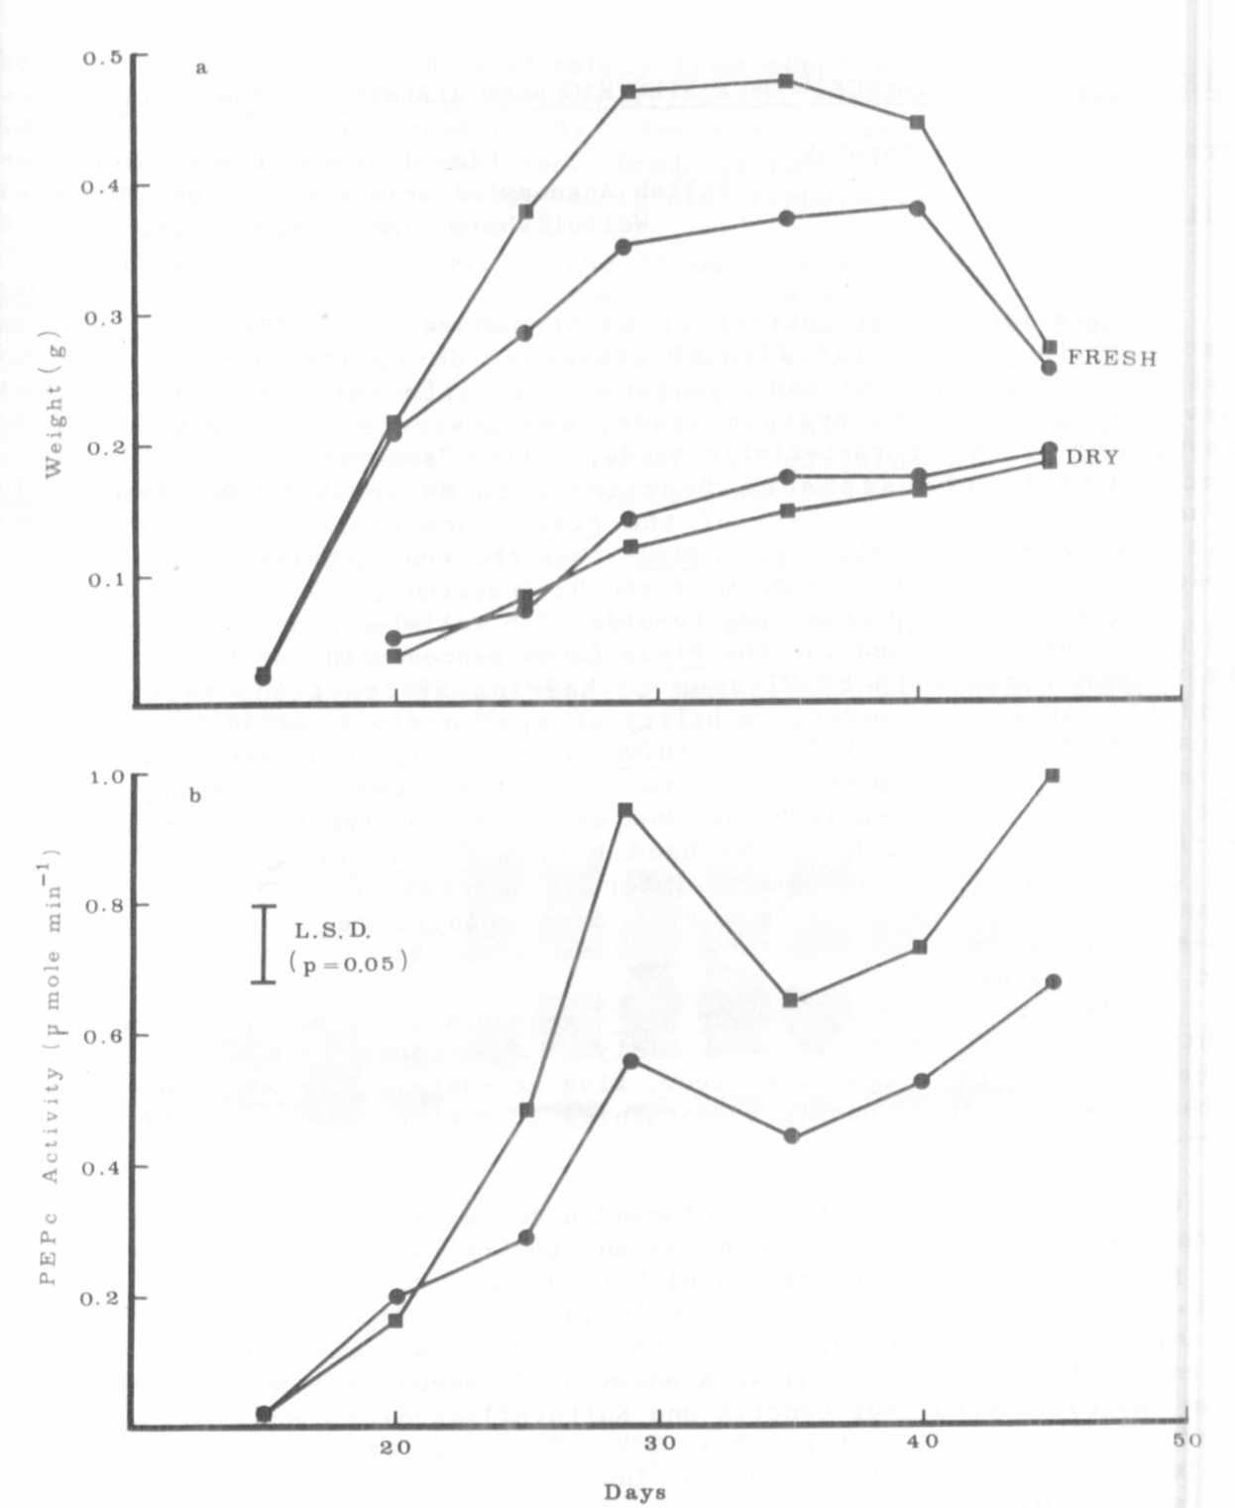
Fig. 1. Changes in (a) the fresh and dry weights and (b) the extractable
PEPc activities (mk moles NADH oxidized min-1) of developing
R/R (•) and r/r (■) cotyledons.

