PNL Volume 16 1984
RESEARCH REPORTS
1

ALLELISM TESTS FOR SOME EARLY FLOWERING MUTANTS

Murfet, I. C. and K. Groom Botany Department, University of Tasmania
Hobart, Tasmania 7001, Australia

We report here on the nature of two early flowering mutants and
their parental lines which were sent for Identification by Dr. W. K.
Swiecicki, Plant Experiment Station, Wiatrowo, Poland.
Six major flowering genes have now been established - Lf, E, Sn,
and Hr (4,6) and two recent additions Veg and Dne. The recessive mutant
veg completely prevents flower initiation regardless of the environmen-
tal conditions or the remaining genotype (1,7). Dne was tentatively
identified (5) from a cross between two early day neutral lines, M218
from Novosibirsk (8,9) and Hobart line 73 (sn). The F1 hybrid behaved
as a late flowering quantitative long day type Indicating that Sn and a
second gene (Dne) acted in a complementary manner to confer a
photoperiod response. This conclusion has now been confirmed and the
dne locus traced to chromosome 3 (King and Murfet, unpub.).
The major genes interact to determine four broad classes of flower-
ing behavior - a day neutral group (class DN) and three photoperiodic
types - an early initiating group (class EI) in which the node of flower
initiation (NFI) is unaffected by photoperiod but the time of first open
flower (FT) is markedly delayed in short days and two late types in
which short days delay both NFI and FT in either a limited quantitative
manner (class K=L) or a very substantial manner (class G=LHR) (2,3,6).
The lines from Wiatrowo and their phenotypes and genotypes as
determined by the use of controlled environment facilities and crossing
with reference lines are shown in Table 1.
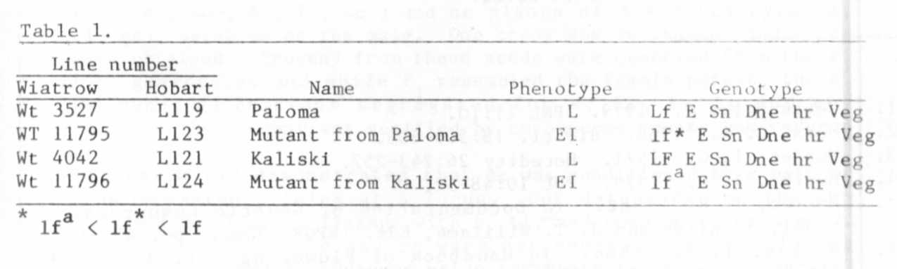
Cultivars 'Kaliski' and 'Paloma' are both typical L class lines.
Their NFI (counting from the first scale leaf as node 1) increased from
around 16 to 17 in a 14 hr photoperiod to around 23 to 30 in an 8 hr
photoperiod (temperature 17° night and 23°C day). The mutant lines are
both typical of class EI; their NFI was not influenced by photoperiod but
FT was delayed in an 8 h photoperiod by around 17 to 22 days as a result
of abortion and slow development of the first flower initials. The
mutant from Kaliski flowered at node 7 or 8 which is typical of a line
with genotype lf . The mutant from Paloma flowered at node 8 or 9 which
is on the early limit for genotype lf. However, it also occasionally
opened two flowers on the one day which is a property characteristic of

:WT-^{C}- ■ I

lfª not lf (6). The above phenotypic information suggests that the
initial lines Kaliski and Paloma have flowering genotype Lf E Sn Dne hr
Veg and that the mutations have been of the type Lf to lfª equivalent and
Lf to an allele intermediate in position between lf and lfª,
respectively. This conclusion was confirmed by the results in Table 2.
Eighteen induced flowering mutants have now been identified by
allelism tests at Hobart (4,5,7) and Novosibirsk (9) - 16 have proved to
be at the lf locus with one each at veg and dne.
The mutant lf allele in Wt 11795 may prove useful in plant breeding
programs for fine tuning the flowering behavior of a cultivar to meet
particular requirements.

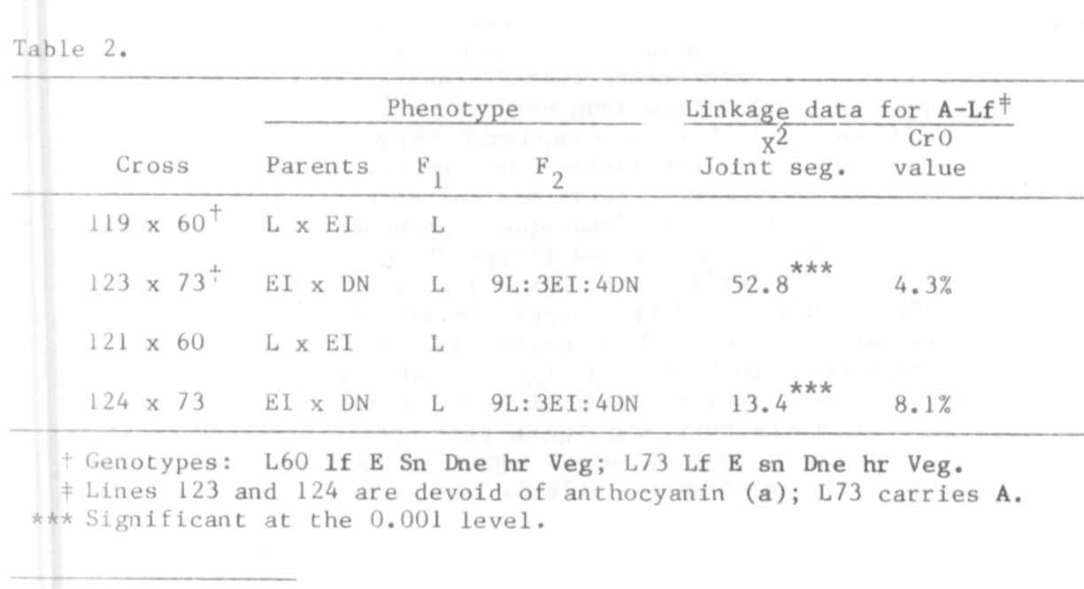

II

1. Gottschalk, W. 1979. PNL 11:10.
2. Marx, G. A. 1968. BioSci. 18:505-506.
3. Murfet, L. C. 1971. Heredity 26:243-257.
4. Murfet, I. C. 1978. PNL 10:48-52.
Murfet, I. E. 1982. In Documentation of Genetic Resources: a
Model, S. Blixt and J. T. Williams, Eds. IBPGR, Rome. pp. 45-51.
6. Murfet, I. C. 1984. In Handbook of Flowering Vol. IV, A. H.
Halevy, Ed., CRC Press, Boca Raton (in press).
7. Reid, J. B. and I. C. Murfet. 1984. Ann. Bot. 53 (in press).
8. Sidorova, K. K. and L. P. Uzhintseva. 1977. PNL 9:51.
9. Uzhintseva, L. P. and K. K. Sidorova. 1979. Genetika 15:1076-1082.

