1. Berry, G. J. and Y. Aitken. 1979. Aust. J. Plant Physiol. 6:573-
587.
2. Gottschalk, W. 1983. PNL 15:24-25.
3. Marx, G. A. 1968. Bioscience 18:505-506.
4. Marx, G. A. 1969. Crop Sci. 9:273-276.
5. Murfet, 1. C. 1971. Heredity 26:243-257.
6. Murfet, I. C. 1975. Heredity 35:85-98.
7. Murfet, I. C. 1977. In_: The Physiology of the Garden Pea, eds.
J. F. Sutcliffe and J. S. Pate. Academic Press, pp. 385-430.
8. Murfet, I. C. i978- PNL 10:48-52.
9. Murfet, 1. C. 1981. PNL 13:40-41.
10. Murfet, I. C. 1984. In: Handbook of Flowering, ed. A. H. Halevy.
CRC Press, Vol. IV (in press).
11. Reid, J. B. 1982. Crop Sci. 22:266-268.

THE RELATIONSHIP BETWEEN THE MUTANT ALLELES AT THE na LOCUS IN LINE
L81 AND WL1766

Murfet, I. C. Botany Department, University of Tasmania
Hobart, Tasmania 7001, Australia

The recessive mutation na (type line WL1766) causes extremely short
internodes and a phenotype known as nana (6). The na locus is on
chromosome 6 (3,7) near wlo (2). The na allele blocks a step early In
the gibberellin biosynthetic pathway and shoots of these nana plants do
not contain detectable levels of C ^-gibberellins (1,4). Two additional
independently isolated mutations have been traced to this locus, one
occurring in a Geneva progeny (2) and the other in a line from Bulgaria
known as Hobart L81 (5). The internodes of L81 are about 75% longer
than those of the nana type line WL1766 (Table 1). Nevertheless, the
phenotype is still regarded as nana since L81 is considerably shorter
than members of the dwarf class. The question arises therefore as to
whether alleles na⁸¹ and na¹⁷⁶⁶ do really differ in their ability to
shorten internode length, i.e. is the length difference between L81 and
WL1/66 due to an allelic difference at the na locus or to a difference
in the remaining genetic background?
Lines 81 and 1766 differ at another chromosome 6 locus, pl, which
shows a recombination value of about 24% with na (2). Thus segregation
for Pl/pl may be used as a moderately effective marker to compare the
action of na⁸¹ and na¹⁷⁶⁶ in a segregating progeny. The results in
Table 1 show no sign of any significant difference in internode length
between the PI- and plpl segregates in either the F2 or F3 of cross 81
(pl) x 1766 (Pl). Indeed, the pl segregates, which should contain an
above random proportion of na^{8l} types, are on average slightly shorter
in both generations. The genetic evidence therefore suggests that
alleles na⁸¹ and na¹⁷⁶⁶ are equivalent and equally effective in short-
ening internode length.

2 PNL Volume 16 1984
RESEARCH REPORTS

Table 1. Stem length between nodes 1 and 9 for parental lines L81 (pl)
and WL1766 (Pl) and Pl- and plpl segregates In the F2 and segregating F3
progenies of cross 81x1 766. The parental data come from plants grown
with the F2.
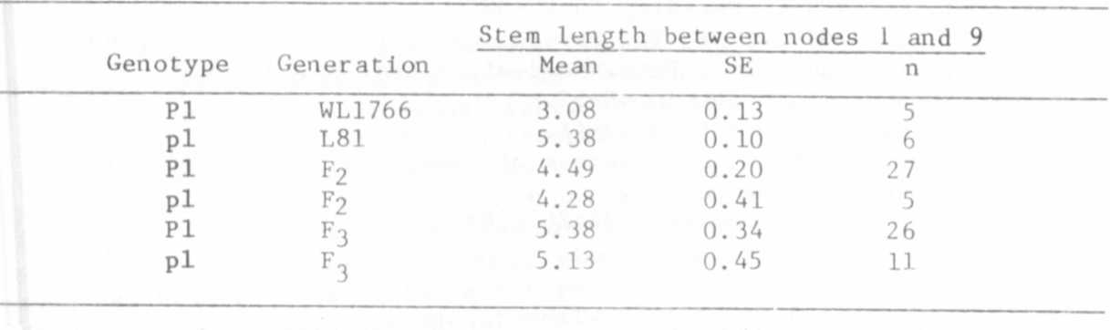
Difference between the genotype means not significant in either F2 or
F3 (t value = 0.43 in each case).

1. Ingram, T. J., J. B. Reid, 1. C. Murfet, P. Gaskin , C. L. Willis,
and J. MacMillan. 1984. Planta 16 J (in press).
2. Marx, G. A. 1981. PNL 13:35-37.
3. Murfet, I. C. 1978. PNL 10:54-55.
4. Potts, W. C. and J. B. Reid. 1983. Physiol. Plant. 57:448-454.
5. Reid, J. B., I. C. Murfet, and W. C. Potts. 1983. J. Ex. Bot.
34:349-364.
6. Wellensiek, S. J. 1969. Z. Pflanzenphysio1. 60:388-402.
7. Wellensiek, S. J. 1971. PNL 3:46.

