INHERITANCE PATTERNS OF SOLUBLE SEED PRO I'EINS AND ESTERASE ISOZYMES IN
PEA SEGREGANTS WITH DIFFERENT COLORED CO I'YLEDONS

Muller, H. P. Institute of Genetics, University of Bonn
lederal Republic of Germany

The purpose of this study was to investigate the mode of
inheritance of some soluble proteins and esterase isozymes in F₂
segregants from a cross between parents having normal yellow vs. orange
cotyledons. Five different F2 color classes were examined: brick,
orange, light orange, dark yellow, yellow. The material was kindly
provided by Dr. W. K. Swiecicki, Poznan, Poland.
Given the limited amounts of seed material available only small
tissue sections of dry cotyledons were used in order to maintain the
viability of the seeds. A quarter of one cotyledon of each genotype was
directly extracted on agarose gel during isoelectric focusing. During
this time (20 min) a physiologically conditioned leakage of seed
proteins occurs which follows the same pattern in all seeds analyzed so
far and which is independent of morphologicai and biochemical dif-
ferences of the seeds. The proteins released from the cotyledonary
tissue are suitable for studying genotypical differences on the basis of
the isoelectric points (IEP) of the respective proteins. The banding
patterns of the proteins are obtained by direct staining of the gels.
They are distinct and reproducible.
The results for the soluble proteins are shown in Fig. 1.
The seed protein phenotypes identified after isoelectric focusing
showed distinct and clear differences between the parental seed
proteins. Therefore, it was possible to follow the inheritance of some
proteins with different IEP's as indicated by the arrows. Some proteins
were expressed fully in the segregants, others only faintly or were even
lacking, as indicated by the staining intensities. Similar results were
obtained with regard to the non-specific esterases, as shown in Fig. 2.
The esterase bands can be appointed to four zones within the
zymograms. Considering the fact that the isozyme technique satisfies
the criteria tor genetic markers better than any other method, the
peculiar mode of esterse segregation is noteworthy. However, further
experimental work is required, mainly with regard to the expression of
the alleles responsible for the isozymes which ranges from full and half
to null expression, as evaluated by their staining intensities.

RESEARCH REPORTS 2
PNL Volume 16 1984

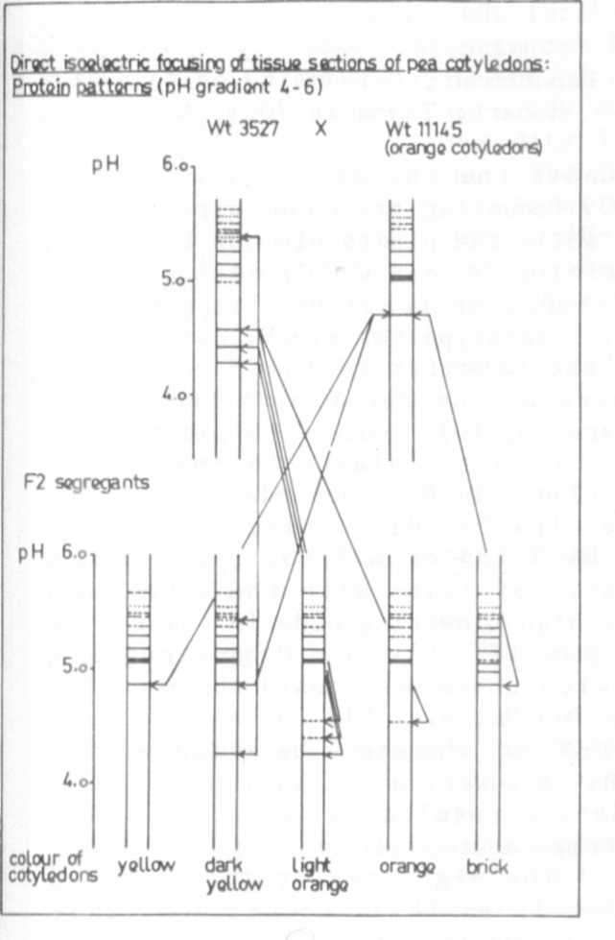
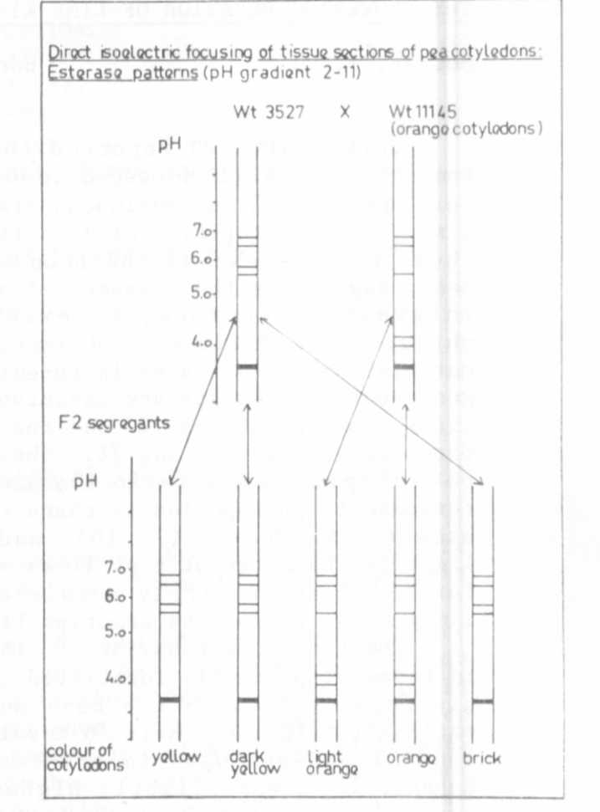

Fig. 1. Protein patterns of parental
seed proteins and their
segregants.
Fig. 2. Esterase patterns of
parental seed proteins
and their F₂ segregants

