LINKAGE RELATIONS OF TENDRILLED ACACIA (tac) AND APULV1NIC
Marx, G. A. NYS Agricultural Experiment Station, Geneva, NY USA

Two excellent seedling markers in peas have been isolated in recent
years. Evidence presented here indicates that both reside in chromo-
some 3.
The first, tendrilled acacia (tac), was described by Sharma
(3,4,5,6). The leaves of tac plants, like those of acacia (tl) plants,
terminate with a fully developed, laminar leaflet. Unlike tl, however,
tac plants have subterminal, tendril-like appendages (Fig. 1). The
mutant behaves as a single recessive but it shows some variability of
expression within the same plant and from plant-to-plant in segregating
populations. Nevertheless, classification of tac in segregating popula-
tions presents little difficulty, especially if scoring is delayed until
6 or 7 nodes have developed on seedling plants.
In 1979, Harvey (2) described a mutant which he provisionally named
apulvinic (Fig. 1). Appearing spontaneously in the cultivar 'Dark
Skinned Perfection', the mutant plants bear leaves in which all foliar
pulvini are replaced with rigid petiolules (2). It, too, is inherited
as a single recessive and can be scored unambiguously in the early
seedling stage. Its phenotype resembles a mutant designated by Blixt
(personal communication) as petiolulatus but apparently the identity
between the two has not been established. Until this matter is settled,
I shall refer to the Harvey mutant as apulvinic, with apu as the
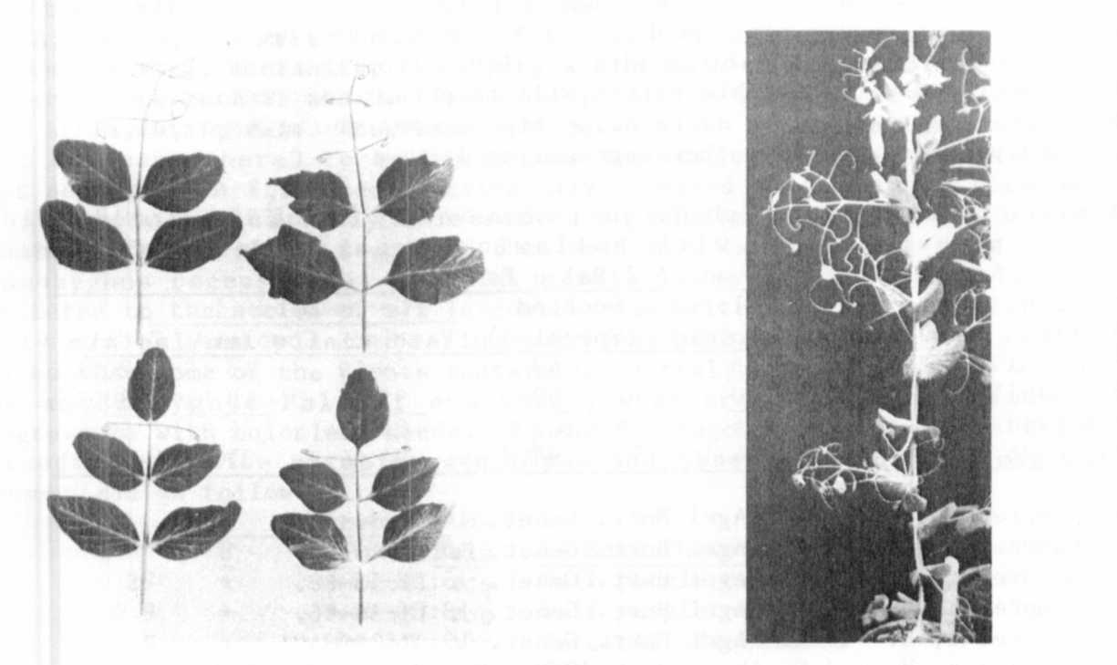
provisional gene symbol.
Fig. 1. Top: (left) Tac Apu Fig. 2. af tac Note small
(right) Tac apu laminar leaflets amid
Bottom: (left) tac Apu otherwise tendrilled leaflets.
(right) tac apu

PNL Volume 16 1984
RESEARCH REPORTS

Both tac and apu were crossed with marker lines in a preliminary
effort to determine their chromosomal location. Table 1 gives single
gene segregation data for tac and for apu in F2's of crosses in which no
linkage was detected. Table 2 shows evidence that both mutants are
situated in chromosome 3, with the following approximate relationship:



It is not certain whether tac and apulvinic lie towards b or towards M
on chromosome 3, but we are in the process of resolving this question.
Sharma and Kumar (7) also tested for linkage between st and tac but
they concluded that their data did not reveal evidence of linkage.

Table 1. Single gene segregation for tac and apu in crosses in which
linked markers were not involved.
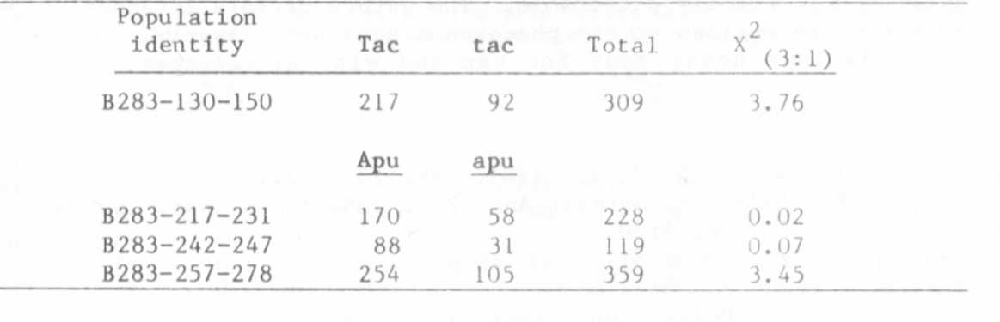

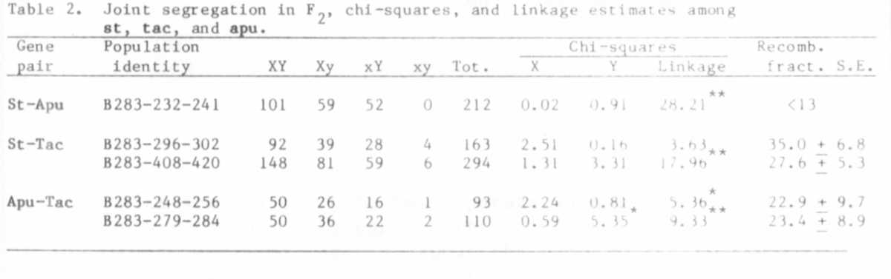

L. G. Cruger has drawn attention (personal communication) to a most
interesting interaction between tac and af. In combination with tac the
af phenotype is modified such that small, irregularly formed leaflets
are produced, apparently without any definite pattern (Fig. 2).
In the course of observing the behavior of tac in various gene
combinations, I encountered one other interaction worth noting. As
already mentioned (1), the normal expression of wlo is masked in com-
bination with af. However, since af tac produce some small laminar
leaf Lets, it might be expected that the upper surface of these leaflets
would be waxless in the presence of wlo, i.e. in af tac wlo plants. But
in fact they do not. Although typical wlo expression occurs in Af tac
wlo plants, both surfaces of the leaflets on af tac wlo plants appear to
be normal waxy (based on visual inspection). Indeed, many af tac plants
display considerable laminar tissue, especially in the nodes bearing the
first true leaf and two or three above. Still, the presence of wlo in
such plants is not readily detectable. The nature of this interaction
is unknown but no exceptions to the phenomenon have been observed among
numerous populations homozygous for tac and wlo but segregating for
Af-af.

1. Hampton, R. 0. and G. A. Marx. 1981. PNL 13:16-17.
1. Harvey, D. M. 1979. Seventieth Ann. Rpt. John Innes Inst. p. 34.
3. Sharma, H. 1972. PNL 4:50.
4. Sharma, B. 1972. PNL 4:51.
5. Sharma, H. 1972. PNL 4:52.
6. Sharma, B. 1981. Pulse Crops News 1. 1( 1):56-57.
7. Sharma, B. and S. Kumar. 1981. Pulse Crops Newsl. 1(3):21-22.

