IN PURSUIT OF pal

Marx, G. A. NYS Agricultural Experiment Station, Geneva, NY USA

Few reports concerning the genetics of seed coat color and pattern
in Pisum have appeared in recent years, perhaps in part because the
complex and seemingly inscrutable inheritance patterns reported in the
past may have discouraged fresh attacks on the problem.
Gene pal (pallens) is one of a number of the so-called "part1y
coloured" — seed genes extensively investigated by Lamprecht (1-6). In
A Z seeds, pal is said to have a "slight and often uncertain" effect
whereas "In A z seeds the effect is distinct" (6). Moreover, in "A z mp
dem cal⁻seed[,] pal causes the entire disappearance of seed-coat
colour", and the seeds appear as if they were borne on a plants. This
implies that, by itself, pal cannot effect a disappearance of seed coil
color but instead requires the simultaneous presence of at least four
additional recessive genes. With this many genes affecting the expres-
sion of the pal, it would seem that most crosses would result in a
confusing array of phenotypes, a situation that might thwart
straightforward Mendelian analysis. If, however, the parental lines of
crosses had several genes in common, then the complexities would be
minimized. Apparently this was the case when Lamprecht used his line
607 (Le A z mp dem Cal Pal str S Wb K) and line 989 (Le A z mp dem pal
Str s wb k), to determine the linkage relations of pal on chromosome 2
(4). Presumably cal was also present in L-989, although Lamprecht doejs
not so state in his 1960 paper.
Murfet (7) described a recessive gene that mapped to chromosome 2
in the vicinity of k and wb. Segregation could be followed in F2 on the
basis that the gene in question diluted the expression of M.
In 1976 I made a series of crosses between WL 578, the type Line
for pal, and a number of my own lines. Blixt lists WL 578 as having the
following genotype: A D^{co}, dem, cal, mp, z, pal, (also pre, ins, td,
gri, wb, k, s, mifo st). My lines carrLed one or more of the following:
U, oh, M, F, or Fs, and one line was f fs. These crosses revealed that
WL 578 evidently is f and fs since the seed of F. plants from crosses in
which the second parent was known to be f fs were unspotted but the d
of F^'s from crosses in which the second parent was F or Fs exhibit tot
typical anthocyanin spots.
Because many of the F₂ plants derived from these crosses exhibited
poor seed set and because the seed color patterns were variable and, at
the time, unfamiliar and difficult to classify, no definite ratios werfe
obtained. Still, a significant portion of the A plants bore seeds which
were colorless or very nearly so, i.e. resembling seeds for a plants.
Selection was practiced among the progenies and eventually a number >i
fully fertile A lines with colorless seed (pal) were available. One of
these, an F _ (A1082-34), was then used in a new cross made in 1982.
1/ _
As Blixt points out in his 1972 monograph (p. 174), these genes would
more appropriately be described as "partly de-coloring".

2 PNL Volume 16 1984
RESEARCH REPORTS

cross made in 1982. The second parent In this cross was an F8 with the
genotype A f Fs (A882-35). Of twenty-five F1 seeds from this cross
planted in the field in 1982, twenty-three produced seed. Most F1
plants were robust and prolific; all were fully fertile. Unexpectedly,
though explicably, all F1 plants produced purple, self-colored seed, a
manifestation of U. The U gene had been introduced in the original
crosses and its expression in line A1082-34 had been masked by pal or by
a combination of genes which includes pal.
A population of 200 F2 plants was grown and scored in the green-
house in the fall of 1982 and additional F2 populations from the same
cross were grown in the field in 1983. Table I summarizes the results.
The seed produced by the individual F2 plants could be placed into five
rather distinct categories: self purple; self pink; spotted; partly de-
colored; and "colorless". The pink seed can be explained by the fact
that the pal parental line also carried b, the pink coloration being
merely an expression of the interaction between U and b. Some of the
seeds In the "colorless" category had a faint trace of color but in
general they readily could be distinguished from those in the partially
de-colored class. In the latter class, while much of the color had
disappeared, the pigment was incompletely inhibited and the background
was somewhat dull in contrast with bright seeds in the colorless class.
The plants with spotted seeds were typical of plants carrying F, Fs or F
Fs, the color of the spots being diluted on the seeds from b segregants.
The simplest interpretation of the results is that the parents of
the cross differed at three loci: U-u, Z-z and Pal-pal. Since A1082-34
was the parent with colorless seed (like a seed), its presumed genotype
is A, Fs, U, z, pal. Completely de-colored seed apparently requires
recessivity at, minimally, two loci, z and pal. This combination is
epistatic to both Fs and U. The genotype of the second parent evidently
was A, Fs, u, Z, Pal. Note that both parents are presumed (on grounds
not discussed here) to be homozygous dominant at Fs and therefore did
not segregate in F2. Seed spotting only appeared to segregate because
this phenotype can only be observed in plants recessive for u and
dominant for Z. It is suggested that both pa u is rrents may have been
homozygous recessive at mp. The partially de-colored class is at-
tributed to the action of z/z in combination with Pal/Pal or Pal/pal,
only z/z pal/pal plants bearing colorless seed. This scheme also im-
plies that some of the plants containing partially de-colored seed would
be heterozygous Pal/pal and would, when progeny tested, produce
segregants with colorless seeds. F3 and F4 progeny tests verified this
expectation. The putative genotypes and observed phenotypes may be
summarized as follows:
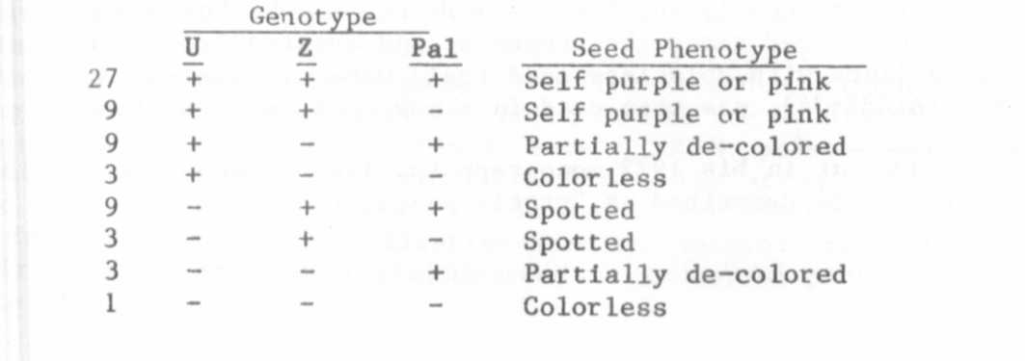

Clearly, this scheme is far less complex than that proposed by
Lamprecht, but it in no way invalidates his extensive analyses.
Applying Lamprecht 'a scheme to the present results would mean that both
parents had certain other genes such as dem and cal in common. It is
difficult to assess the probability of that occurrence. The participa-
tion, if any, of other genes such as ca, cat, den, disp, lob, str and ve
are even more problematical. Nor is it possible accurately to assess
the involvement of complicating factors such as multiple heterozygosity,
modifier genes behaving in a quantitative manner, or environmental
influences. The discussion and illustrations provided by the Tedins (8)
emphasize the variation that can be encountered.
In the present case the distinction between classes was remarkably
clear. The partially de-colored class (resulting from z z) was the only
moderately variable class and even so there was unquestionably a greater
affinity between the partly de-colored and colorless classes than be-
tween the two remaining classes, i.e. self purple or pink and spotted.
Also, whatever the interpretation, the present data show that it is
possible to effect the conversion (in A plants) from self purple to
colorless with segregation at only two Mendelian loci.
Coincidental to these studies segregation occurred for a difference
in axil color. In addition to the normal wild-type axil color as-
sociated with wild-type flowers and to the diluted, pink axil color
associated with b/b, there appeared in these populations plants bearing
wild-type flowers with an axil color similar to that conferred by b/b.
This difference was followed only in the glasshouse populations where it
was observed that of the 134 B/- segregants, 107 had wild-type axil
color and 27 had orangy pink axils. In the remaining 66 b/b plants,
orangy pink axils could not be distinguished from the pink color nor-
mally associated with b. This matter will be pursued further but at the
moment there appears to be no relationship between the orangy pink axil
color and pal, or with any other segregating locus.
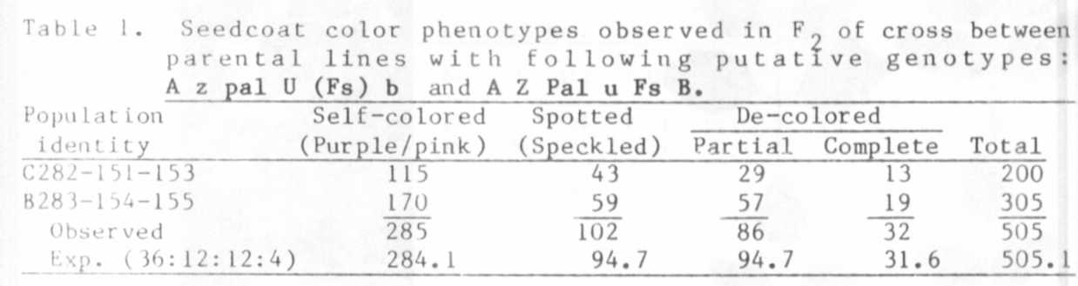
1. Lamprecht, H. 1956. Agrl Hort. Genet. 14:34-44.
2. Lamprecht, H. 1957. Agrl Hort. Genet. 15:48-57.
3. Lamprecht, H. 1957. Agrl Hort. Genet. 15:58-89.
4. Lamprecht, H. 1960. Agrl Hort. Genet. 18:86-96.
5. Lamprecht, H. 1961. Agrl Hort. Genet. 19:360-401.
6. Lamprecht, H. and E. Akerberg. 1939. Hereditas 25:323-348.
7. Murfet, I. C. 1978. PNL 10:53-54.
8. Tedin, H. and 0. Tedin. 1928. Hereditas 11:1-62.

