PROBLEMS OF MUTATION RESEARCH IN AUTOGAMOUS PLANTS WITH LOW RATES OF
CROSS FERTILIZATION

Loennig, W.-E.
Institute of Genetics, University of Bonn
Federal Republic of Germany

Autogamous plants have distinct advantages over allogamous species
for mutation research. However, virtually any incidence of cross fer-
tilization can critically affect the results of studies of the rates and
kinds of spontaneous and induced mutations (including para-, back-, and
suppressor-mutations), research on transposons, and intragenic recom-
bination, etc. The following example illustrates how unwanted cross
pollination may affect the interpretation of such studies.
Table 1 shows the M2 of our recombinant 650 A, which has tendrils
instead of leaflets (gene af, 'afila') and a fasciated stem instead of a
normal one (gene fa). This recombinant was originally chosen to study
back- and/or suppressor-mutations in higher plants. The seeds were
treated with ethylenimine (14 hours in a 0.03% ethylenimine solution).
As a pilot test, 33 M2 families were investigated in 1983. Excluding
family No. 33 (24 seeds were sown, but the exact number of plants grown
from them was not ascertained) the 32 families were composed of 878
plants. Twenty (=2.3%) of the latter bore the dominant alleles Fa
and/or Af. These 20 plants were distributed among 10 (=31.2%) of the 32
families. In the case of back- or suppressor-mutations this would be an
exceptionally high rate. The data are, however, in full agreement with
the rates of cross fertilizations obtained for other pea lines (compare
the preceding research report).
Apart from the cases where marker genes of lines growing in the
same field and at the same time as the M1 could be identified in the M2
(red flower color among others), suppressor mutations could be distin-
guished from cross fertilizations only by a crossing program with the
other genotypes which were grown in the same experimental field. By
recombination, not closely linked supressor gene loci would segregate
from the fa and/or af loci and the original recessive phenotype would be
regained. This method is, however, ineffective in the case of close
linkage between the suppressor locus and the recessive gene and is
useless in the case of true back mutations.
Further problems involved may be shown by the following example:
As no fa plants with afila leaves were In the field together with the
M1, the only explanation for a Fa~af phenotype (one was among them)
would have been a back or suppressor mutation [or impenetrant fa - Ed.].
In the field there were, however, two control groups of R 380, which has
a normal stem and pleiofila Leaves - one group stood adjacent to
R 650 A. Because the pleiofila leaves result from a specific interac-
tion between the two recessive genes af and tl (acacia) and R 650 A has
af and the dominant allele Tl, a cross fertilization between these two
lines would result in plants with afila leaves and normal stems. So at
present none of the plants can be proved to bear a suppressor or back
mutation.

1 PNL Volume 16 1984
RESEARCH REPORTS

Table 1. M2 of the recombinant R 650 A.
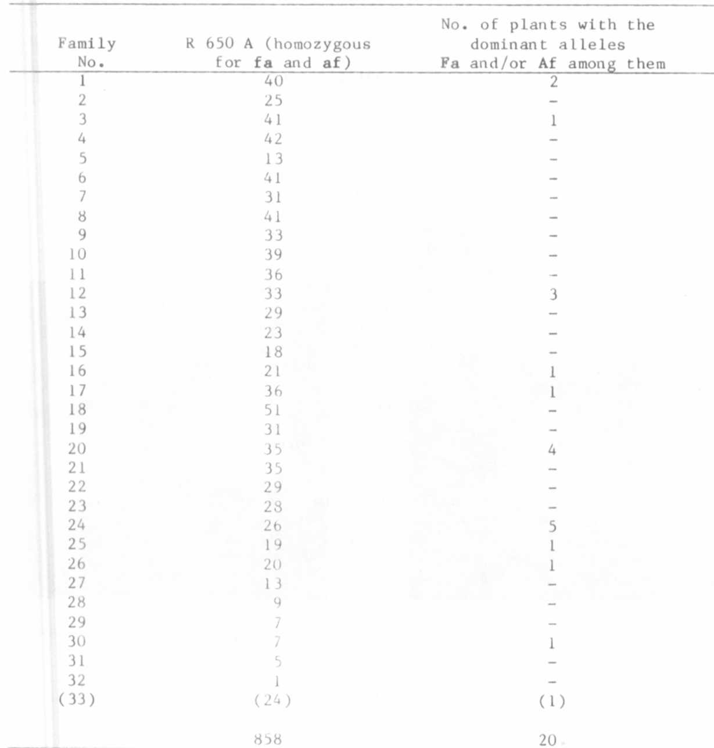
The extent of the whole problem may be Illustrated as follows:
Assuming that 10,000 seeds be treated with a mutagenic agent and 5,000
M1 plants be grown: 1-2% cross fertilizations result in 50 to 100
plants being already heterozygous for different genes without a mutation
having taken place. As nearly one third of all the plants will again
be subject to cross fertilizations, some 1,500 plants could bear one
or more heterozygous seeds, from which a whole array of descendents
could be confused with mutants. To avoid such disturbances, which is
also important for gene localization studies, special precautions may be
required, such as closed greenhouses or isolation plots containing a
single line.

