1 PNL Volume 16 1984
RESEARCH REPORTS

CULT1VAR DIFFERENCES IN SUSCEPTIBILITY TO ASCOCHYTA STEM BLIGHT, ENATION
MOSAIC, AND RED CLOVER VEIN MOSAIC

Baggett, J. R. Oregon State University
Corvallis, Oregon

Commercial pea cultivars and Oregon State University lines were
field tested for resistance to a complex of Ascochyta and
Mycosphaere11a blights (purple stem), pea enation mosaic (PEM), and red
clover vein mosaic (RCVM) at Corvallis and Brooks, Oregon. Two replica-
tions were included at each location. For each disease, a 0-5 scoring
system, with 5 most severe, was used, except that a few 6 scores were
gned to unusually severe infections of purple stem. RCVM scores
were assigned only at Corvallis. Accurate scoring for RCVM is not
possible when PEM symptoms are strong, so the scores assigned for RCVM
are approximations.
Table 1 gives mean scores for 35 commercial cultivars. With few
exceptions, these were clearly either susceptible or resistant to PEM,
but with a range of reactions to purple stem and RCVM. Mean scores are
also shown for 37 lines, mostly resistant to PEM, derived from crosses
of OSL) lines x 'Lowata' for purple stem resistance. These lines were
survivors of one previous field screening.
There was an apparent general correlation between virus infection
and purple stem severity. Table 2 shows correlation coefficients for
various disease combinations for the 35 cultivars shown in Table 1 and
tor the Lowata derived lines. Correlation coefficients were often non-
significant for the latter which received lower scores in general,
especially for PEM. For the commercial cultivars, only the RCVM vs.
Corvallis purple stem correlation was not significant. Some relation-
ship between virus infection and purple stem severity, perhaps involving
predisposition, is suggested by these data.

Table 2. Correlations (r) between virus infection scores and purple
stem scores, Corvallis and Brooks, Oregon, 1983.
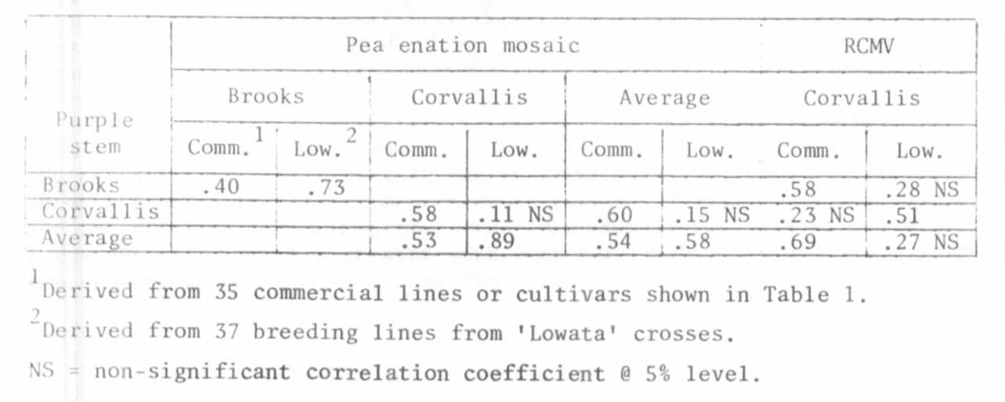

PNL Volume 16 198A
RESEARCH REPORTS
3

