1 PNL Volume 16 1984
RESEARCH REPORTS

CROSS FERTILIZATION IN PEAS UNDER DIFFERENT ECOLOGICAL CONDITIONS

Loennig, W.-E. Institute of Genetics, University of Bonn
Federal Republic of Germany

A simple method to determine the frequency of cross fertilizations
occurring in cultivated peas recently was described (1). The work has
been continued with WL 6040 which has green cotyledons (gene i) and is
linearly fasciated. Table 1 shows ten and Table 2 eleven control groups
of this line on two ecologically different fields (locations I and II).
Location II has a richer insect fauna than location 1. The control
groups were distributed among 20,000 plants with the dominant allele
(gene I, yellow cotyledons) on location I and about 7,000 plants with
this allele on location II.
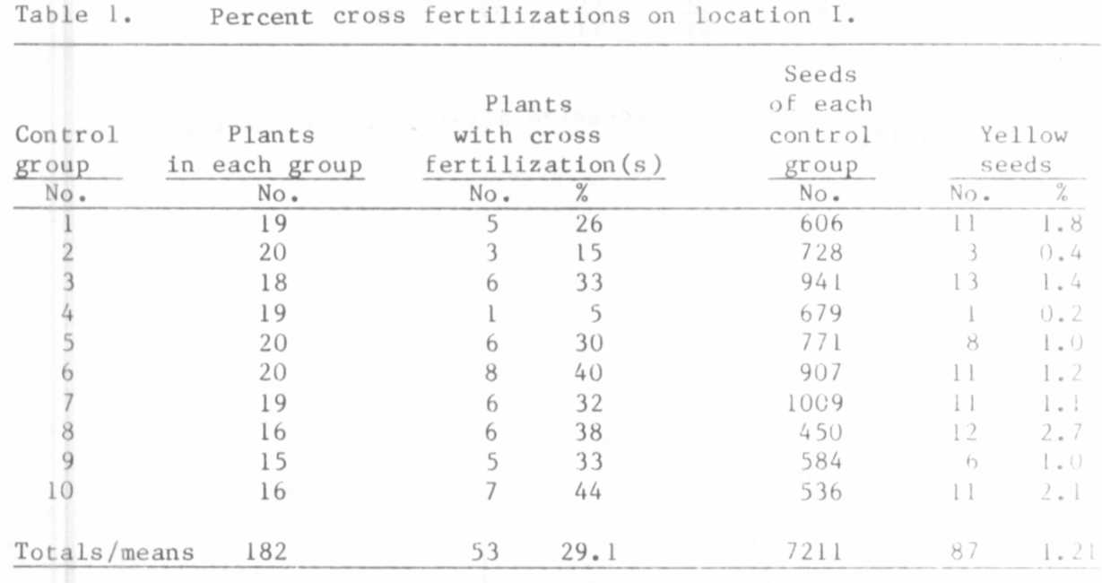
The tables show that nearly one third of all plants bear one or
more cross fertilizations. In comparison with the data from location 1
( = 100%), the number of seeds arising from cross pollinations was 59.13%
higher on location II (non-rounded numbers as basis). Unexpectedly, the
percentage of contaminated plants was only slightly higher on location
II (+ 1.29%). I have not yet found a satisfactory explanation for this.

PNL VoLume 16 1984
3
RESEARCH REPORTS

The percentage of cross fertilizations in the ten most severely
Table 2. Percent cross fertilizations on location II.
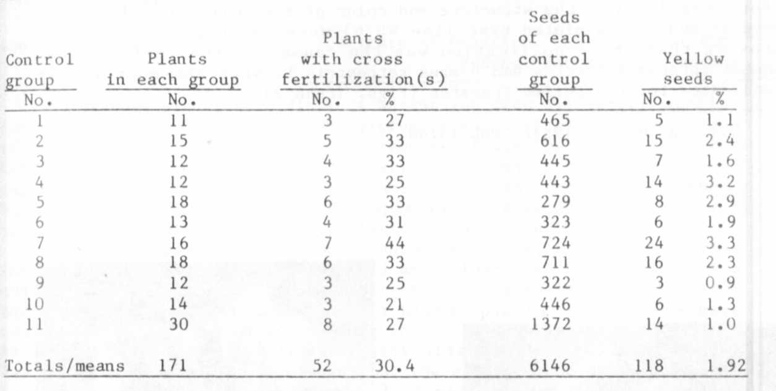
contaminated plants is given in Table 3.

Table 3. Percent cross fertilizations of the 10 most severely
contaminated plants.
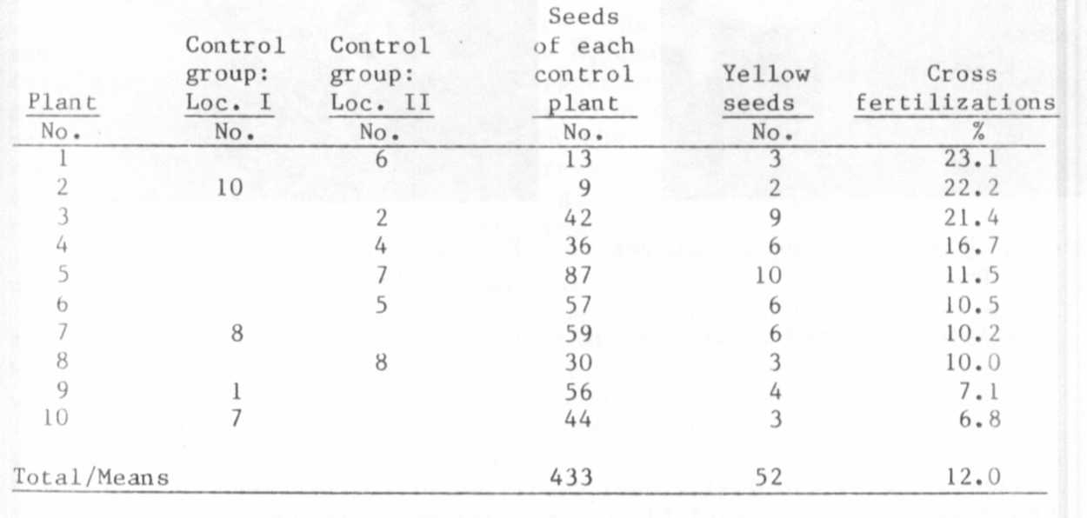
To make sure whether the seeds of the stated cross fertilizations had
really been correctly determined, 54 plants grown from such yellow
seeds were investigated. Of these, 51 plants segregated for yellow and
green cotyledons; the other three plants which did not show segregation
produced 9, 10, and 37 yellow seeds respectively. For the first two a
deficit of the recessives may be the explanation; for the last plant the
problem is open. Nevertheless, all seeds had been correctly determined
as yellow.

Special marker genes of the plants growing around the control groups
(for example, for the structure and color of the seed coats of ecotype
arvense and the fasciated type line WL 6) were identified in the F2
proving that cross-po1lination was the cause for the yellow seeds.
Bombus agrorum Fabricius and Bombus terrestris L. were the most likely
candidates for the pollen transfer (Figs. 1 and 2).

1. Loennig, W.-E. 1983. PNL 15:40.
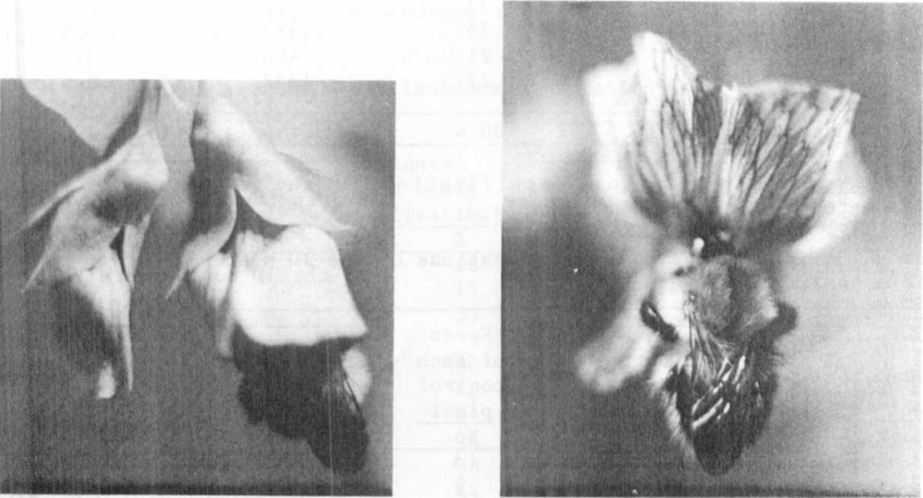

Fig. 1. Bombus agrorum in younger Fig. 2. B. agrorum on older
pea-blossom. blossom.

(Original colored photos converted to black and white.)

