GENES REPORTED TO AFFECT SYMBIOTIC NITROGEN FIXATION BY PEAS

Kneen, B. and T. A. LaRue
Boyce Thompson Institute
Ithaca, NY 14853 USA

Weeden, N.
NYS Agricultural Experiment Station
Geneva, NY 14456 USA

Ptsum sativum has many desirable features which make it suitable
for research in symbiotic nitrogen fixation. Compared to other legume
hosts, peas are genetically and physiologically well characterized.
They are specifically nodulated by their nitrogen-fixlng symbiont
Rhizobium leguminosarum, and some lines exhibit further specificity for
certain strains of the bacteria. There are now nine plant genes repor-
tedly involved in nodulation on peas.
Three genes are reported to condition the number of nodules. Gelln
and Blixt (2) crossed 'Parvus', a line with a relatively high number of
nodules, or "Parvus low", a line with about half the number of nodules,
with the low nodulating line 1127P. The Parvus x 1127P progeny
varied from 0 to >70 nodules per plant on a continuum well beyond the
parental type. With no discrete classes, divisions were made based on
how the data would best fit monogenic or dihybrid genetic ratios. It
was concluded that high nodule number in Parvus was determined by two
recessive gene pairs, nod-1 and nod-2 (= no and nod). Jacobsen and
Feenstra (5) mutagenized 'Rondo' and obtained a mutant with higher than
normal nodule numbers. Unlike the lines described by Gelin and Blixt,
the mutant is highly nodulated even In the presence of 15 mM KNO₃. The
mutant gene is tentatively designated nod-3, although tests for allelism
with nod-1 and nod-2 are yet to be done.
Nodulation is sensitive to environmental factors, but only one per-
tinent gene has been described. Lie (8) found that the wild variety
'Iran' did not nodulate with temperature sensitive strains of R.
leguminosarum at 20C, but a brief exposure to 26C permitted formation of
normal nodules. Lie reported that the temperature dependent nodulation
resistance In Iran is dominant (11); the gene was designated sym-l (4).
The variety 'Afghanistan' (9,10) is representative of a small class
of wild peas with Rhizobium strain specificity (6,16,17). These peas
are nodulated hy some Middle East strains of R. leguminosarum, typified
by strain TOM, but form few or no nodules with strains from temperate
soils. Lie and his coworkers (13) found that R. leguminosarum from
European soils competitively inhibited the formation of nodules by
strain TOM, though the European strains themselves are not infective.
The intectivity of strain TOM is associated with a transmissible plasmid
(1).
Holl (3) crossed Lie's nodulation-resistant Afghanistan with
nodulating 'Trapper'. With commercial inoculant, the F2 segregation fit
a 3:1 ratio, suggesting that non-nodulation is conditioned by homozygous
recessive alleles (sym-2 sym-2). Lie, et al. (11) claimed that nodula-
tion resistance was dominant based on analysis of F2 and backcross
progeny of Afghanistan x Rondo crosses tested with R. leguminosarum
strain PRE in hydroponics. Nodule numbers were both temperature and
strain dependent (11).
Ohlendorf (14) presented evidence for two partially dominant genes,
A and B, controlling nodulation resistance. The two genes were found in
different lines from Afghanistan; it is not known if they are similar to
Lie's Afghanistan line. In both the F1 and F2 generations of crosses
between completely resistant "Afgh I" and occasionally low (<4) nodulat-
ing "Afgh III", approximately 15% of the plants had higher (4-25) nodule
counts than the parental lines. When either line was crossed with
'Bottnia' (35-102), the F. plants varied from 0-30 nodules and F2
populations exhibited a wide and continuous range of nodulation (0-105)
which was attributed to the segregation of a third gene, C, for nodule
number. If the F2 populations are arbitrarily divided into two nodula-
tion classes, <30:>30, the data fit a dihybrid 13:3 ratio. However,
nodulation patterns of F3 progeny of selected F2 plants did not confirm
the existence of all the expected genotypes.
At the Boyce Thompson Institute, reciprocal crosses between an
inbred line of Lie's Afghanistan (which has no, or rarely, a few (<5)
nodules) and 'Sparkle' (20-90 nodules) yield F1 plants with 5-50 nodules
when grown in vermiculite inoculated with R. leguminosarum 128C53.
Nodule number on F1 plants tends to be lower when Afghanistan is the
female parent. F2 populations show continuous variation for nodulation
with 20-27% nonnods, 10-30% 1-9, 25-50% 10-50, and 10-30% >50 nodules.
The segregation for presence versus absence of nodules fit that expected
for two alleles at a single locus (sym-2). How to delineate classes
within the non-parental intermediates is unclear. We hoped to clarify
the segregation ratios by repeatedly backcrossing selected non-
nodulating plants to 'Sparkle' and eliminating variation due to genes
modifying nodule numbers. With rhizobial strain 128C53, Afghanistan x
Sparkle BC4F1 plants all noduled in the Sparkle parental range. BC4F2
populations still included 20-40% non-parental type intermediate
nodulating plants and 5-25% nonnods. Selection against genes for low
nodule number and for strain specific nodulation resistance will require
testing each plant with 2 strains of R. leguminosarum - one infective,
eg. TOM, to select for high number of nodules and one to which
Afghanistan is nodulation resistant, eg. 128C53. Afghanistan x Sparkle
F2 populations scored with R. leguminosarum strain TOM all nodulated
with a range of 10-90 nodules. Testcrosses of F1 plants to both parents
were made. With strain 128C53, 42% of the progeny from F1's x
Afghanistan and reciprocals were nonnod, while the remaining 58% nodu-
lated in the range of the F1's. Backcrossing F1's to Sparkle yielded
nodulating plants with wide variation in nodule number.
We have investigated the genetics of nodulation resistance by
analyzing for linkage between non-nodulation and isozyme loci which
segregated In F2 progeny of Sparkle x Afghanistan and reciprocal crosses
as well as F plants testcrossed to Afghanistan.
A correlation was observed (Table 1) with the isocitrate
dehydrogenase (IDH) phenotype, which is specified by the locus Idh on
chromosome 1 (15). The Afghanistan parent was homozygous for the "fast"
allele at Idh and Sparkle was homozygous for the "slow" allele. Of the
23 F2 individuals resistant to nodulation, 15 were homozygous for the
"fast' allele at Idh. In the testcross progeny, 9 out of 12 nonnodulat-
ing plants were "fast", a significant deviation from random assortment.
No correlation was observed between low nodule number (1-5) and the IDH

PNL Volume 16 1984
3
RESEARCH REPORTS

Holl (3) reported that F₂ seedlings from crosses of Afghanistan and
"fast" phenotype, indicating that the sym-2 gene acts primarily as an
on-off switch for nodulation by temperate strains of R. leguminosarum.
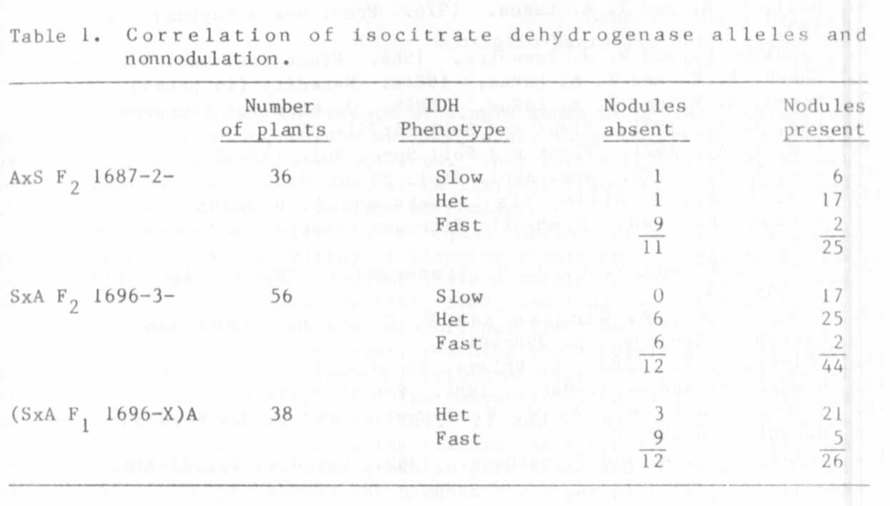
'Trapper' included segregants which nodulated but did not fix nitrogen.
The gene pair conditioning the nonfix character was designated sym-3
8ym-3. Lie (pers. comm., 1983) has discovered another wild pea with
strain specific nodulation (sym-4 sym-4). Afghanistan also has a gene
pair (sym-6 sym-6) conditioning partially ineffective nodules with R.
leguminosarum strain F13 (12).
We have mutagenized Sparkle with EMS and obtained a stable mutant
resistant to nodulation by all rhizobial strains tested, including
strains infective on Afghanistan (7). In crosses between Sparkle and
the mutant, F1 plants nodulate like Sparkle and the F2 progeny segregate
3 nodulated : 1 nodulation resistant (nonnod or <10). Testcrosses of F1
plants to the mutant segregate 1:1. When inoculated with R.
leguminosarum 128C53, Afghanistan x mutant F1 plants are nodulating (10-
50) and F2 progeny include nodulating (>10) recombinants. With the TOM
strain, 25% of the F2 progeny have nodulation resistance inherited from
the mutant line. The differences in strain specificity and genetic data
is evidence that the mutant gene is nonallelic with Afghanistan. This
mutant has been designated sym-5.
Analysis of such pea mutants defective in nodule formation will
help elucidate the role of the host in symbiotic nitrogen fixation.

1. Brewin, N. J., J. E. Beringer and A. W. B. Johnston. 1980. J.
Gen. Microbiol. 120:413-420.
2. Gelin, 0. and S. Blixt. 1964. Agrl Hort. Genet. 22:149-159.
3. Holl, F. B. 1975. Euphytica 24:767-770.
4. Holl, F. B. and T. A. LaRue. 1976. Proc. World Soybean Conf. 156-
163.
5. Jacobsen F. and W. J. Feenstra. 1984. Plant Sci. Let. 33:337-344.
6. Kneen, B. E. and T. A. LaRue. 1984a. Heredity (in press).
7. Kneen, B. E. and T. A. LaRue. 1984b. J. Heredity (in press).
8. Lie, T. A. 1971. Plant and Soil 34:751-752.
9. Lie, T. A. 1971. Plant and Soil Spec. Vol. 117-127.
10. Lie, T. A. 1978. Ann. Appl. Biol. 88:462-465.
II. Lie, T. A., D. Hille, Ris Lambers and A. Houwers. 1976. In:
Nutman, P.S. ed. Symbiotic Nitrogen Fixation in Plants, p. 319-
333.
12. Lie, T. A. and P. C. J. M. Timmermans. 1983. Plant and Soil
75:449-453.
11. Lie, T. A., R. Winarno and P. C. J. M. Timmermans. 1978.
Microbial Ecology. p. 398-401.
14. Ohlendorf, H. 1983. Z. Pflanz. 90:204-221
15. Weeden, N. and G. A. Marx. 1984. PNL 16:75-76.
16. Young, J. P. W., A. W. B. Johnston and N. L. Brewin. 1982.
Heredity 48:197-201.
17. Young, J. P. W. and P. Mathews. 1982. Heredity 48:203-210.

