ISOLATION OF THE SPECIFIC ALBUMINS FROM PISUM SEEDS—

Jakubek, M. Institute of Plant Genetics
Polish Academy of Sciences, Poznan, Poland

An electrophoretic study of seed albumins of various Pisum forms
revealed five distinct banding patterns that differed in the number and
electrophoretic mobility of major bands designated "a"-"f" (1; see
Fig. 1). Proteins corresponding to these bands were called "specific
albumins".
The first attempt to isolate the specific albumins was separation
from the rest of the water soluble proteins by fractionation on a
Sephadex column (2). The separated fraction (fraction S2) was, however,
heterogeneous in most of the Pisum forms analyzed: Its albumin spectra
showed from one to three characteristic bands (2).
The present communication describes a simple fractionation proce-
dure using an ion exchange chromatography technique that resulted in
isolation of some specific pea seed albumins from different lines.
The following lines from the Weibullsholm Collection were
investigated: P. sativum, WL 110 ('Kungsart'); P. humile, WL 936; P.
cinereum, WL 1490; P. abyssinicum, WL 808; and P. fulvum, WL 1 256.
Albumin extracts were obtained from cotyledons of mature seeds with 0.15M
acetate buffer, pH 4.6 (2). Disc electrophoresis was carried out
according to Davis (3). Ion exchange chromatography was performed on
Whatman DE-22 cellulose. A column was equilibrated with 5 mM phosphate,
pH 7.5, and eluted with the same buffer until all unbound proteins were
washed out. Elution was continued with 0.1 M phosphate, pH 7.0 and then
with 0.1 M phosphate containing 0.4 M NaCl, pH 6.0 (4).
Elution profiles of seed albumins of all lines were similar; three
main peaks were obtained. Electrophoretic spectra of the extracts and
chromatographic fractions containing isolated specific albumins are
shown in Fig. 1.
The specific albumins of P. abyssinicum and P. fulvum, correspond-
ing to the bands "e" and "f", appeared in peak 1. At the trailing edge
of this peak the specific albumins of P. sativum, P. humile, and P.
cinereum, corresponding to the band "a", were eluted from the column.
Albumins corresponding to bands "b" in P. sativum and "d" in P. cinereum
were washed out with 0.1 M buffer at the trailing edge of peak 2. In P.
fulvum the albumin corresponding to the band "b" was probably eluted
with the starting buffer, at the trailing edge of peak 1 (data now
shown). This albumin seems to differ from the albumins corresponding to
the band "b" in other Pisum lines (5).
In comparison to Sephadex fractionation, DEAE-cellulose chromatog-
raphy gave better results in three out of five lines studied. The best
result was achieved in P_. sativum; the specific albumins corresponding
to the bands "a" and "b" were clearly separated from each other
(Fig. 1). Similar separation of the major albumins of P_. sativum was
reported by Croy (6).

— This work was supported by the Governmental Project PR-4; it repre-
sents part of a doctor's dissertation (4).
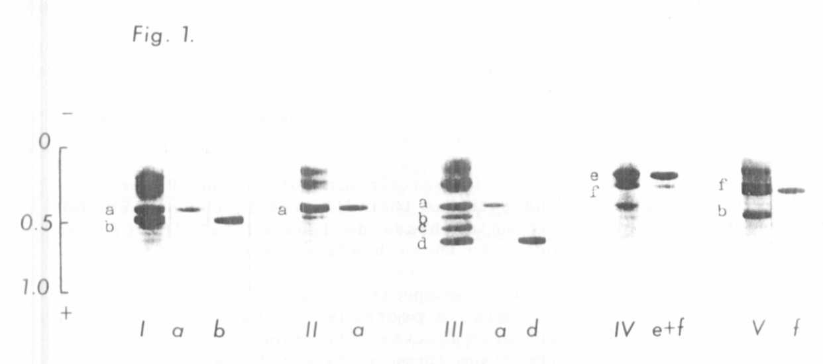
Fig. 1. Electrophoretic spectra of total albumin extracts (Roman
numerals) and the specific albumins (a-f), isolated by DEAE-cellulose
chromatography. The following Pisum lines were studied: I - P. sativum,
WL 110; II - P. humile, WL 936; III - P. cinereum, WL 1490; IV - P.
abyssinicum, WL 808; V - P. fulvum, WL 1256.
The results showed some resemblance between the specific albumins
corresponding to the bands "e" and "f" in P. abyssinicum and P. fulvum
and their distinction from the albumins corresponding to the bands " a" -
"d" in the other three lines. The specific proteins of P. abyssinicum
and P_. fulvum were not retarded by the cellulose and were eluted in peak
1. The specific proteins of P. sativum, P. humile and P. cinereum were
retarded or bound to the resin and were eluted at the trailing edge of
peak 1 or 2.

1. Przybylska J., S. Blixt, J. Hurich, and Z. Zimniak-Przybylska.
1977. Genetlca Polonlca 18:27-38.
2. Jakubek M. and J. Przybylska. 1979. Genetlca Polonlca 20:369-380.
3. Davis B. J. 1964. Ann. New York Acad. Sci. 121:404-427.
4. Jakubek M. 1982. Doctor's thesis completed at the Institute of
Plant Genetics, Polish Academy of Sciences, Poznan.
5. Przybylska, J., Z. Zimn iak-Pr zy by lska, E. Kozubek, and S. Blixt.
1983. Genetica Polonica. (In press).
6. Croy, R. 1984. Biochem. J. 218 (In press).

