PNL Volume 16 1984
RESEARCH REPORTS
1

GENOTYPE-DEPENDENT CALLUS GROWTH IN PEA

Jacobsen, H-J. and A.
A. Salha Institute of Genetics
University of Bonn, Federal Republic of Germany

A study was performed to elucidate the genetic basis of callus
growth in pea. The aim of the study was to select genetic lines with
the ability to produce a quickly growing callus, which later should
serve as starting material for the Initiation of suspension cultures.
Malmberg (1) demonstrated that qualitative in vitro behavior depends
strongly on the genotype investigated, but no correlation between
regeneration ability and morphological characters could be detected. In
the present study, 14 genotypes of pea were tested, including the mother
variety (IL), 4 mutants (423, 1201A, 489C and 251A), and 9 recombinants
(R 177, RM 879, RM 837 , RM 513, RM 836, R 46C, RM 20D, RM 20E, RM 516)
(Table 1).

Table 1. The origin of the recombinants.
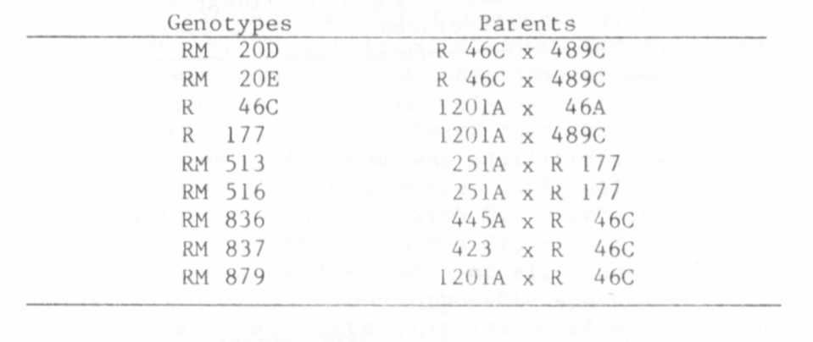
Leaf and epicotyl segments of sterile-grown seedlings (2 weeks old)
were inoculated on MS-medium supplemented with 2.5% sucrose and 1% agar,
with 0.06 mg/1 picloram as auxin and 0.1 mg/1 kinetin. The approximate
weight of leaf segments inoculated was 5 mg, and of the epicotyl seg-
ments 12-15 mg. Callus induction was performed in the dark, and the
weight increase was estimated after 5 weeks prior to inoculating the
tissues on fresh media.
The results are shown Fig. 1. In this figure the genotypes are
grouped according to Increasing callus weight (Fig. la: leaf-segments;
lb: epicotyl segments). Analysis of variance showed highly significant
(0.1%) differences. From the position numbers in Fig. la and lb, by
addition a callus growth index can be estimated, which characterizes the
respective callus weight increase in both tissues from every genotype.
In Table 2, the genotypes are grouped according to their increasing
callus growth index, showing that also with this quantitative trait
there was no clear correlation with a morphological character, although
in the group of slowly growing lines no fasciated genotype occurred.

1. Malmberg, R. L. 1979. PNL 11:21-22.

3 PNL Volume 16 1984
RESEARCH REPORTS

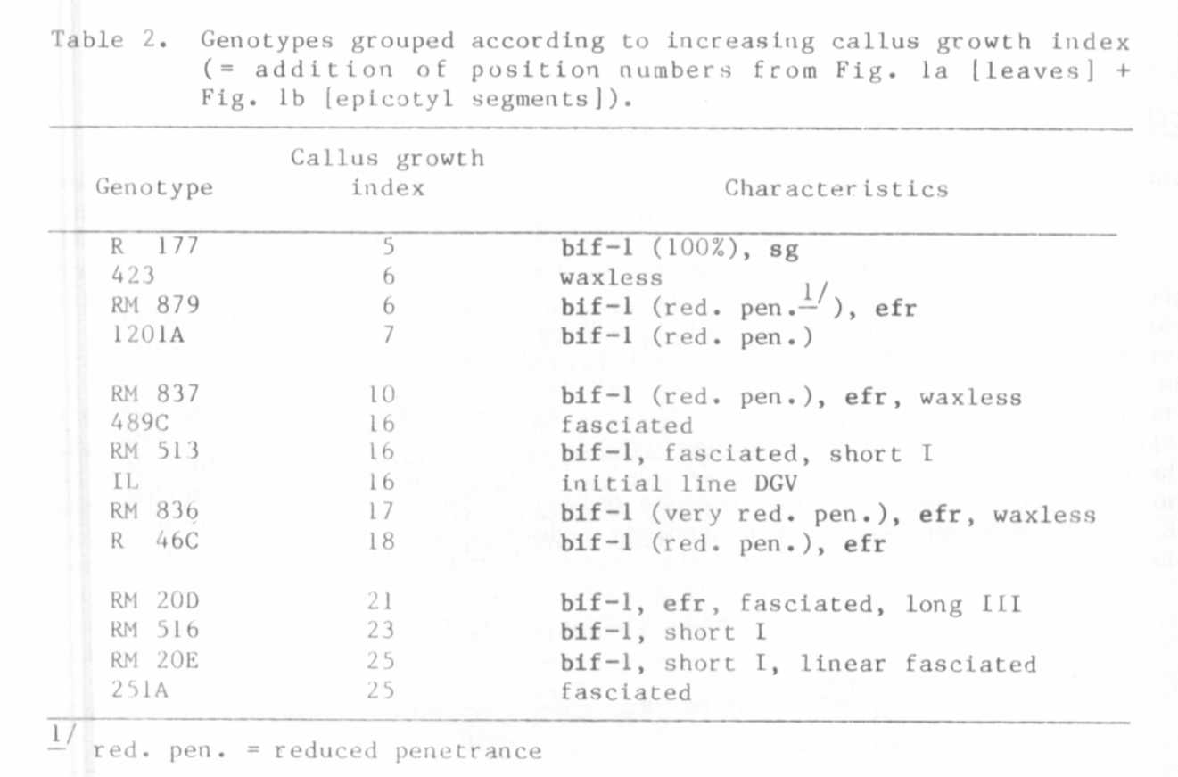
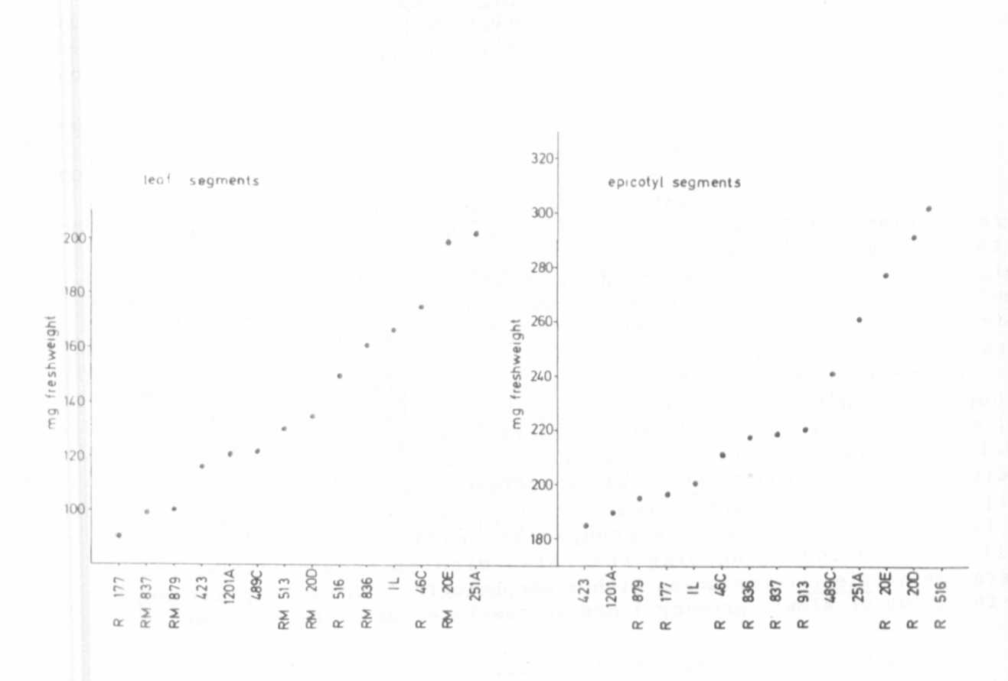

Fig. 1. Fresh weight increase during callus formation of leaf-and
epicotyl segments of 14 genotypes after 5 weeks in culture.

