RESEARCH REPORTS
1984
PNL Volume 16
1

SELECTION OF NODULATION RESISTANT MUTANTS OF PEA

Jacobsen, E.
Dept. of Genetics, University of Groningen
Haren, The Netherlands

Legumes are capable of fixing with nodules containing bacteriods
of Rhizobium, a symbiosis which is affected by several genes of both
partners. Moreover, natural variants and mutants that negatively affect
nodulation and/or N₂ fixation have been found in both partners. In pea,
natural variation with respect to nodulation has been described (1,2)
and recently nodulation resistance has been found in material after
mutagenic treatment (3). In the present contribution, the successful
selection of other nodulation resistant mutants is reported. Selection
of these mutants was carried out in M2 families which had been used
before for the isolation of nitrate reductase deficient mutants (4) and
a mutant, nod-3, highly nodulating in the presence of nitrate (5).
Seeds were germinated in moistened vermiculite, and after one week,
seedlings were transferred to aerated nitrogen-free liquid medium inocu-
lated with Rhizobium leguminosarurn strain PF2. Sixty seedlings were
grown per plastic container, including 10 plants of the parent variety
'Rondo'. The latter were included to verify the effectiveness of the
infection. Eighteen days after sowing, Rondo seedlings were clearly
nodulated. Twenty-eight days after sowing, M₂ seedlings were screened
for nodulation. Plants with well-developed roots but without nodules,
from containers in which all 10 control plants had nodulated well, were
transferred to aerated nitrogen containing liquid medium for seed
multiplication. In all, 20 plants were selected from among 250
families screened. A few of the M3 progenies showed nodulation resis-
tance in all plants tested. Of these, lines and were investigated
more extensively. Nodulation of M3 and M4 plants and of F1 and F2
plants after crossing with Rondo is shown in Table 1. The results
indicate that recessively inherited mutations are involved. These
results support the experiences of LaRue (3; personal communication),
who showed that nodulation resistance can be found in M₂ material in
relatively high frequencies.

Table 1. Nodulation of nodulation resistant lines K5 and K9 in the M3
and M4 generation, and in the F1 and F2 after crossing with Rondo after
inoculation with R. leguminosarum strain PF2.
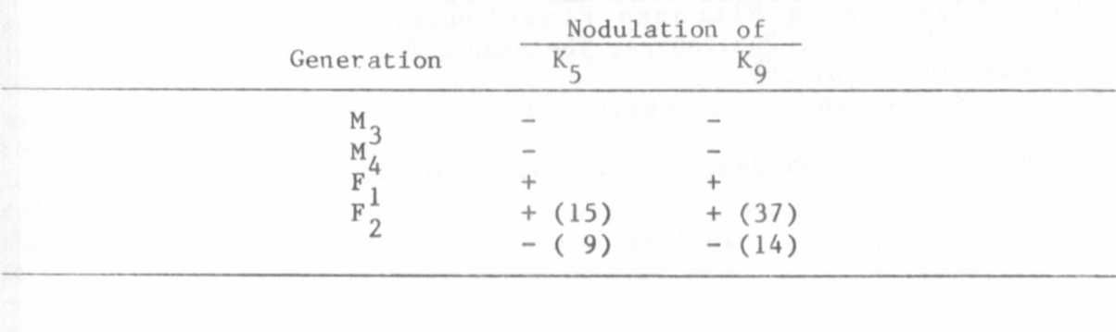

3 PNL Volume 16 1984
RESEARCH REPORTS

Mutants other than those affecting nodulation were also recovered
from these crosses. In the generation of mutant K5 x Rondo, another
recessively inherited character, viz a weak root development, segregated
independently of the nodulation resistance. In the F2 generation of K9.
x Rondo, two other mutations were isolated, viz narrow leaves and
dwarfness.
The nodulation resistance of mutant K5 has been tested for strain
specificity. In Table 2, nodulation results of Rondo, after inoculation
with strains PF2, F13 and Him (kindly supplied by Dr. Lie, Wageningen,
the Netherlands) are given; the data indicate that the nodulation resis-
tance of K5 is not restricted to R. leguminosarum strain PF2 and show
that sometimes nodules appear on the lateral roots of mutant K5. This
observation indicates that this mutation strongly inhibits but does not
preclude nodulation. Preliminary observations on root hairs showed that
after inoculation with Rhizobium root hair curling takes place and
infection threads are present, suggesting that in line K5, the block in
the development of nodules probably occurs after or at a late stage of
the infection process.

Table 2. Nodulation of Rondo and mutant K5 with Rhizobium leguminosarum
strain PF2, F13 or Him.
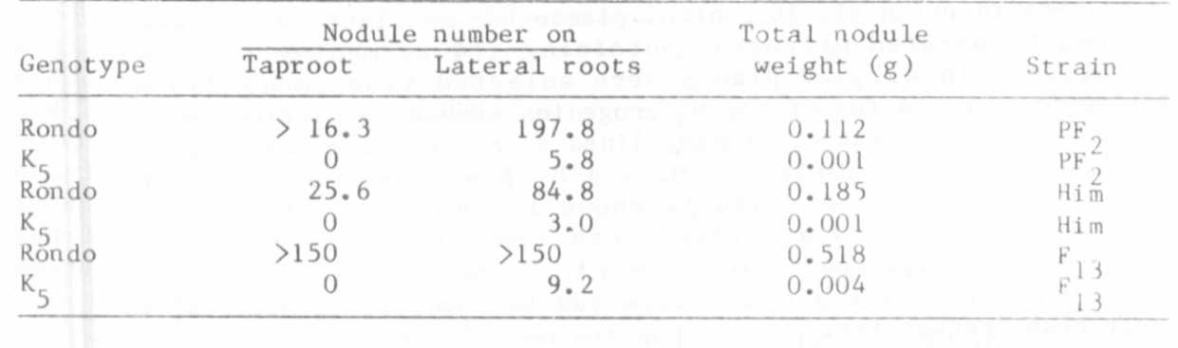
1. Lie, T. A., D. Hille, R. Lambers and A. Houwers. 1975. In:
Nutman, P. S. (ed.) Symbiotic Nitrogen Fixation in Plants. JBP 7
Cambridge University Press, London p. 319-333.
2. Holl, F. B. 1975. Euphytica 24:767-770.
3. Kneen, B. E. , and T. A. LaRue. In_: C. Veeger and W. E. Newton
(eds.). Advances in Nitrogen Fixation Research. Mart inns
Nijhoff/Dr. W. Junk, Publishers, The Hague, Boston, Lancaster and
PUDOC, Wageningen, p. 599.
4. Feenstra, W. J., and E. Jacobsen. 1980. Theor. Appl. Genet.
58:39-42.
5. Jacobsen, E., and H. Nijdam. 1983. PNL 15:31-32.

