PNL Volume 16 1984 RESEARCH REPORTS 1

FURTHER CHARACTERIZATION OF MUTANT nod-3, HIGHLY NODULATING IN THE
PRESENCE OF NITRATE

Jacobsen, E. Dept. of Genetics, University of Groningen
Haren , The Netherlands

In pea, nodulation is strongly inhibited when plants are grown and
inoculated on a nitrogen-containing medium (1). A mutant (nod-3) was
found which is highly nodulating both on nitrate-free and on nitrate-
containing media, whereas acetylene reduction is much higher than that
of parent variety 'Rondo' (2).
The effect of ammonium and nitrate on nodulation and on taproot
length of both genotypes is shown in Table 1. In these experiments,
nodulation of cv Rondo on nitrogen-free medium was relatively high and
the negative effect of nitrate on nodule number and nodule mass was
stronger than that of ammonium. In mutant nod-3, nodulation expressed
in nodule number and nodule mass is also inhibited by nitrate and am-
monium, but to a much lower extent. In contrast with Rondo, nodulation
of nod-3 seems to be affected more by ammonium than by nitrate. It is
clear that mutant nod-3 is highly nodulating on nitrogen-free medium and
in the presence of both nitrate and ammonium.
The taproot length of plants of Rondo is essentially the same in
all experiments (Table 1). Mutant nod-3 had a much shorter taproot
compared with Rondo, and showed differences in length when grown on
ammonium (43.3) than on KC1 or KNO₃ (29.8 cm and 32.2 cm respectively).
Root branching of mutant nod-3 and Rondo was compared after growth of
seedlings without Rhizobium on nitrate-free and on nitrate containing
medium. The number of secondary lateral roots appeared to be much
higher in mutant nod-3 (data not shown). All of these observations
could be an indication that the phytohormone balance in the two
genotypes is different.

Table 1. Nodulation of cv Rondo and mutant nod-3 inoculated with R_.
leguminosarum strain PF„ and cultured on standard mineral solution (SMS)
plus 15 mM KC1, 15 mM KNO₃ or 7.5 mM
(NH₄)₂S0₄-(n=5).
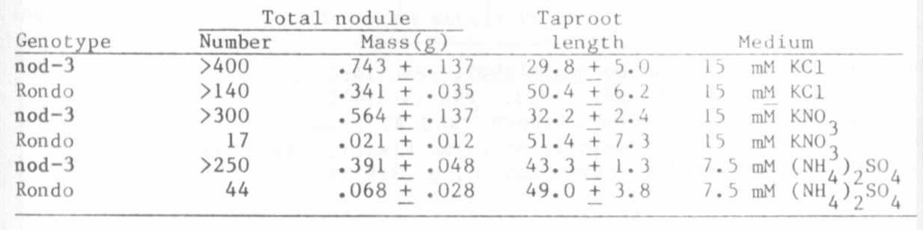

2 PNL Volume 16 1984
RESEARCH REPORTS

Mutant nod-3 was originally selected on nitrate containing medium
ai i er inoculation with R. leguminosarum strain PF2 (2). An important
question is whether the mutant properties of nod-3 are restricted to
strain PF2. Therefore, the mutant and Rondo were inoculated with strain
PRE (W. Europe), TOM (Turkey) and P8 (kindly supplied by Dr. Lie,
Wageningen, the Netherlands). Rondo was nodulated by strain P8, but the
nodules were ineffective (3). Table 2 shows that Rondo was nodulated by
all strains used and that nodulation was always strongly affected by
nitrate. Mutant nod-3 was highly nodulating with all strains on
nitrogen-free medium, whereas the effect of nitrate on nodulation was
comparable with the relatively weak effect found for strain PF2.
Acetylene reduction was measured for Rondo and mutant nod-3 after
nodulation with strain P8. In both genotypes, the nodules appeared to
be ineffective, indicating that strain P8 is acting in the same way in
both genotypes.

Table 2. Nodulation of cv Rondo and mutant nod-3 cultured on nitrogen-
free and on 15 mM KNO₃ containing standard mineral solution
(SMS), inoculated with different strains of Rhizobium.
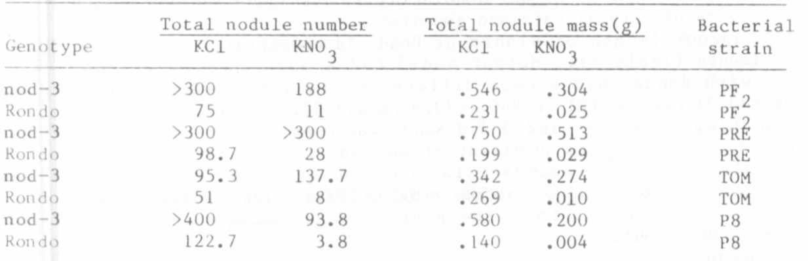
The observations (1) that mutant nod-3 is highly nodulating in the
presence of both nitrate and ammonium, (2) that the mutant characters of
nod-3 are strain independent, and (3) that the taproot length of nod-3
is reduced, are of importance when considering the use of nod-3 in
agriculture and breeding.

1. Jacobsen, E. and I. van Dongen. 1982. PNL 14:23-24.
:. Jacobsen, E. and H. Nijdaai. 1983. PNL 15:31-32.
3. Lie, T. A., D. Hille, R. Lambers, and A. Houwers. 1975. In:
Nutman, P. S. (ed.). Symbiotic Nitrogen Fixation in Plants. JBP
7, Cambridge University Press, London, p. 319-333.

