Recombinant R 20D is homozygous for bif-1, efr and a gene for long
internodes. The plants are tall and repeatedly bifurcated. They begin
flowering very early due to the presence of efr but seed ripening is
considerably delayed. The high yield of this genotype is mainly due to
the completely stabilized penetrance of bif-1 in this combination.
Plants of recombinant R 20E likewise were early and repeatedly bifur-
cated, with full penetrance of bif-1, but their internodes were strongly
shortened. This may be the main reason for their relatively low seed
production.
The opposite effect was noted in recombinant R 836, homozygous for
bif-1 and a gene for waxlessness. In this combination, the penetrance
of gene bif-1 was very low, demonstrating thereby a negative influence
of the gene for waxlessness on the penetrance of bif-1.
Correspondingly, the seed yield of this genotype was lower than that of
mutant 1201A and of the initial line. Some mutant genes, which suppress
the action of bif-1 completely or reduce its penetrance markedly, are
under study.

SDS-ELECTROPHORETIC INVESTIGATION ON SEED ALBUMINS IN PISUM

Grillo, S. and R. Rao Plant Breeding Institute
University of Naples, Portici, Italy

The e lectrophoretic analyses of seed albumins in P isum are of
interest in taxonomic identification (1). In this genus, however,
scanty data are available on variation of albumin subunit molecular
weights.
The seed albumins of three taxa were investigated by SDS-
electrophoresis; six lines of P. abyssinicum, seven of P. fulvum
obtained from John Innes Institute, and one of P. sativum (cultivar
'Proteo') were analyzed.
Albumin extracts were obtained from cotyledons of mature seeds (2)
and .submitted to SDS-polyacrilamide gel electrophoresis on slab gels
with 15% running and 4% staking, according to Laemmli (3).
Two major bands, ranging in the 28 Kd and 18 Kd zones, were always
present (Fig. la and lb). Slight differences were found among P. abys-
sinicum lines, mainly regarding bands falling in the 18 Kd zone. Larger
differences were found among P. fulvum lines, particularly for the bands
ng in the 15-20 Kd area; line JI 1010 (Fig. lb) showed a specific
pattern characterized by the presence of an additional band of molecular
weight around 23 Kd. The P. sativum patterns were less different from
the P. abyssinicum than from the P. fulvum profiles.

1. Przybylska, J., S. Blixt, J. Hurich, and Z. Zimniak-Przybylska.
1977. Genetica Polonica 18:27-38.
2. Grillo, S. and R. Rao. 1982. Ann. Fac. Agraria, University of
Naples Serie IV XVI:l-5.
3. Laemmli, U. K. 1970. Nature 227:680-685.

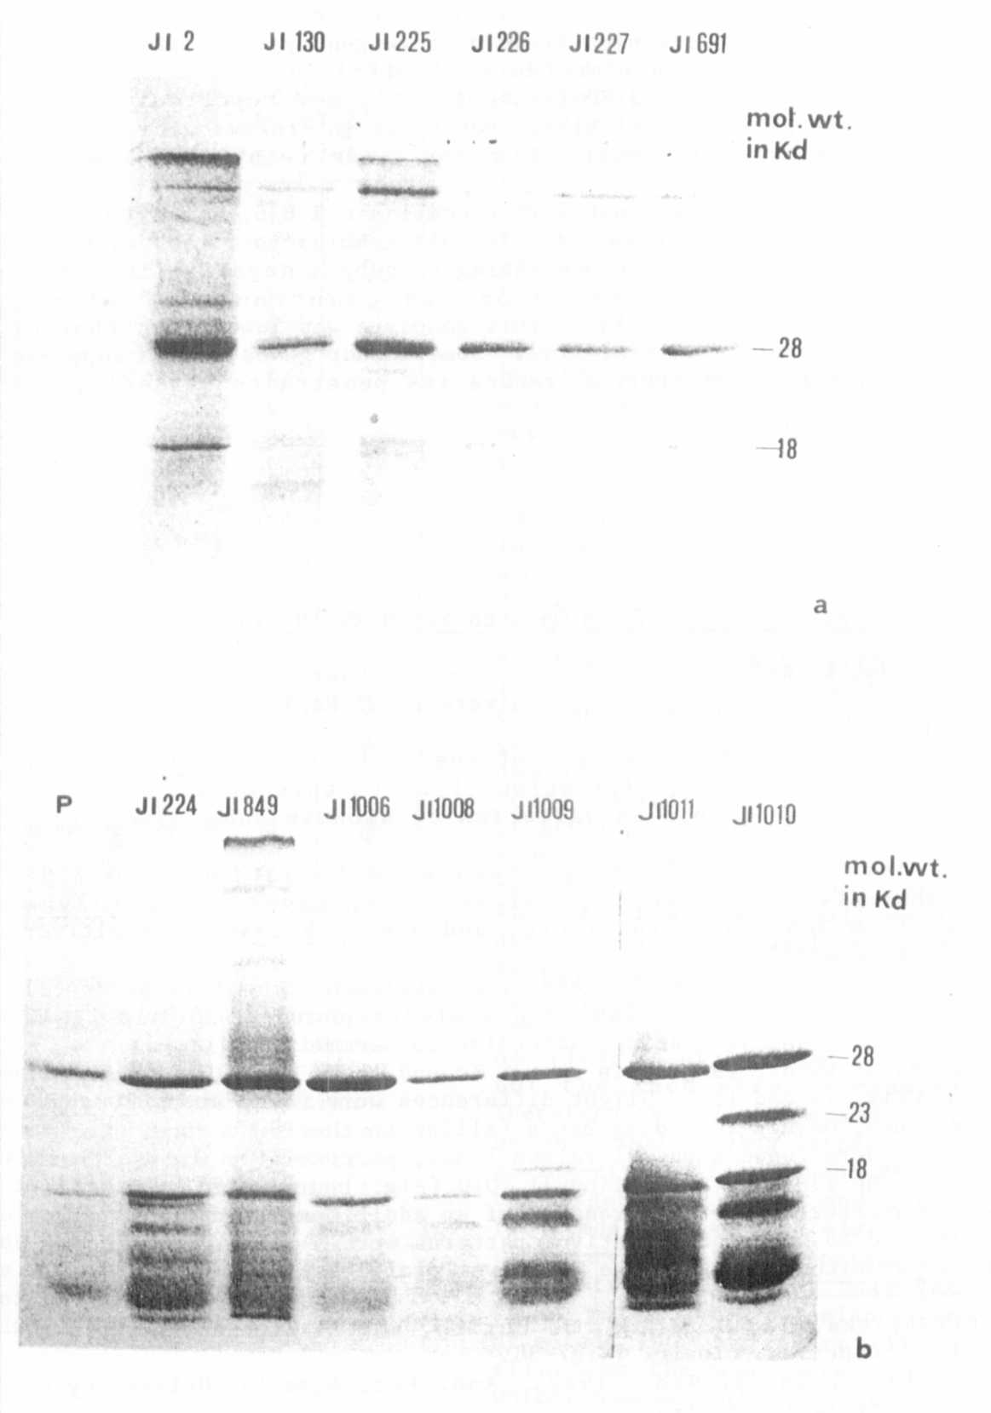
Fig. 1 - SDS-electrophoregram of seed Albumins in P. abyssinicum (a), in
P. sativum (P) and in P. fulvum (b).

