PNL Volume 16 1984
RESEARCH REPORTS
1

PENETRANCE AND SEED PRODUCTION IN PISUM

Gottschalk, W.
and A. Abou-Salha
Institute of Genetics, University of Bonn
Federal Republic of Germany

Two polymeric genes of Pisum, bif-1 and bif-2, are responsible for
altering the monopodial shoot into a dichotomous shoot. The agronomic
value of these genotypes is reduced by the unstable penetrance of the
genes involved. In spite of this disadvantage, mutant 1201A, homozygous
for bif-1, showed higher productivity than its mother variety in most of
the 22 generations tested so far (Fig. 1, lefthand part). Mutant 157A,
homozygous for bif-2, was found to be not as productive as 1201A con-
sidering the mean values of 12 generations. Recombinant R 837 is
homozygous for gene bif-1, gene efr for earliness and a gene for
waxlessness. The seed production of this genotype was relatively low.
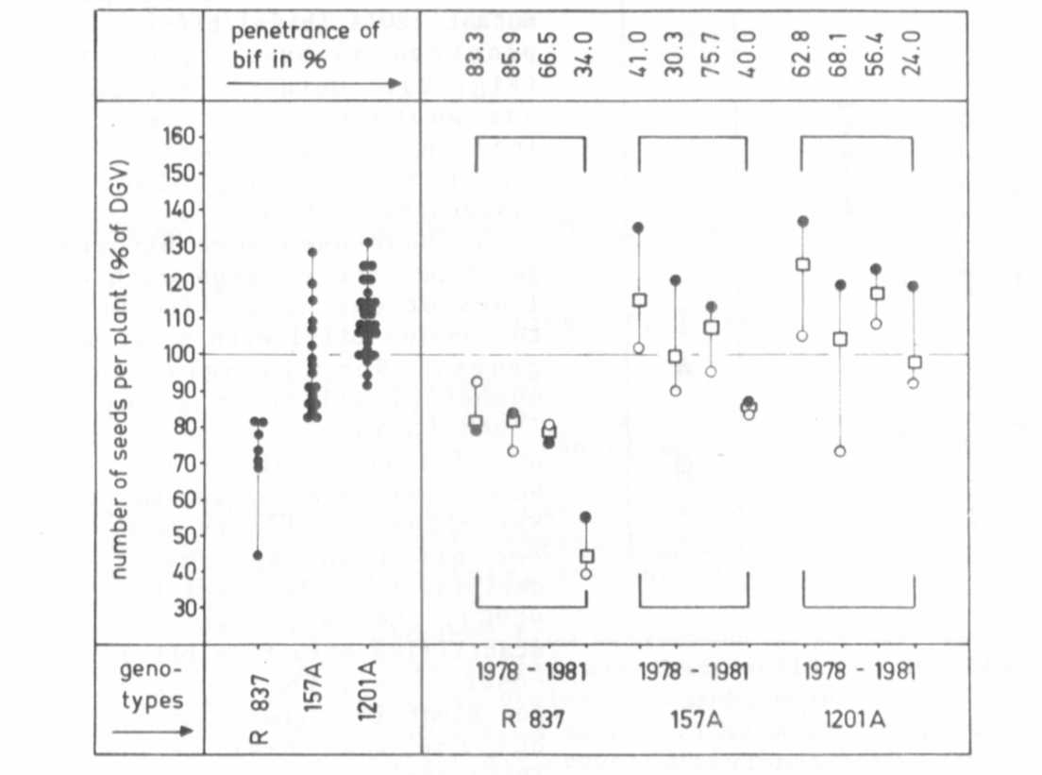
Fig. 1. Relationship between seed production of bifurcated Pisum
genotypes and the penetrance of the bif-gene. Left: The yield
of mutants 157A, 1201A and of recombinant R 837 in different
generations. Each dot is the mean value for one generation.
Right: The yield of the same genotypes in the last 4 gener-
ations in relation to the penetrance of the bif-genes. Solid
circles: Bifurcated plants. Open circles: Entire strains with
bifurcated and non-bifurcated plants.

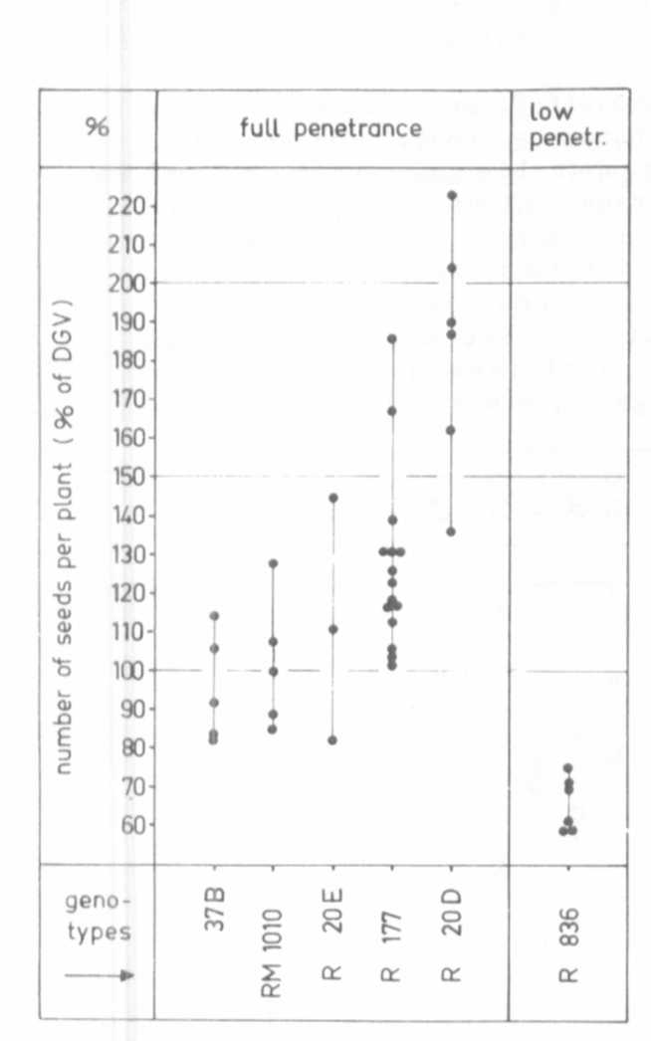
Fig. 2.
Seed production of the bifurcated
mutant 37B and the bifurcated re-
combinants R 20D, R 20E, R 177,
RM 1010 with stablized penetrance
of gene bif-1. Right: Recombinant
R 836 with extremely low penetrance
of bif-1. Each dot represents the
mean value for the trait "number
of seeds per plant" for one genera-
tion as related to the control
value of the mother variety
DVG = 100%.
The penetrance of the two bif-
genes varies from year to year
depending on the climatic
conditions. In the three
genotypes mentioned, a certain
correlation between penetrance and
seed production was observed, the
productivity of the strains
decreasing with decreasing
penetrance (Fig. 1, righthand
part). This, however, did not
hold true for mutant 37B contain-
ing a multiple allele of bif-1.
This allele shows full penetrance,
but the seed production of the
mutant was lower than that of
mutant 1201A (bif-1/bif-l, reduced
penetrance) over 5 generations
(Fig. 2). Mutant 37B evidently
has another mutant gene which
Influences yield negatively but
which has no morphologically
discernible effect.
We have used some bifurcated
genotypes for crosses with other
lines of our collection In order
to combine bif-1 with other mutant
genes. Surprisingly, quite a
number of different genes were
found to influence the penetrance
of bif-1 positively or negatively.
Some examples are given in Fig. 2.
Recombinant R 177 is homozygous
for bif-1 and sg (small seeds,
deriving from the fasciated mutant
489C), the latter gene having a
stabilizing effect on bif-1. As a
consequence, the number of seeds
per plant is higher than In 1201A,
but the seed size is reduced.
Therefore, R 177 was crossed with
mutant 1000 (having larger seeds)
giving rise to recombinant RM 1010
homozygous for bif-1 and a gene
for almost normal seed size. All
the plants of this genotype were
bifurcated. Thus, not only gene
8g of mutant 489C but also a gene
of mutant 1000 had a stabilizing
effect on the penetrance of bif-1
which, however, did not result in
the increased seed production
expected.

Recombinant R 20D is homozygous for bif-1, efr and a gene for long
internodes. The plants are tall and repeatedly bifurcated. They begin
flowering very early due to the presence of efr but seed ripening is
considerably delayed. The high yield of this genotype is mainly due to
the completely stabilized penetrance of bif-1 in this combination.
Plants of recombinant R 20E likewise were early and repeatedly bifur-
cated, with full penetrance of bif-1, but their internodes were strongly
shortened. This may be the main reason for their relatively low seed
production.
The opposite effect was noted in recombinant R 836, homozygous for
bif-1 and a gene for waxlessness. In this combination, the penetrance
of gene bif-1 was very low, demonstrating thereby a negative influence
of the gene for waxlessness on the penetrance of bif-1.
Correspondingly, the seed yield of this genotype was lower than that of
mutant 1201A and of the initial line. Some mutant genes, which suppress
the action of bif-1 completely or reduce its penetrance markedly, are
under study.

SDS-ELECTROPHORETIC INVESTIGATION ON SEED ALBUMINS IN PISUM

Grillo, S. and R. Rao Plant Breeding Institute
University of Naples, Portici, Italy

The e lectrophoretic analyses of seed albumins in P isum are of
interest in taxonomic identification (1). In this genus, however,
scanty data are available on variation of albumin subunit molecular
weights.
The seed albumins of three taxa were investigated by SDS-
electrophoresis; six lines of P. abyssinicum, seven of P. fulvum
obtained from John Innes Institute, and one of P. sativum (cultivar
'Proteo') were analyzed.
Albumin extracts were obtained from cotyledons of mature seeds (2)
and .submitted to SDS-polyacrilamide gel electrophoresis on slab gels
with 15% running and 4% staking, according to Laemmli (3).
Two major bands, ranging in the 28 Kd and 18 Kd zones, were always
present (Fig. la and lb). Slight differences were found among P. abys-
sinicum lines, mainly regarding bands falling in the 18 Kd zone. Larger
differences were found among P. fulvum lines, particularly for the bands
ng in the 15-20 Kd area; line JI 1010 (Fig. lb) showed a specific
pattern characterized by the presence of an additional band of molecular
weight around 23 Kd. The P. sativum patterns were less different from
the P. abyssinicum than from the P. fulvum profiles.

1. Przybylska, J., S. Blixt, J. Hurich, and Z. Zimniak-Przybylska.
1977. Genetica Polonica 18:27-38.
2. Grillo, S. and R. Rao. 1982. Ann. Fac. Agraria, University of
Naples Serie IV XVI:l-5.
3. Laemmli, U. K. 1970. Nature 227:680-685.

