RESEARCH REPORTS IT
PNL Volume 16 1984

IDENTITY AND ALLELISM OF MUTANT GENES

Gottschalk, W. Institute of Genetics, University of Bonn
Federal Republic of Germany

In some cases it is difficult or even impossible to decide reliably
whether two independently arisen mutants are genetically identical or
whether their deviating characters are due to the action of multiple
alleles which do not differ from each other with regard to their in-
fluence on plant morphology. This situation is realized in the X-ray
induced waxless mutants Nos. 423 and 445A of our Pisum collection. They
are morphologically so similar that they cannot be distinguished from
each other. F1's between them are waxless and there is no segregation
in F2. From these findings, it was concluded that the two mutants are
identical and that the same gene has mutated in two different embryos.
This interpretation was found to be wrong. Both these mutants were
crossed with recombinant R 46C homozygous for genes efr (earliness) and
bif-1 (stem bifurcation with reduced penetrance). In the F2 families,
recombinants homozygous for the three genes involved were selected and
developed into pure lines as follows:
- R 46C x 445A R 836
- R 46C x 423 R 837
In both these recombinants, the penetrance of bif-1 was studied over
a period of several years and very clear differences were found, as
shown in the following table:
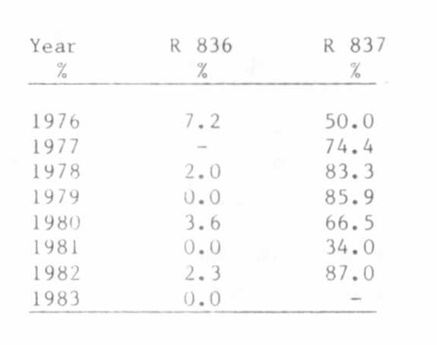
In R 837, the penetrance of gene bif-1 was similar to that of
mutant 1201A, the donor of bif-1, ranging between 34% and 87%. In
R 836, however, the penetrance of bif-1 was extremely low. In the
growing seasons of 1979, 1981, and 1983, the gene was not at all able to
express its action in that particular gene combination.
Thus, the two genes for waxlessness influence the penetrance of
bif-1 in a different way; consequently, they are deemed to be not
identical. I interpret the results of the crosses between mutants 423 x
445A to mean that the same gene has mutated in two embryos, giving rise
to two different alleles. The genes of the two mutants belong to a
series of multiple alleles which should provisionally be designated as
wax⁴²³ and wax⁴⁴⁵. They cause the same kind of waxlessness; therefore,
it is not possible to state the order of dominance within the multiple

series. But they differ from each other with regard to their influence
on the penetrance of bif-1.
- allele wax⁴²³ has no influence on the penetrance of bif-1.
- allele wax⁴⁴⁵ suppresses the action of bif-1 strongly.
This is the first case that the problem "identity or allelism of
mutant genes" has been clarified by using the penetrance phenomenon.

