THE SEED PROTEIN PRODUCTION OF SOME PISUM GENOTYPES

Gottschalk, W. Institute of Genetics, University of Bonn
Federal Republic of Germany

The seed protein production of a crop depends on some yield
criteria, such as number of seeds per plant, seed size and protein
content of the seed meal. Each of these traits is genetically control-
led and highly influenced by environmental factors. Therefore, the
character "seed protein production per plant" may be highly variable for
the same genotype in successive generations.
More than a hundred genotypes of our collection of radiation-
induced Pisum mutants and recombinants were Investigated with regard to
their protein production. So far, only a single gene of our material
was found to increase the protein content of the seed flour considerably
(gene ipc), but the seed production of the respective mutant is so low
that this gene cannot at present be utilized agronomically. The protein
content of the other genotypes tested so far is not significantly higher
than that of the mother variety. Thus, the protein production of our
genotypes can only be increased by increasing seed production. This has
been done preferably by means of two groups of mutants which have a
positive selection value:
- Fasciated mutants having a very high seed production as a
consequence of the apical stem fasciation.
- Bifurcated mutants having two corresponding stems in the upper
part of the shoot thus producing an increased number of pods
per plant.
Of many fasciated genotypes studied, the best 22 for seed protein
production are considered in the lefthand part of Fig. 1. For nine of
them, values of several generations are available; they are listed
separately in the graph. For the remaining 13 genotypes, only one
generation has been evaluated so far. Their mean values are given in a
summarized form under "other recombinants".
The graph shows that for quite a number of fasciated genotypes the
protein production was higher than the control values of the mother
variety. Furthermore, the marked variability of the mean values obtained
for the same genotype in successive generations demonstrates the need
for repeated evaluation over a number of generations. For example,
fasciated mutant 251 (one of the donors of the three or four fasciata
genes present in our fasciated genotypes) we have yield and protein
determinations over 11 generations. The total mean for all generations
tested was 135.5% of the corresponding value of the initial line. This
presumably is attributable to a larger number of pods per plant and only
a small reduction in seed size. In one generation (M17/1980), however,
the number of pods per plant was only slightly increased, whereas the
seed size was strongly reduced in response to the unfavorable climatic
conditions during that particular season. Therefore, the seed protein
production per plant was 35% lower than the control and about 50% lower
than the average of the mutant over all years. All other values ob-
tained were clearly higher than the control values. The recombinants
R 849 and R 665 likewise showed a very high seed protein production, as
did some of the high yielding recombinants, of which only one generation
has been studied so far.

3 PNL Volume 16 1984
RESEARCH REPORTS

A similar situation was observed for group of genotypes showing a
dichotomous stem bifurcation. This trait is controlled by gene bif-1,
deriving from mutant 1201A. The mean values for seed protein per plant
of this mutant were relatively clustered in 11 successive generations,
the total mean being 7% higher than the control value. Some of the
bifurcated recombinants also showed a high protein production.
The favorable mean values of some fasciated and bifurcated recom-
binants are due to an additive effect of high seed production, tallness
and lateness. We currently are attempting to introduce shorter stature
into these lines without reducing their yielding capacity in order to
make them more suitable for cultivation in the field.
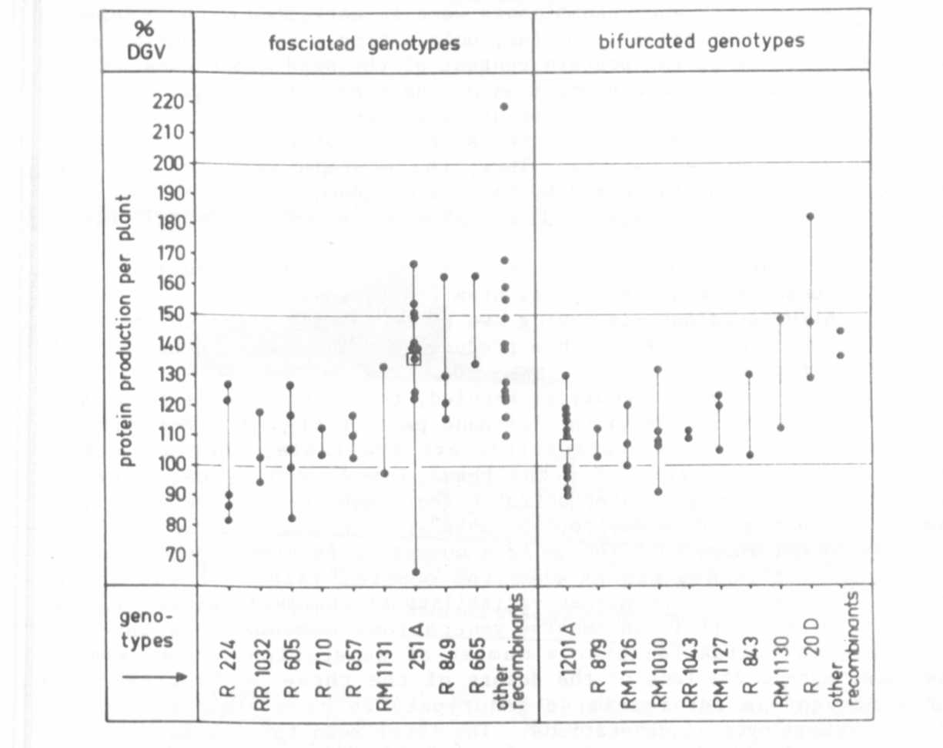
Fig. 1. The seed protein production per plant of 22 fasciated and 11
bifurcated Pisum genotypes as related to the control values of the
mother variety 'Dippes Gelbe Viktoria' (DGV) = 100%. Each dot gives the
mean value for one generation.

