LINKAGE OF TWO CHLOROPHYLL MUTATIONS

Ezhova, T. A. and S. A. Gostimski Moscow State University, USSR

This report presents evidence concerning the linkage relations of
two newly isolated chlorophyll mutants of pea.
Recessive monogenic chlorotlca mutant (line No. 7) was obtained by
EMS treatment of seeds of the variety 'Capital'. The mutant has
yellowish-green leaves in the early stages of growth. Later, mutant
plants gradually became light-green. Mature mutant plants are capable
of bearing seeds and differ from normal plants only by somewhat lighter
apices. However, when exposed to bright sunlight in the field the
plants succumb without producing seeds.
An analysis of the F2from crosses of the mutant with various
marker-lines revealed linkage with gp on chromosome 5 (CrO <15%)
(Table 1).

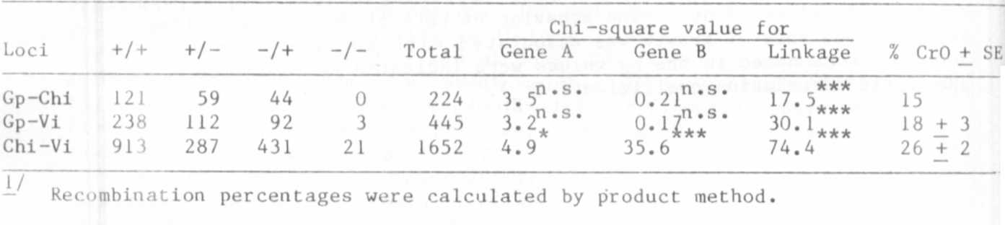
Table 1. F2 segregation and linkage data^{1/} (repulsion) of genes in chromosome 5
Another recessive monogenic virido-aurescens mutant (line No. 23)
was obtained by EI treatment of seeds of 'Nemchinovsky'. The lower
leaves of mutant plants suddenly become yellowish-gold shortly before
flowering. This mutant is only slightly less productive than the con-
trol plant.
An analysis of F2's from crosses of the mutant with translocation
tester lines and with marker lines revealed linkage on chromosome 5.
The calculated percent recombination with Gp gene was 18 +_ 3%.
Crosses between the two mutants revealed a linkage of 25.5 + 2%.
This figure should, however, be considered as approximate, because in
this segregation a deficit of virido-aurescens mutants was observed.
The results suggest that the mutants are situated in
1. Blixt, S. 1978. Agri Hort. Gen. 36:23-47.
2. Marx, G. A. 1971. PNL 3:20-21.
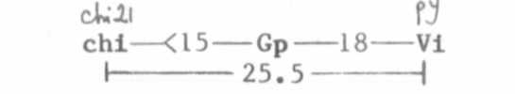
chromosome 5 in the following order:
According to the published list of descriptions of mutants local-
ized in chromosome 5, the chlorotica mutant resembles chi 21 mutant (1),
while virido-aurescens mutant resembles py mutant (2). It is therefore
posslbile that these are mutations of genes identified earlier by other
authors.

