ELECTROPHORETIC ANALYSIS OF PISUM SEED AMYLASES

Zimniak-Przybylska, Z
J. Przybylska
and
Institute of Plant Genetics
Polish Academy of Sciences, Poznan, Poland

Zymograms of pea seed amylases were reported to display two anodic
variant zones of enzyme activity (2); bands forming the faster moving
zone Amy-1 were well-defined while those in the slower moving zone Amy-2
were faint. In 108 accessions, representing different Pisum forms, six
single-banded phenotypes in each zone were distinguished (2).
Separation and detection of Amy -2 variants have since been
improved. In a modified technique, electrophoretic separation i3 per-
formed in a discontinuous buffer system; resolving and stacking
polyacrylamide gels are prepared according to Davis (1) and 0.125 M
tris-borate buffer, pH 8.9 (3) is used as an electrode buffer. Starch
(0.3%) is incorporated into gels. After electrophoresis, gels are in-
cubated in 0.2 M acetate buffer, pH 5.3, for 5 hrs and then stained with
I₂-KI solution. Under the above experimental conditions zone Amy-1 is
not revealed.
The 108 Pisum accessions previously examined have now been
reanalyzed with this modified technique. The comparative
electrophoretic analysis was performed in slab gels and the distinction
of Amy-2 variants was based on the observed differences in migration
distance. In total, eleven Amy-2 variants could be distinguished. It
should be stressed, however, that differences in electrophoretic
mobility among some of the successive variants are so small that the
bands could not be resolved if a mixture of the respective extracts were
subjected to electrophoresis. The distinguished Amy-2 variants
(phenotypes) are shown in Fig. 1. Variants designated now as 2c₁, 2c₂,
and 2c₃ were not separated in the previous investigation and were clas-
sified as variant 2c. Similarly, variants 2e₁, 2e₂, 2e₃, and 2e₄ were
previously classified as variant 2e.
The modified technique has revealed an additional polymorphism of
the Amy-2 zone in ecotypes el.atius, humile, and sativum. The most com-
monly occurring Amy-2 phenotypes were variants 2c₂, and 2e₃. Variant 2c₂
was found in 40 Pisum forms classified as P. humile, P. sativum,
P. abyssinicum. and P. fulvum. Variant 2e₃ was observed in 3 2 P.
sativum accessions and in P. elatius. W 805. "Variants 2a, 2b, 2c₃, and
2d were found in single accessions indicated in Fig. 1. The distribu-
tion of Amy-2 phenotypes seems to show no correlation to this taxonomic
scheme.

1. Davis, B. J. 1964. Ann. New York Acad. Sci. 121:404-427.
2. Przybylska, J., S, Blixt, H. Parzysz, Z. Zimniak-Przybylska. 1982.
Genetica Polonica 23:103-121.
3. Stegemann, S. , H. Francksen, and V. Kacko. 1973. Z. Naturforsch.
28:722-732.

^{1/}

^{1/} Cooperative investigation with Dr. S. Blixt from the Weibullsholm
Plant Breeding Institute, Landskrona, Sweden, performed under an
Agreement between the Royal Swedish Academy of Sciences and the
Polish Academy of Sciences. The project involves cooperation with
Dr. Ch. Lehmann from "Zentralinstitut fur Gene tik und
Kulturpflanzenforschung" of German Academy of Sciences, Gatersleben,
GDR.

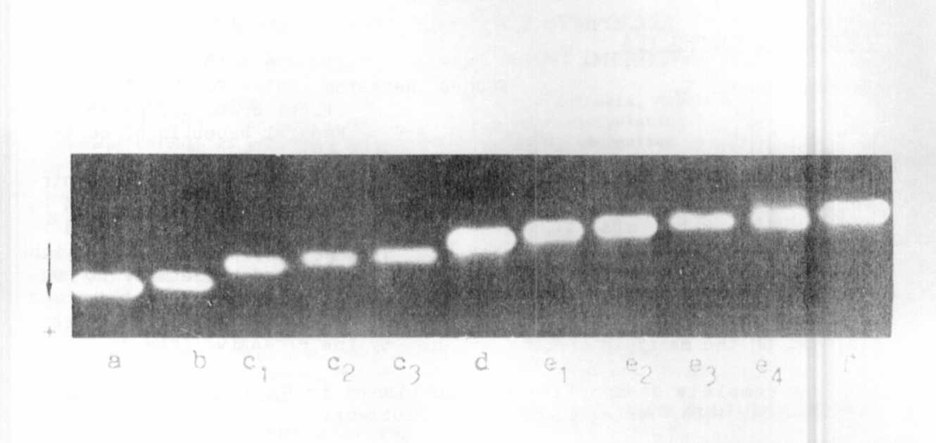
Fig. 1. Amy-2 phenotypes in pea seeds. The phenotypes shown are
produced by the following accessions: a - The accession of
P. fulvum obtained from the Hebrew University of Jerusalem; b -
Gat. 2 55, P. elatius; c1 - W 809, P. sativum; c2 - W 1 998,
P. sativum; c3 - W 1951, P. sativum; d - JI 224a, P. fulvum ;
e1 - W226, P. elatius: e2 - W 1447, P. elatius: e3 - W 1201,
P. sativum: e4 - W 1968, P. sativum: f - W 1647, P. sativum.

mi an

Editor's Note: In order to maintain a consistent system of nom-
enclature for the amylase variants observed, the authors have
used subscripts to designate further variation within mobility
classes (a-e) originally reported in Przybylska, et al. Genetica
Polonica 23:103, 1982. This somewhat unconventional format may
lead to very cumbersome allelic designations should additional
cryptic variation be revealed in further studies. We respect-
fully suggest that after the investigators have completed their
analysis of amylase phenotypes and the genetic basis for the
observed variation has been determined, the allelic designations
be modified to a more conventional and convenient form. The
rules for genetic symbols (PNL 9:67-70) do not explicitly deal
with this problem, but since more and more biochemical markers
are being reported, it is important that we develop a consistent
system which is acceptable to most, if not all, Pisum genetic-
ists.

