PNL Volume 15 1983
RESEARCH REPORTS
56

PEA 6-PHOSPHOGLUCONATE DEHYDROGENASE ISOZYMES

Weeden, N. F. NYS Agricultural Experiment Station, Geneva, NY, USA

Two isozymes of 6-phosphogluconate dehydrogenase (6PGD) have been
identified in spinach (1), radish (2), castor bean (4) and Senecio syl-
vaticus (5). In each of these species one of the isozymes is found in
the cytosol while the second is localized in the plastid (chloroplast,
leucoplast, etc.). In this report I present evidence that two isozymes
of 6PGD are also present in pea leaves, that one of these is in the
cytosol and the other in the chloroplast, and that the two isozymes are
specified by distinct genes.
Starch gel electrophoresis was performed as described in the accom-
panying article (8) using the pH 6.1 buffer system. Chloroplast and
cytosolic fractions were obtained as described previously (6) . The as-
say for 6PGD was modified from Shaw and Prasad (3). Two zones of 6PGD
activity were observed after electrophoresis of extract from a number of
inbred lines (Fig. 1). In every line examined only one band of activity
within Group A and one within Group B were observed (see Fig. 1). The
more anodal set (Group A) was present in whole leaf and chloroplast ex-
tracts but absent from soaked pollen extracts, indicating a plastid
localization. The slower migrating bands (Group B) were observed in
whole leaf and soaked pollen but not in the chloroplast pellet and are
believed to be contained in the cytosol. Mitochondrial, peroxisomal and
vacuolar compartments were not investigated.
The variability present between lines permitted genetic analysis of
the isozymes by classical inheritance studies. An appropriate F2
progeny was tested for segregation of forms A and A' and forms B and B'.
Within each set three phenotypes were observed in the F2; two were
parental and the third consisted of a broad region of activity covering
both parental zones. This third phenotype was that seen in all F₁
plants and is considered to be that of a heterozygous individual because
allelic forms of isozymes are generaly codominant. For both sets the
ratio of the three phenotypic classes in the F2 was very close to the
1:2:1 ratio expected for two alleles segregating at one locus (Table 1).
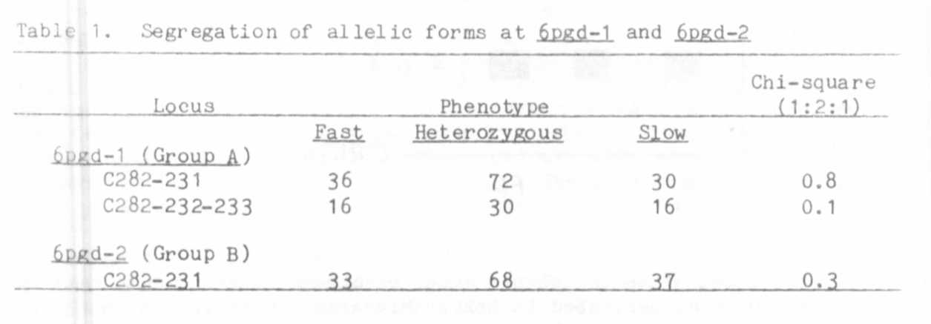

PNL Volume 15 1983
RESEARCH REPORTS

These results demonstrate that the 6PGD's in each subcellular
compartment are coded by genes located on nuclear DNA. In order to
determine whether the two sets of 6PGD's are coded by the same or by
distinct nuclear genes their joint segregation was investigated
(Table 2). The analysis indicates that the chloroplast and cytosolic
isozymes are specified by distinct genes, 6pgd-1 and 6pgd-2 respec-
tively, and are only distantly linked, if linked at all. These findings
represent the first demonstration of the genetic basis of plastid and
cytosolic 6PGD's. The results parallel those for three other
chloroplast/cytosolic isozyme pairs which have been investigated at the
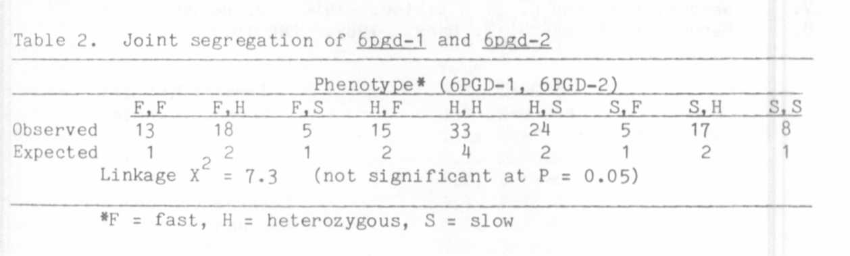
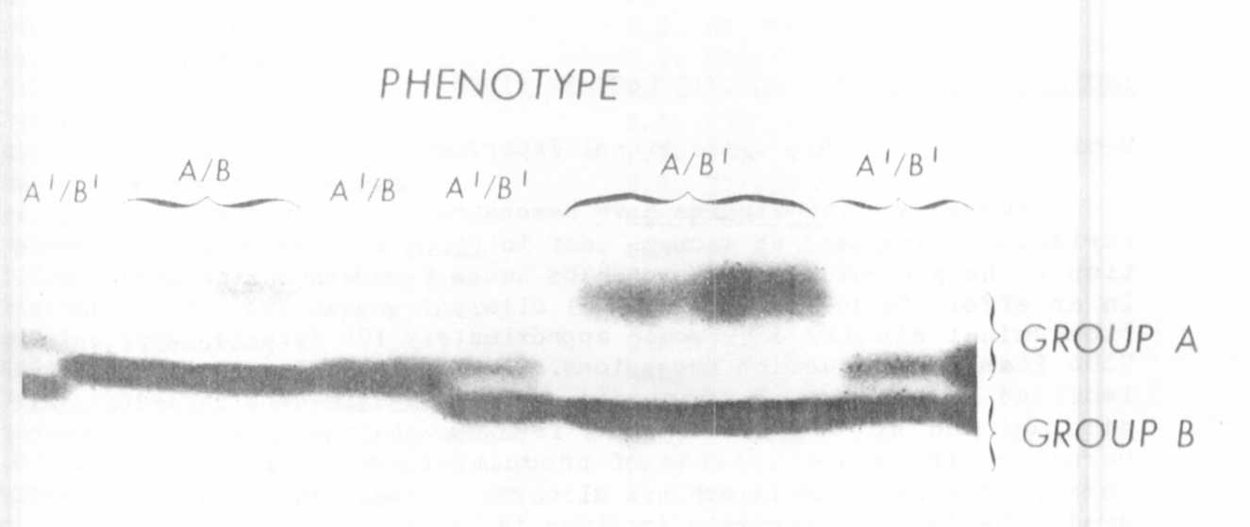
genetic level (7) .

Fig. 1. Electrophoretic patterns of 6PGD isozymes in homozygous breed-
ing lines. Direction of migration is toward the anode at the
top of the photograph. Group A consists of the two more anodal
bands labeled A and A'. Group B includes the intense bands
designated B and B'.

1. Schnarrenberger, C, A. Oeser and N. E. Tolbert. 1973- Arch.
Biochem. Biophys. 154:438-418.
2. Schnarrenberger, C, M. Tetour and M. Herbert. 1 975. Plant
Physiol. 56:836-840.
3. Shaw, C. R. and R. Prasad. 1970. Biochem. Genet. 4:297-320.
4. Simcox, P. D. and D. T. Dennis. 1978. Plant Physiol. 62:287-
290.
5. Verkley, J. A. C. and J. J. Zuetenhorst. 1 980. Biochem.
Physiol. Pflanzen. 175:9-14.
6. Weeden, N. F. and L. D. Gottlieb. 1980. Plant Physiol. 6 6 : 40 0-
403-
7. Weeden, N.F. and L. D. Gottlieb. 1980. J. Hered. 71:392-296.
8. Weeden, N. F. and G. A. Marx. 1983- PNL 15:^{r}₃4-55.

ISOZYME VARIATION AT SELECTED LOCI IN PISUM

Weeden, N. F.
NYS Agricultural Experiment Station, Geneva, NY, USA

Several recent studies have demonstrated the existence of allelic
variants (allozymes) at isozyme loci in Pisum and have used such varia-
tion to help elucidate relationships among taxa within the genus (1,2).
In an effort to identify additional allozymic variation for linkage and
biochemical studies I surveyed approximately 100 diverse lines and ten
USDA Plant Introduction accessions. The latter group included samples
labelled P. elatius. P. jomardii. and P. sativum ssp. syriacum. abys-
sinicum and hortense. The 43 isozyme stains used in the survey
permitted the visualization of products from 77 distinct loci. Of
these, 40 were found to exhibit allozymic forms. The list of currently
available isozyme variants is given in Table 1 along with the lines in
which the rarer variants were discovered. This author would appreciate
information regarding polymorphism at additional isozyme loci not in-
cluded in Table 1.

1. Parzysz, H. , J. Przybylaaka and S. Blixt. 1982. PNL 14:55-56.
2. Przybylska, J., H. Parzysz and S. Blixt. 1981. PNL 1 3:42-43.

